

Pesto Pizza

Ingredients  75g strong white flour  25g strong wholemeal flour  ½ x 5 ml spoon salt  ½ sachet dried yeast  1 x 10ml spoon sunflower oil  3 x 15ml spoon warm water  2 x 15ml spoon pesto (level)  25g sundried tomatoes  5 black pitted olives  30g feta cheese  Handful of basil leaves  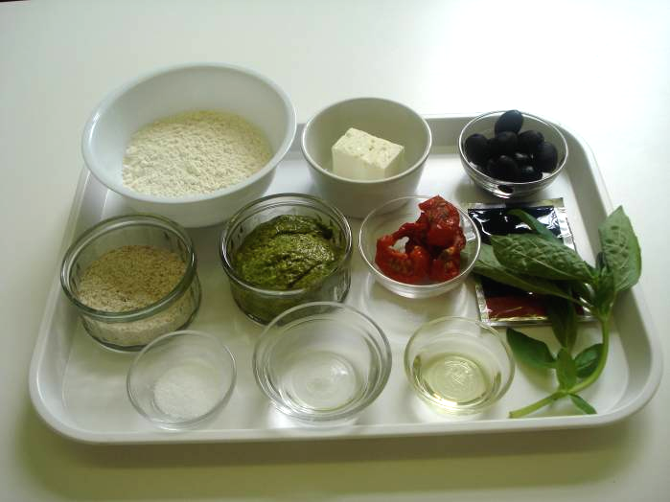 |  | Equipment  Baking tray, pastry brush, weighing scales, sieve, mixing bowl, palette knife, measuring spoons, measuring jug, flour dredger, rolling pin, chopping board, sharp knife, and cooling rack.  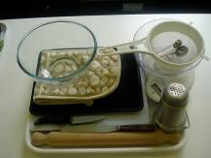
Method
1. Preheat the oven to 200°C or gas mark 6.   |  | 2. Grease or line the baking tray.  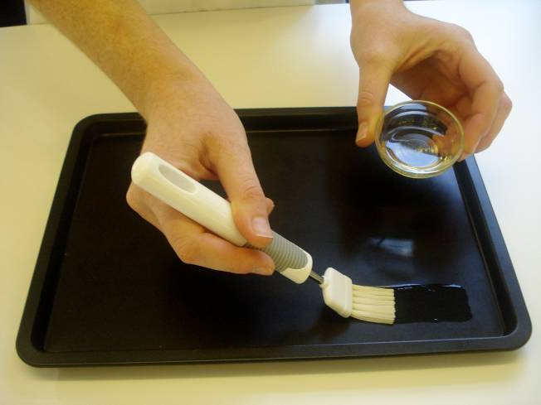
3. Sift the flour and salt into the mixing bowl.  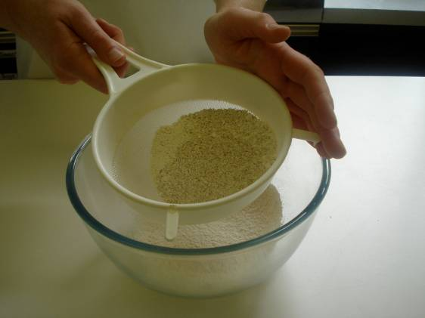 |  | 4. Stir in the yeast and make a well in the middle.  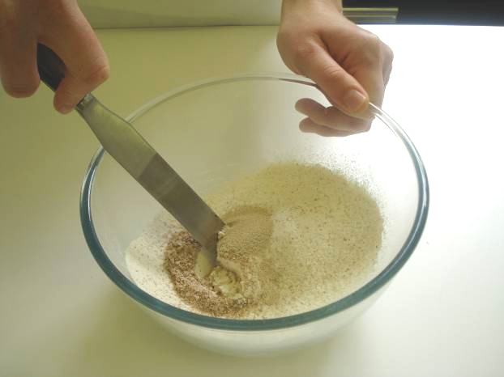
5 Add the oil and enough warm water to mix into a soft dough with your hands.  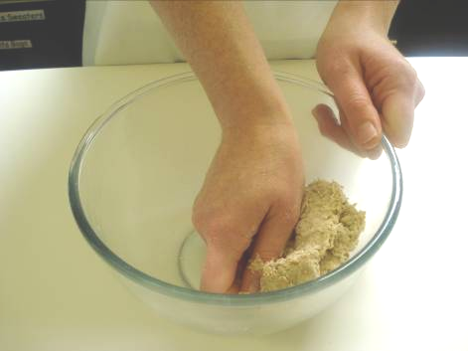 |  | 6. Turn the dough out onto a lightly floured surface and knead for 5-10 minutes .  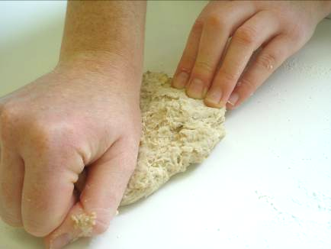
7. Place the dough in the bowl, cover with cling film and allow to prove in a warm place for 15 minutes.  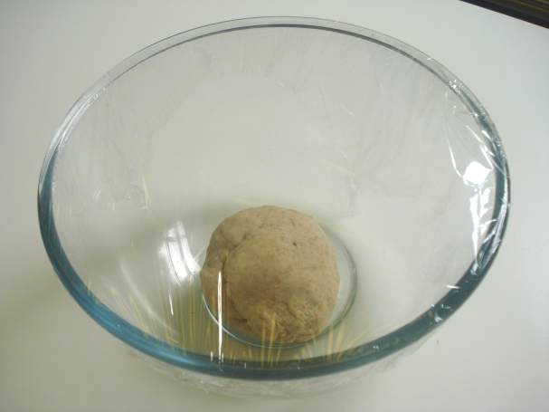 |  | 8. Roll out and shape the dough into a rectangle. Place the dough onto the baking tray.  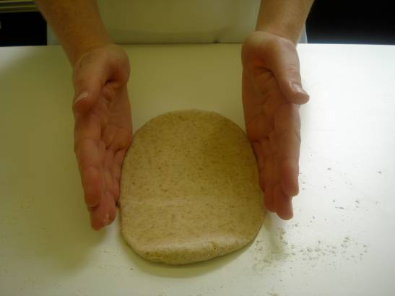
9. Spread the pesto on the base almost to the edge of the pizza with a palette knife.  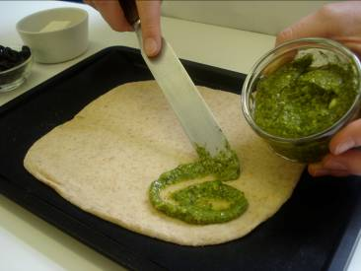 |  | 10. Thinly slice the sun dried tomatoes and olives.  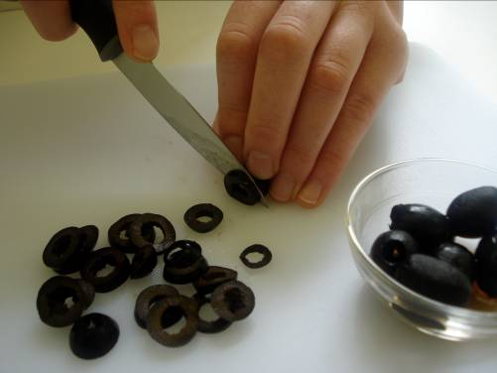
11. Arrange the tomato and olives on top of the pizza.  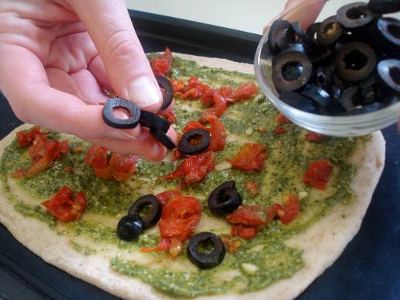 |  | 12. Crumble the feta cheese on top.  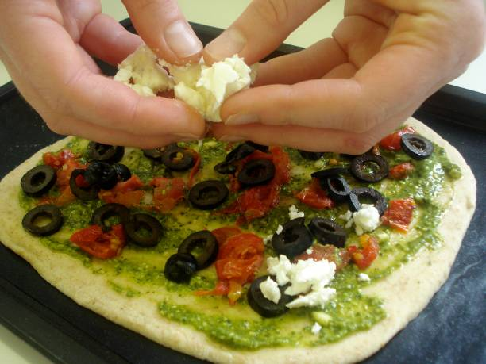
13. Bake for 10-15 minutes.  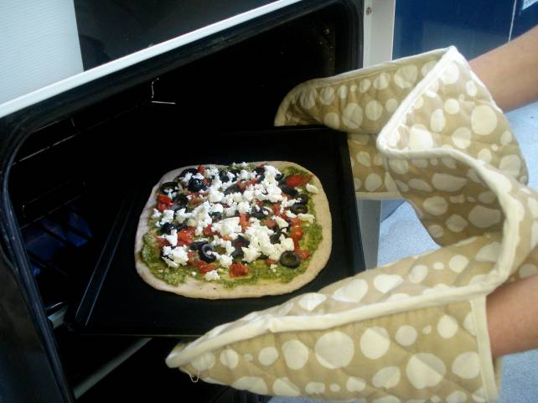 |  | 14. Remove from the oven and place the pizza on a cooling rack. Roughly tear the basil leaves and sprinkle over the pizza.  