
ANZAC Biscuits

Ingredients  100g plain white flour  25g rolled oats  30g caster sugar  25g desiccated coconut  20ml spoon golden syrup  50g margarine  ½ x 5ml spoon bicarbonate soda  10ml spoon boiling hot water  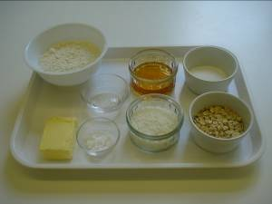 |  | Equipment  Baking tray, weighing scales, sieve, mixing bowl, saucepan, wooden spoon, 5 ml spoon, 15ml spoon, kettle, small bowl, spatula, palette knife, flour dredger, fork, oven gloves and cooling rack.  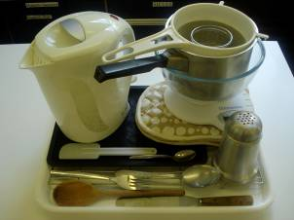
Method
1. Preheat the oven to 160ºC or gas mark 4.  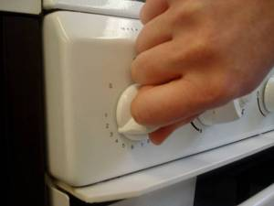 |  | 2. Grease or line the baking tray.  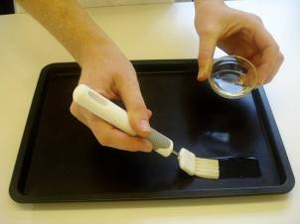
3. Sift flour into the bowl.  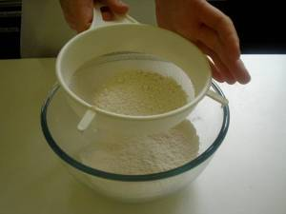 |  | 4. Mix in the coconut, oats, and sugar.  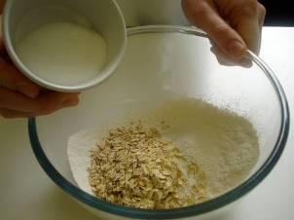
5. Melt the golden syrup and margarine together on a low heat in a small saucepan.  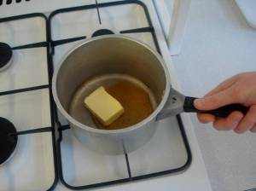 |  | 6. Mix the bicarbonate of soda with the boiling hot water and add to the melted butter immediately.  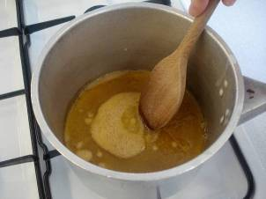
7. Add the wet mixture to the dry ingredients.  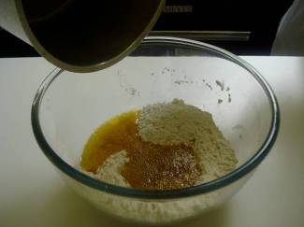 |  | 8. Mix thoroughly until combined.  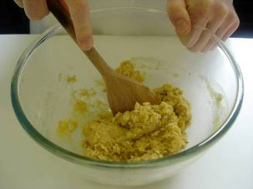
9. Divide the mixture evenly into 8 portions using the 15ml spoon.  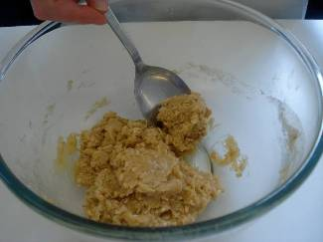 |  | 10. Use lightly floured hands to shape the biscuits into round balls and place onto the prepared baking tray.  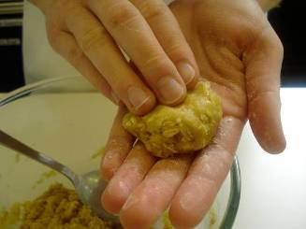
11. Slightly flatten the biscuits with a lightly floured fork.  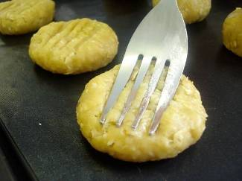 |  | 12. Bake for 15-20 minutes, until golden brown.  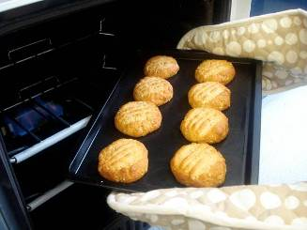
13. Cool on the baking tray for a few minutes, to allow the biscuits to firm, before transferring them to a cooling rack.

