
Tuna and Broccoli Pasta

Ingredients | Equipment
100g rigatoni  40g cheese  100g broccoli  100g canned tuna (in water) drained  25g soft margarine  25g plain flour  250ml semi-skimmed milk  1 x 5ml spoon dried oregano  50g sweetcorn (canned or frozen)  Black pepper | Two saucepans, weighing scales, grater, chopping board, knife, measuring jug, whisk, measuring spoons, colander, wooden spoon, ovenproof dish or foil tray.
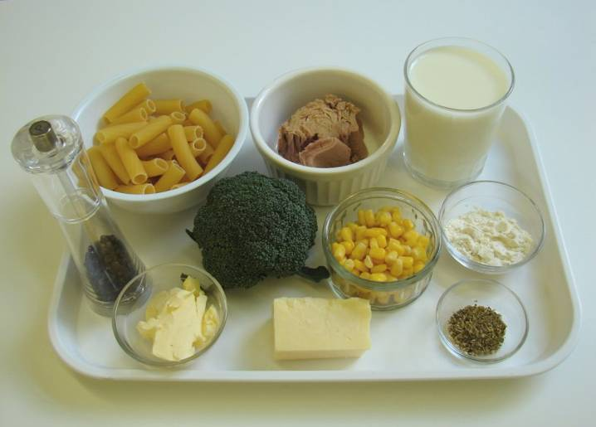 | 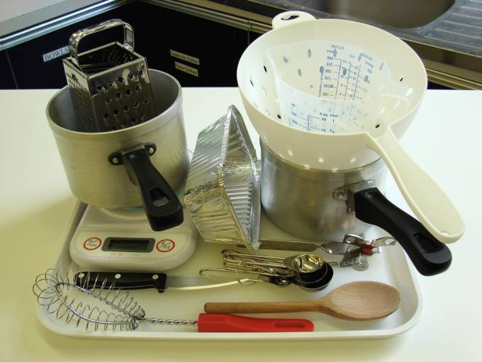
Method
1. Bring a saucepan of water to the boil, and then add the pasta. Simmer for about 10 – 12 minutes, until al dente. | 2. Grate the cheese and cut the broccoli into small pieces.
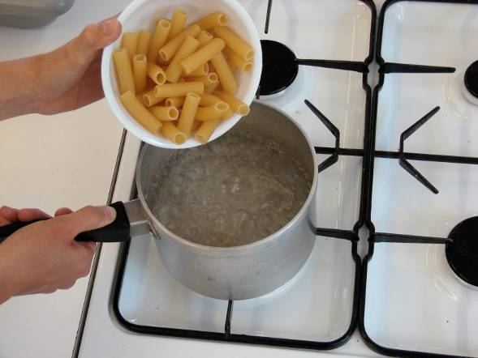 | 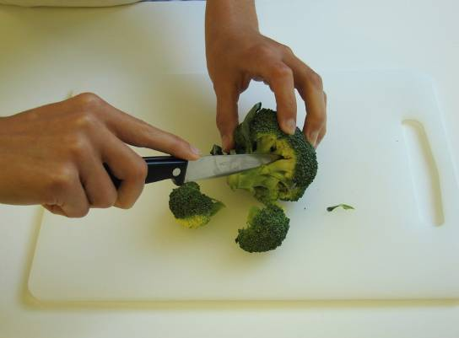
3. While the pasta is cooking, make the sauce:  - place the butter or margarine, flour and milk into a small saucepan; | - bring the sauce to a simmer, whisking all the time until it has thickened;
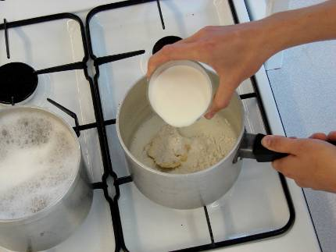 | 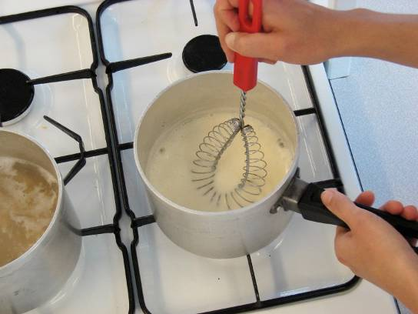
- reduce the heat, stir in the oregano, and allow to simmer for 2 minutes; | 4. During the last 2 minutes of the pasta boiling, add the sweetcorn and broccoli to the saucepan.
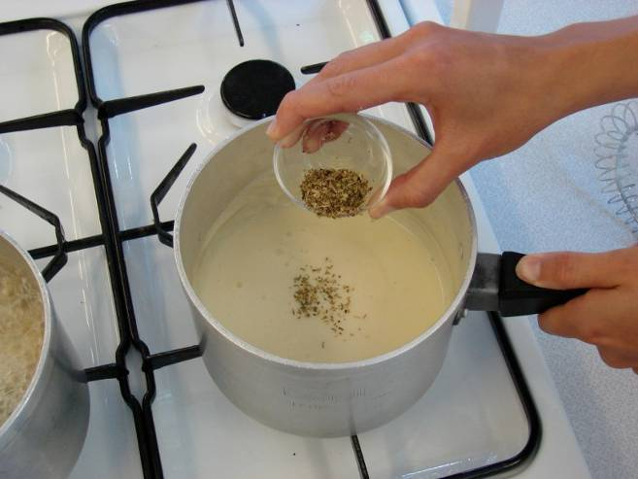 | 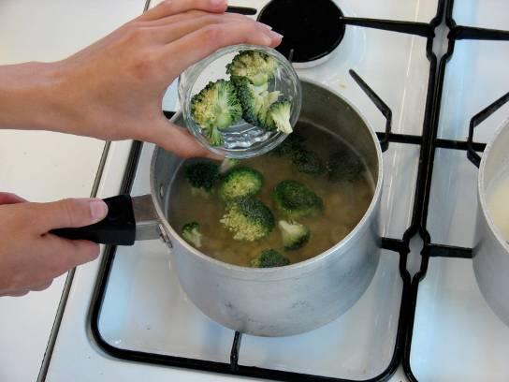
5. Preheat the grill. | 6. Drain the boiling hot water away from the pasta and vegetables into a colander in the sink.
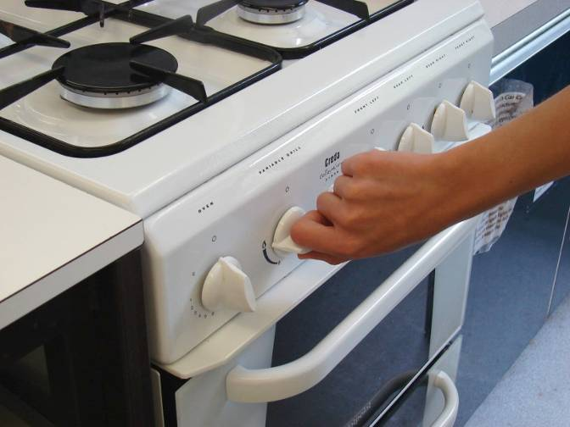 | 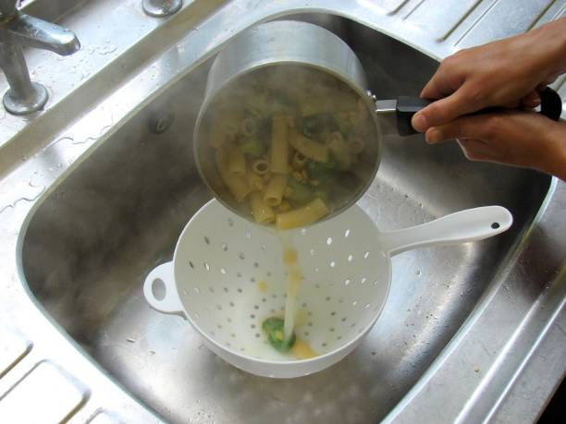
7. Pour the drained pasta and vegetables into the sauce. | 8. Stir in the canned tuna.
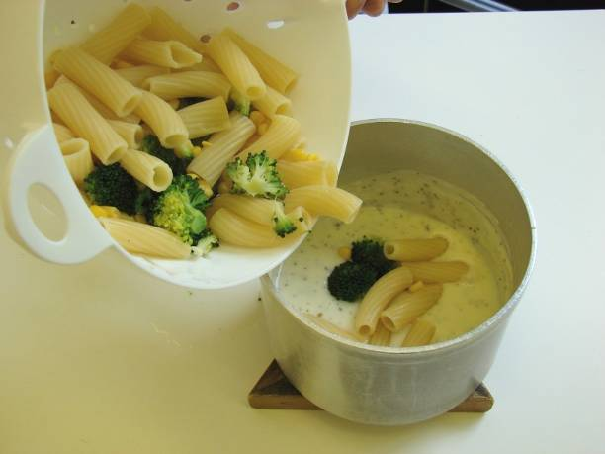 | 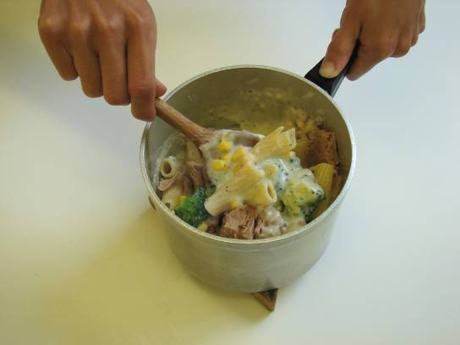
10. Sprinkle the cheese over the top, and add a few twists of black pepper. | 11. Place under a hot grill until the cheese is bubbling and golden brown.
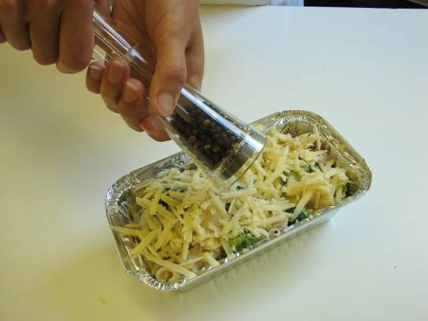 | 