

Macaroni Cheese

Ingredients | Equipment
100g macaroni  100g Cheddar cheese  1 tomato  25g soft margarine  25g plain flour  250ml semi-skimmed milk  Black pepper | Two saucepans, weighing scales, grater, chopping board, knife, colander, measuring jug, wooden spoon, whisk, ovenproof dish (or foil tray).
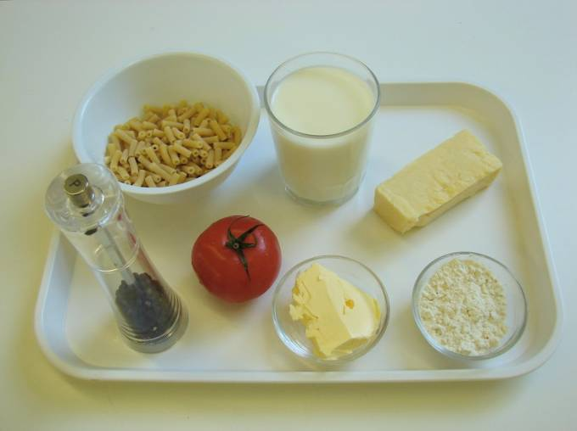 | 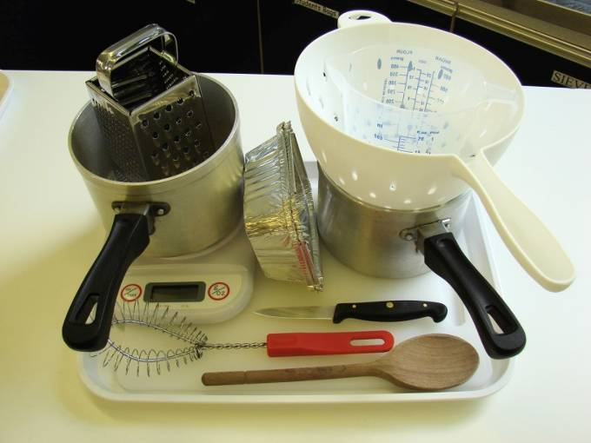
Method
1. Bring a saucepan of water to the boil, and then add the macaroni. Cook for about 10 – 12 minutes, until al dente. | 2. Grate the cheese and slice the tomato.
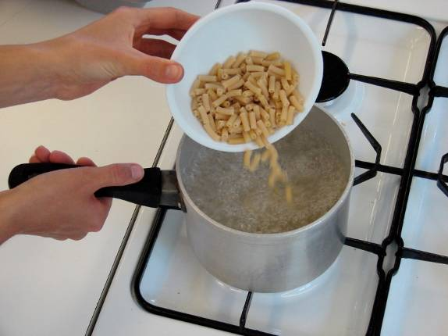 | 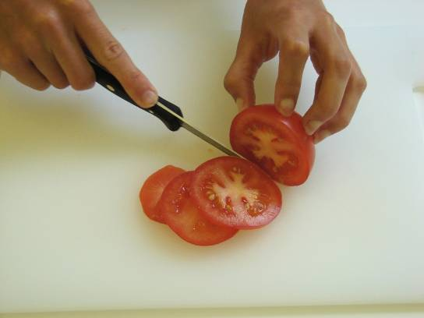
3. While the pasta is cooking, make the sauce:  - place the butter or margarine, flour and milk into a small saucepan; | - bring the sauce to a simmer, whisking all the time until it has thickened;
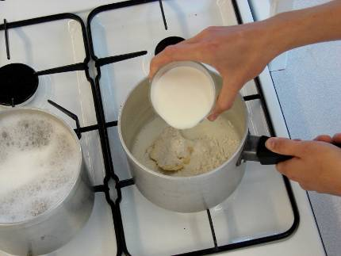 | 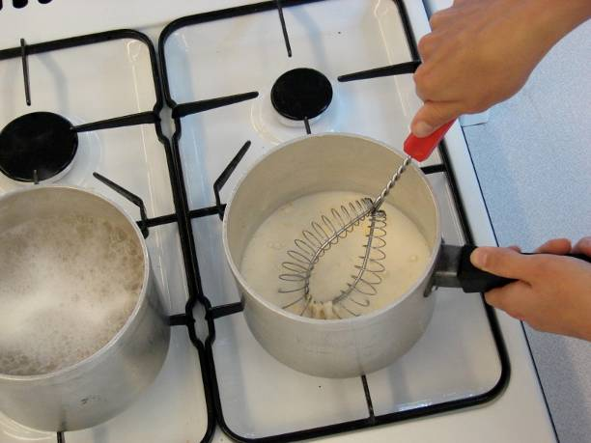
- stir in 75g of the grated cheese. | 4. Preheat the grill.
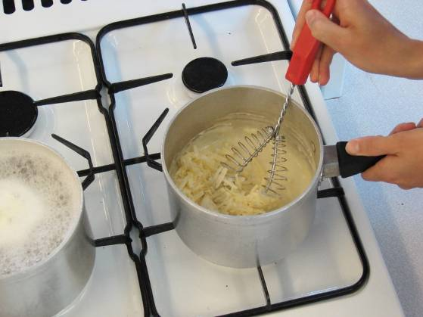 | 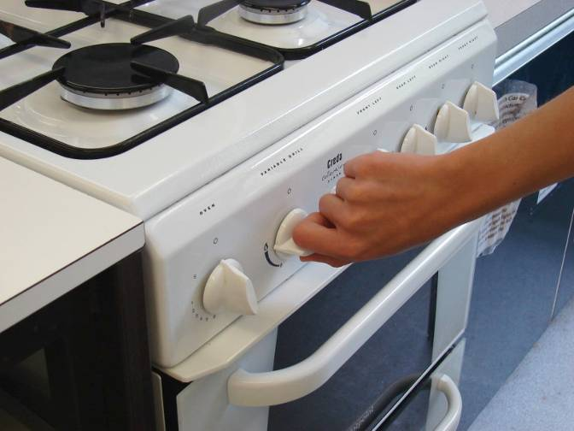
5. Drain the boiling hot water away from the macaroni into a colander in the sink. | 6. Stir the drained macaroni into the cheese sauce and add a few twists of black pepper.
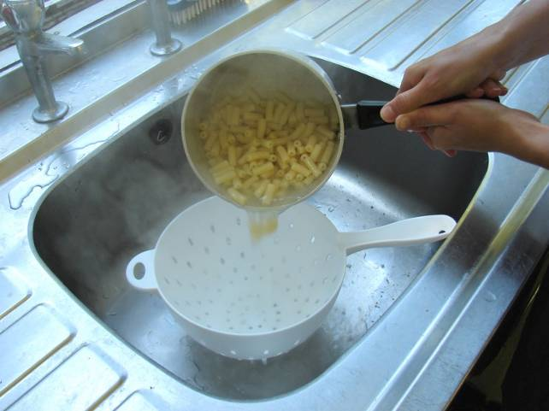 | 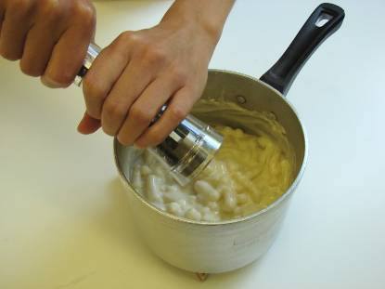
7. Pour the macaroni into an oven-proof dish (or foil tray). | 8. Arrange the tomato slices over the macaroni.
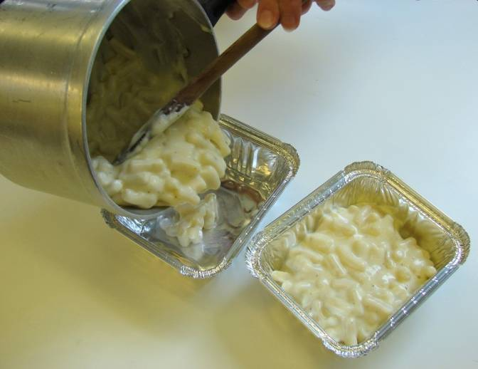 | 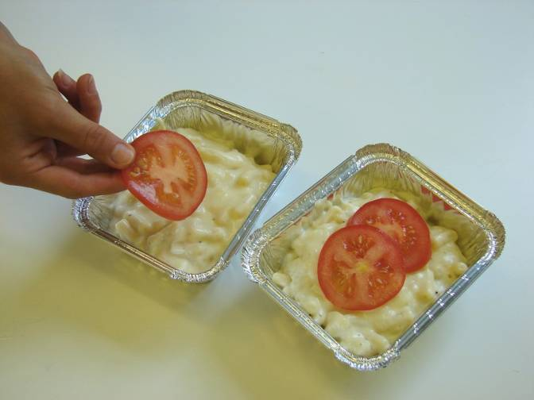
10. Place under a hot grill until the cheese is bubbling and golden brown.

