

Rocking rock cakes

Ingredients | Equipment
200g self-raising flour  75g butter or margarine  75g sugar  75g mixed dried fruit  1 egg | Sieve, mixing bowl, weighing scales, palette knife, small bowl, fork, 2 spoons, Non-stick baking tray (lined), cooling rack.
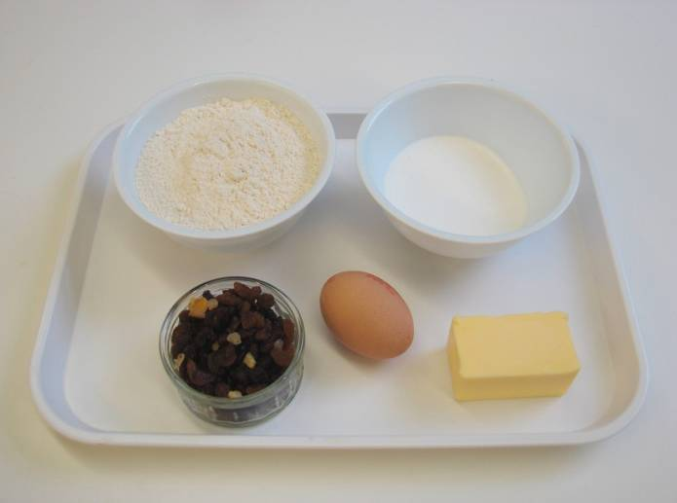 | 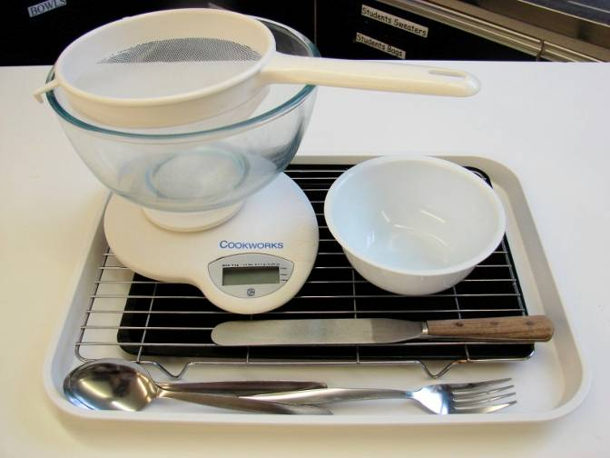
Method  1. Preheat the oven to 220°C or gas mark 7. | 2. Sieve the flour into the bowl.
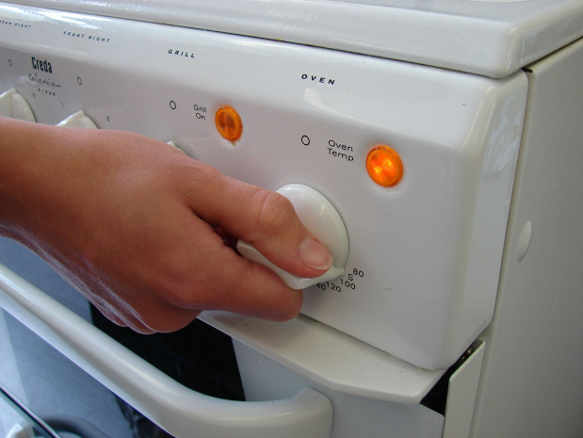 | 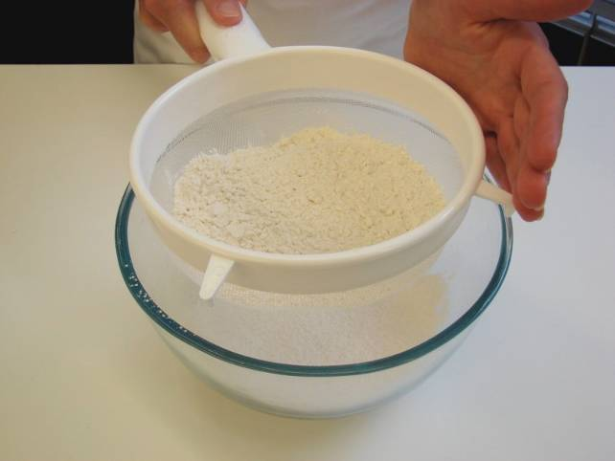
3. Rub in the butter or margarine into the flour until it resembles breadcrumbs. | 4. Stir in the sugar and dried fruit.
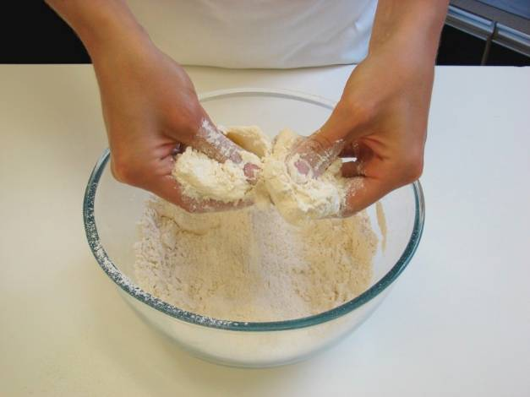 | 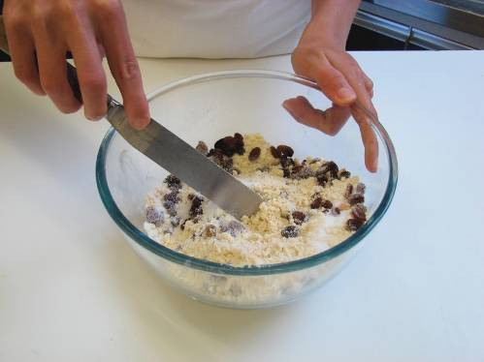
5. Whisk the egg lightly in a small bowl. | 6. Make a well in the middle of the flour and carefully add the egg.
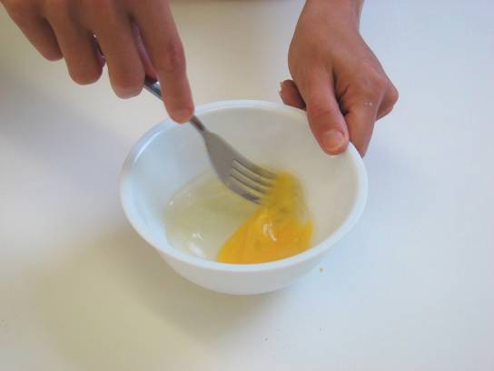 | 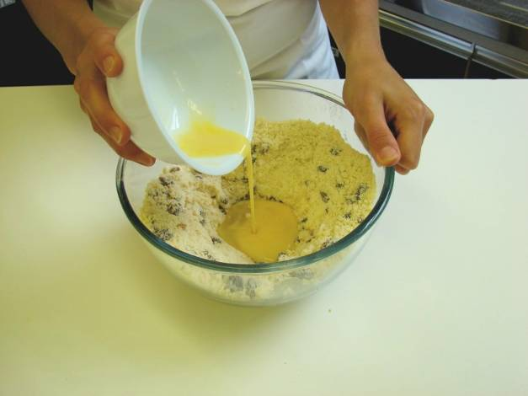
7. Mix to form a soft, yet firm dough. | 8. Using 2 spoons, divide the dough into 8 ‘rocks’ and place on the baking tray.
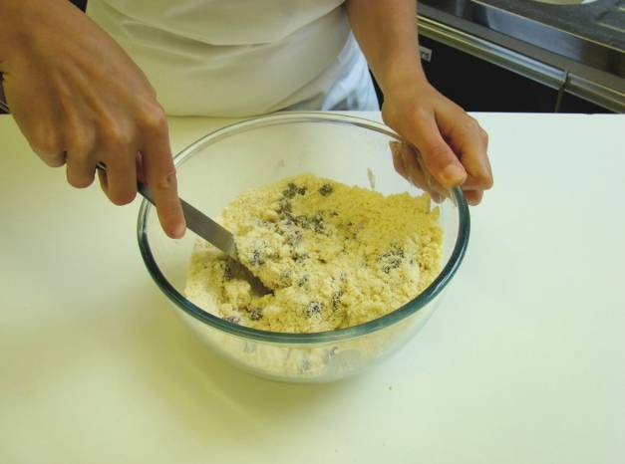 | 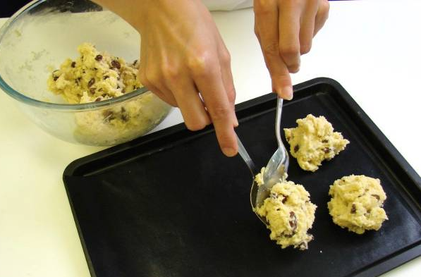
9. Bake for 12 – 15 minutes, until golden brown. | 10. Allow to cool on a cooling rack.
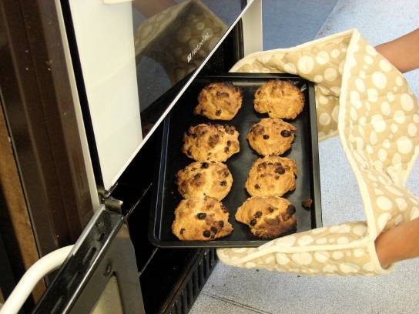 | 