
Cheesy scones

Ingredients | Equipment
250g self raising flour  1 x 5ml spoon mustard powder  40g butter or margarine  75g hard cheese  125ml semi-skimmed milk | Non-stick baking tray, pastry brush, weighing scales, sieve, mixing bowl, measuring spoons, grater, chopping board, measuring jug, flour dredger, rolling pin, scone cutter, cooling rack.
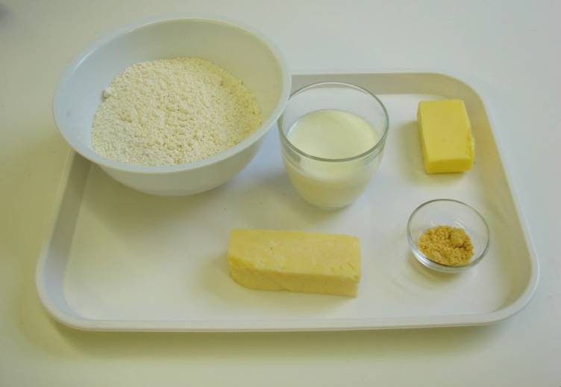 | 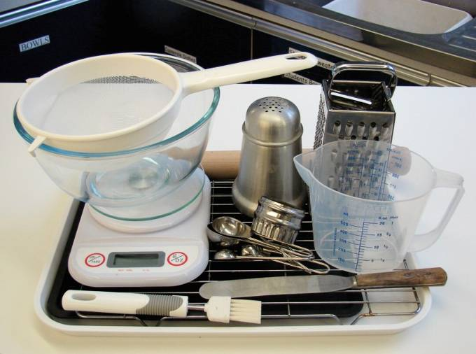
Method
1. Preheat the oven to 220°C or gas mark 7. | 2. Prepare a baking tray, e.g. greased.
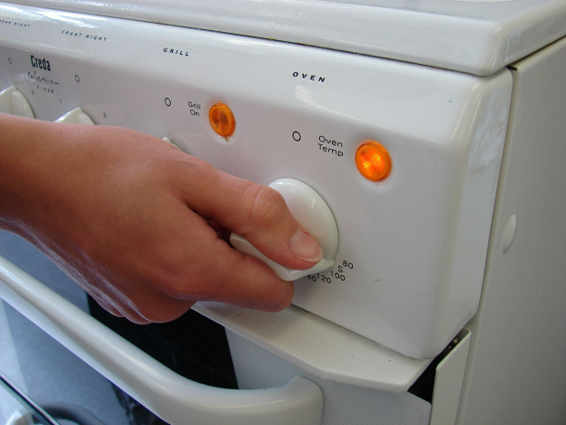 | 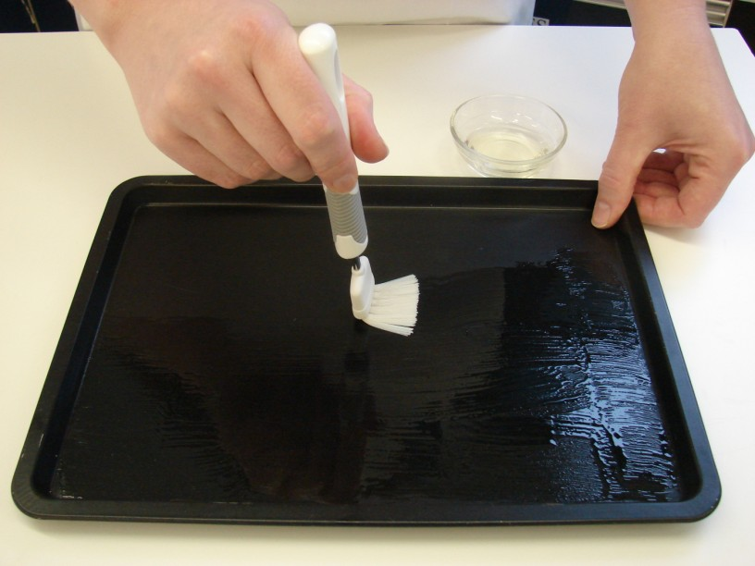
3. Sieve the flour and mustard into the bowl. | 4. Rub in the butter or margarine into the flour until it resembles breadcrumbs.
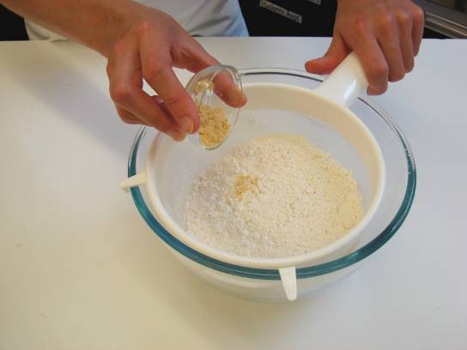 | 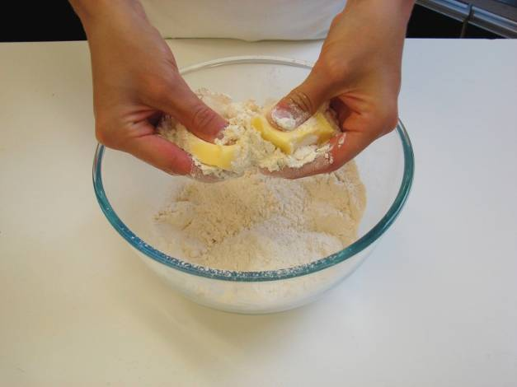
5. Grate the cheese. | 6. Stir in the cheese.
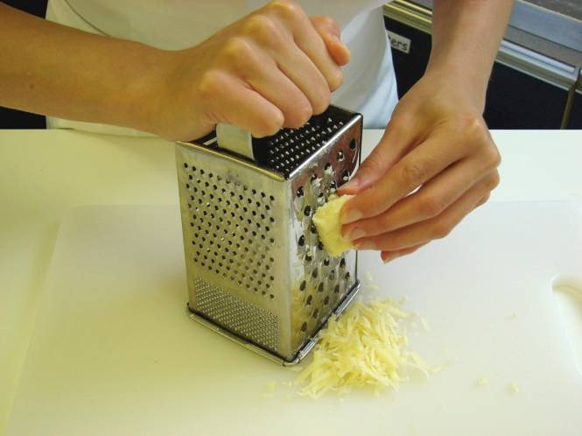 | 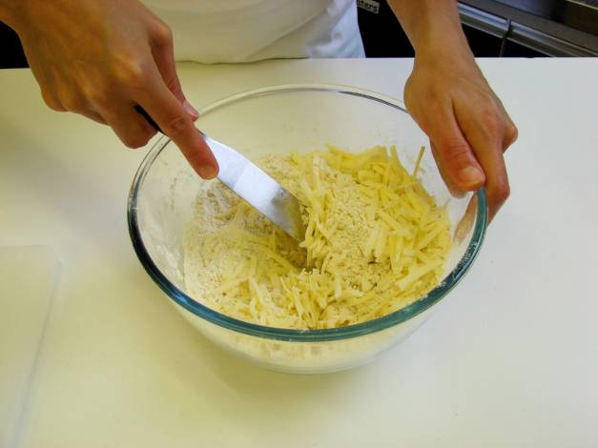
7. Make a well in the middle of the flour and carefully pour in the milk. (Save just a little of the milk). | 8. Mix to form a soft dough.
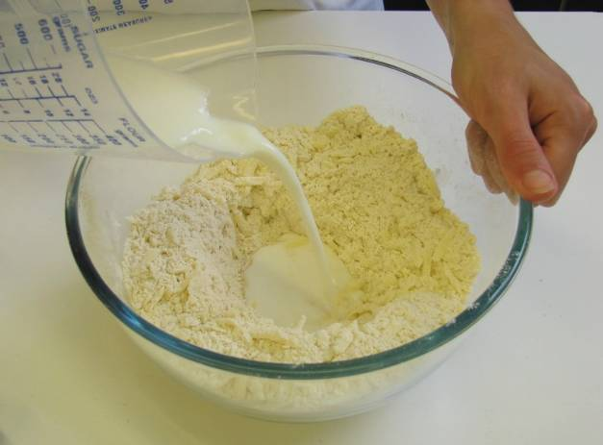 | 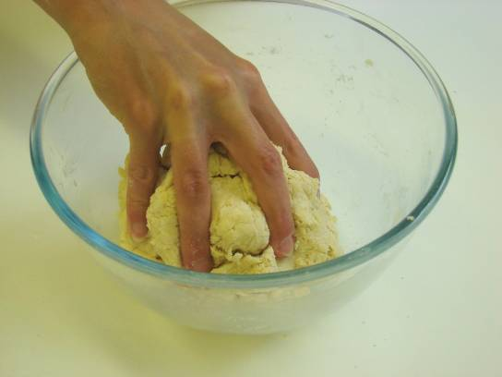
9. Place the dough on a lightly floured work surface. | 10. Roll out the dough to about 1½cm thick.
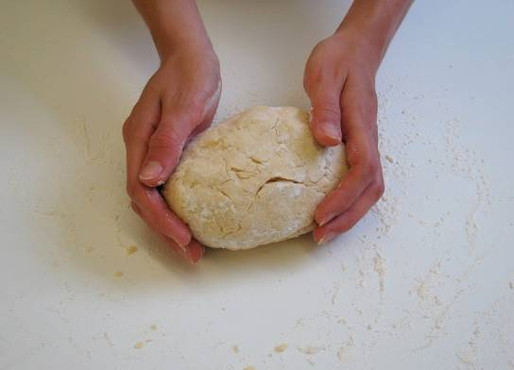 | 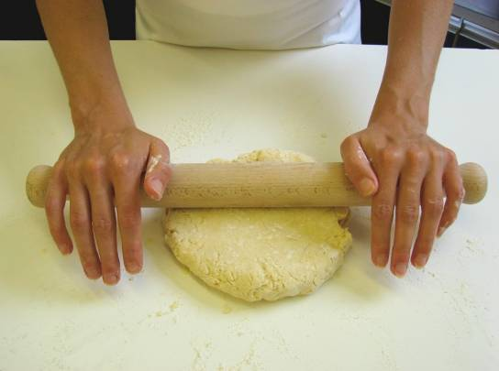
11. Shape the scones using a cutter. | 12. Place the scones on a baking tray and brush each top with a little milk.
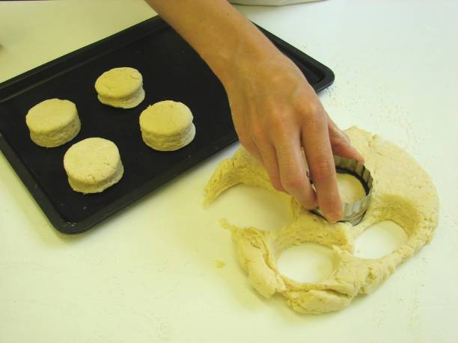 | 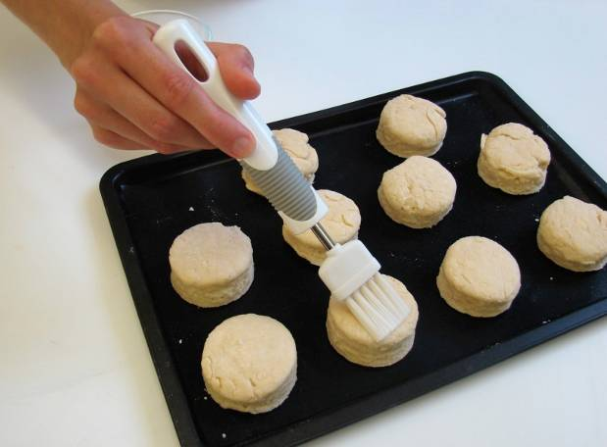
13. Bake for 12 – 15 minutes, until golden brown. | 14. Allow to cool on a cooling rack.
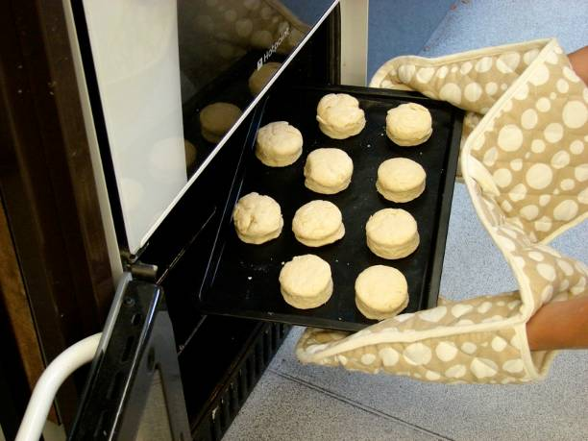 | 