

Apple and sultana crumble

Ingredients | Equipment
100g plain flour  50g butter or margarine  50g oats  25g sugar  2 eating apples  50g sultanas | Weighing scales, mixing bowl, wooden spoon, chopping board, knife, ovenproof dish or foil tray, baking tray.
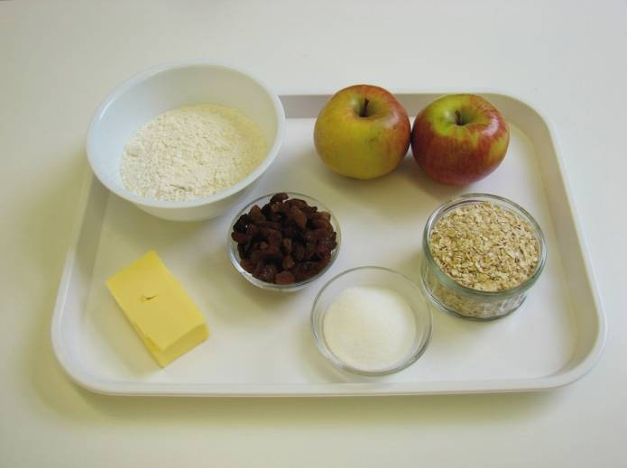 | 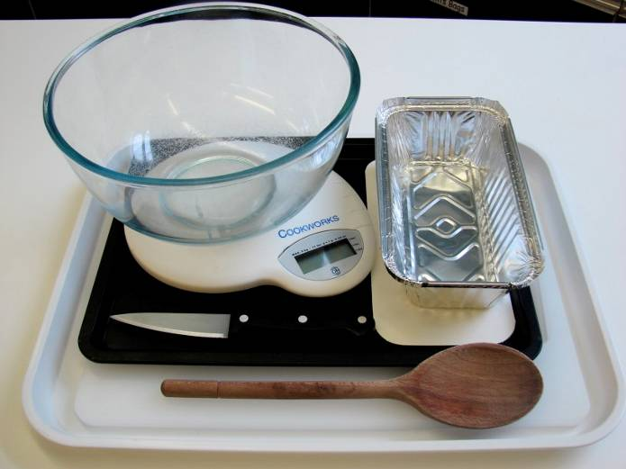
Method
1. Preheat the oven to 190°C or gas mark 5. | 2. Rub in the butter or margarine into the flour until it resembles breadcrumbs.
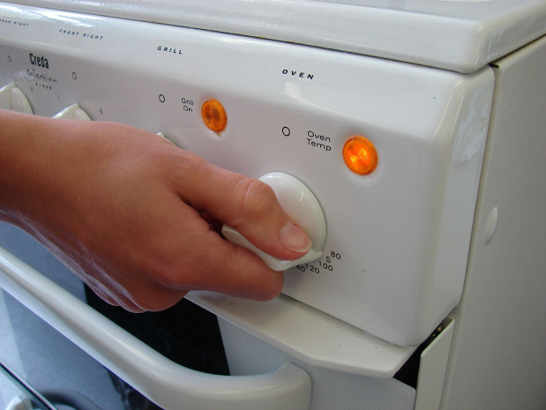 | 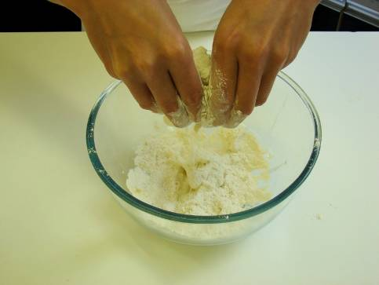
3. Stir in the oats and sugar. | 4. Cut the apples into quarters and remove the core. Slice thinly.
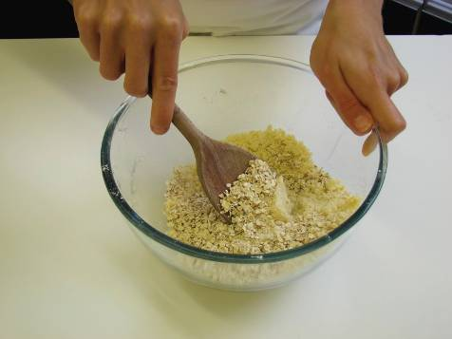 | 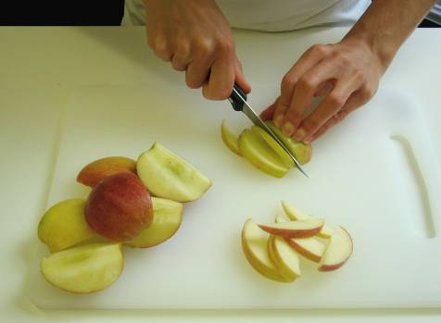
5. Arrange the apple slices in an oven proof/foil tray dish on a baking tray, and then add the sultanas. | 6. Sprinkle the crumble topping over the apple slices.
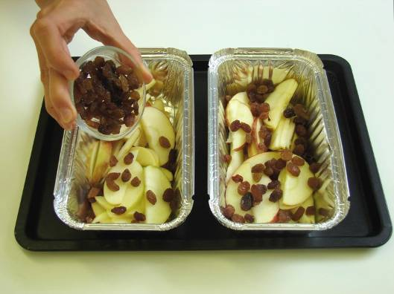 | 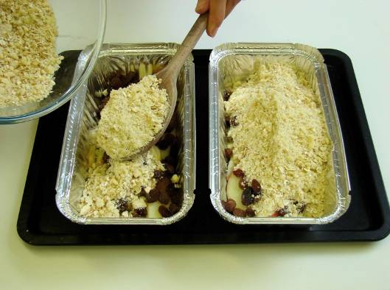
7. Bake for 25 – 30 minutes, until the apples are soft and the crumble is golden.

