

Fruity muffins

Ingredients | Equipment
250g self raising flour  2 x 5ml spoons baking powder  100g caster sugar  230ml semi-skimmed milk  1 egg  60ml oil  150g canned fruit, drained | 12 muffin cases, muffin tin, weighing scales, measuring spoons, measuring jug, mixing bowl, wooden spoons, can opener, 2 spoons, cooling rack.
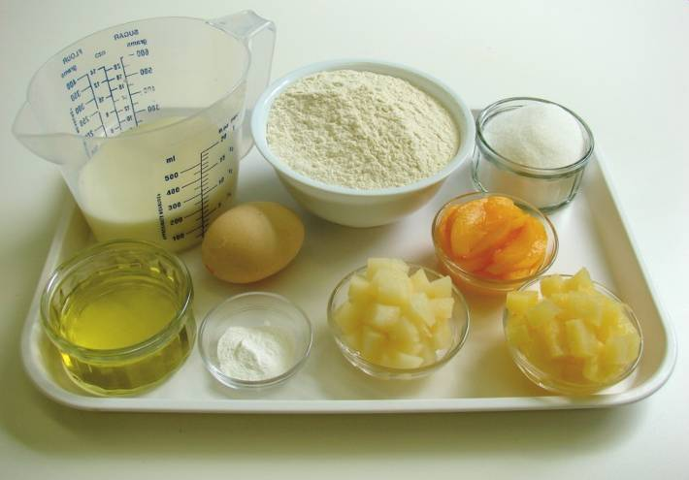 | 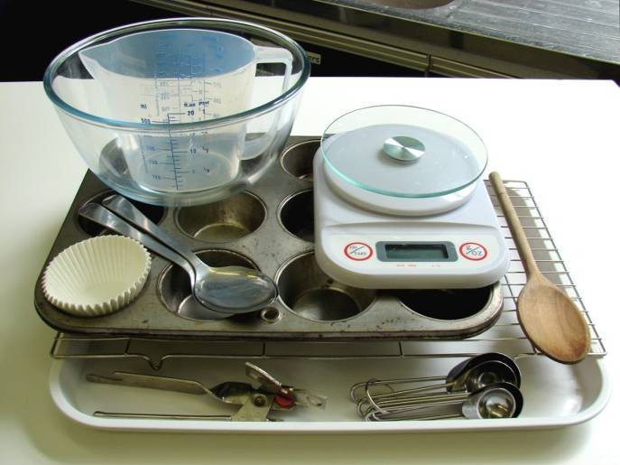
Method
1. Preheat oven to 180°C or gas mark 4. | 2. Mix all the ingredients together to form a smooth batter.
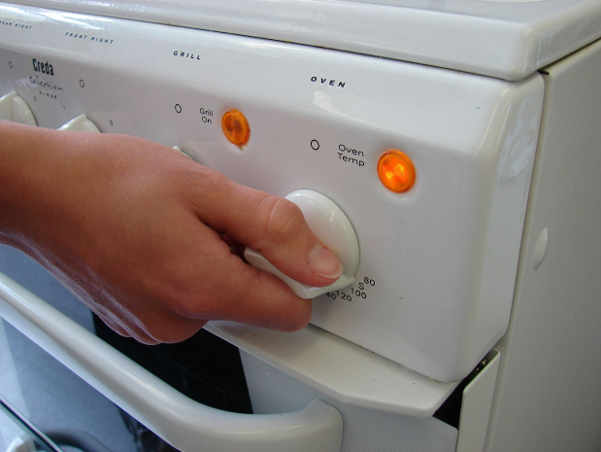 | 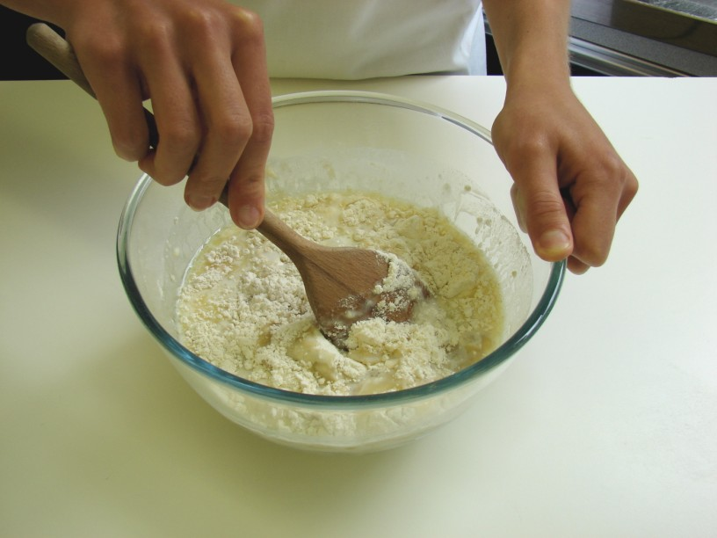
3. Stir in the fruit. | 4. Divide the mixture equally between the muffin cases using 2 spoons.
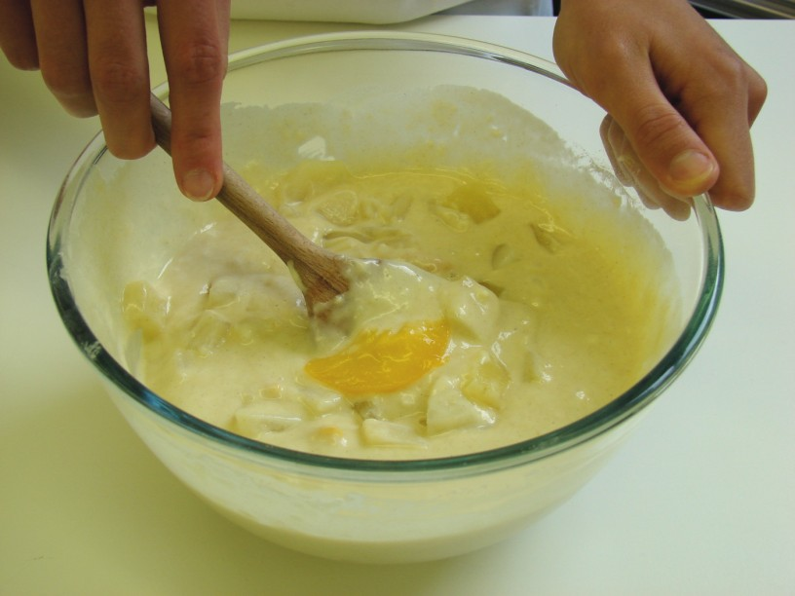 | 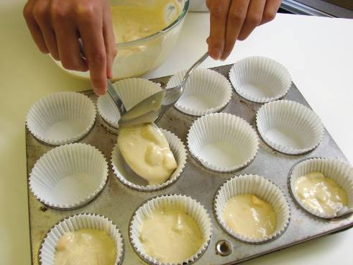
5. Bake for 20 – 25 minutes, until golden. | 6. Allow to cool on a cooling rack.
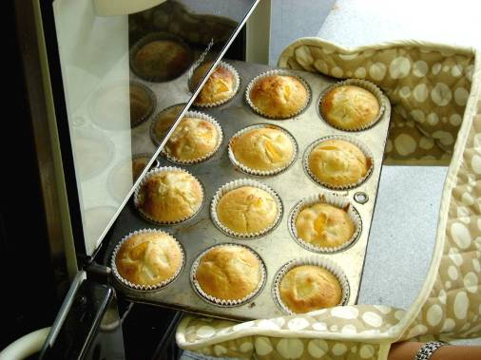 | 