

Mini-fruit Cakes

Ingredients | Equipment
100g self raising flour  100g caster sugar  100g soft margarine  2 eggs  50g dried fruit, e.g. sultanas | 12 cake cases, cake tin, weighing scales, sieve, mixing bowl, wooden spoon, 2 spoons, cooling rack.
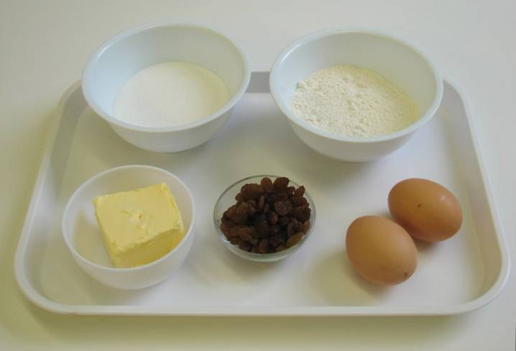 | 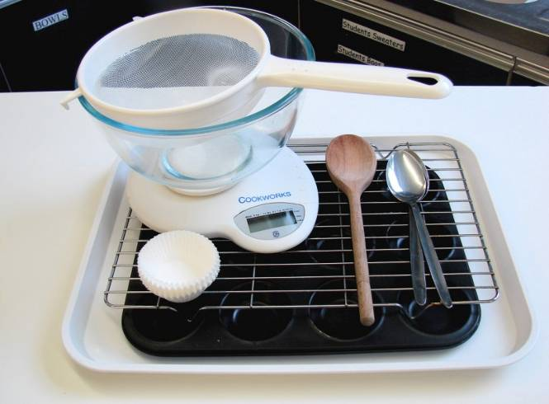
Method
1. Preheat the oven to 200°C or gas mark 6. | 2. Place the case cases in the cake tin.
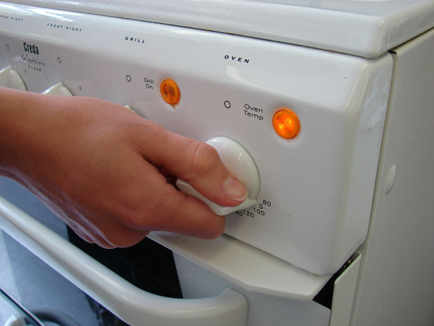 | 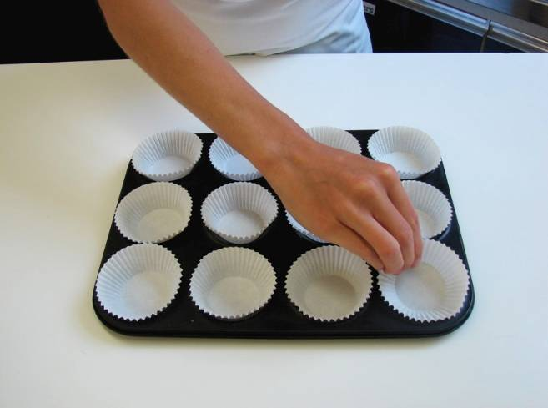
3. Sieve the flour into the mixing bowl and then add all the other ingredients. | 4. Mix everything together until light and fluffy.
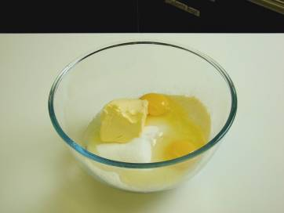 | 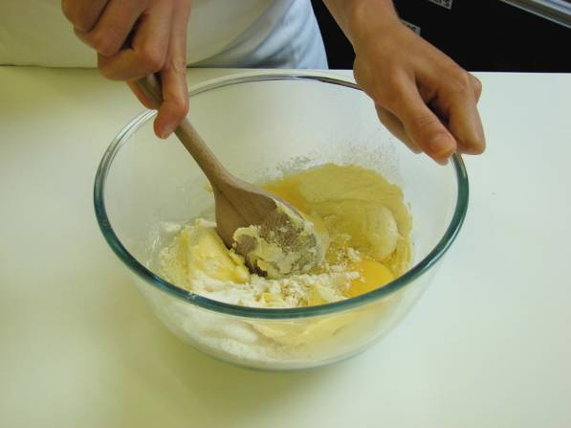
5. Stir in the dried fruit. | 6. Divide the mixture equally between the cake cases using 2 spoons.
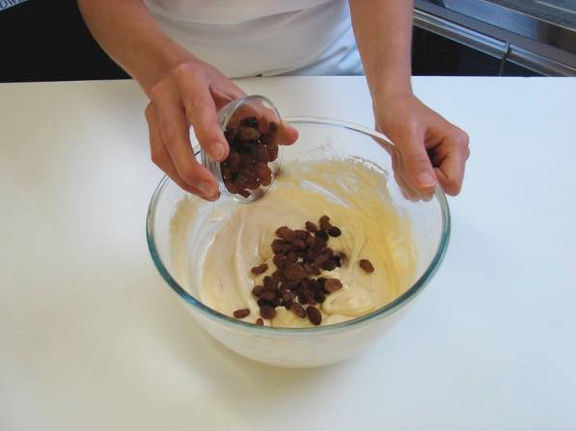 | 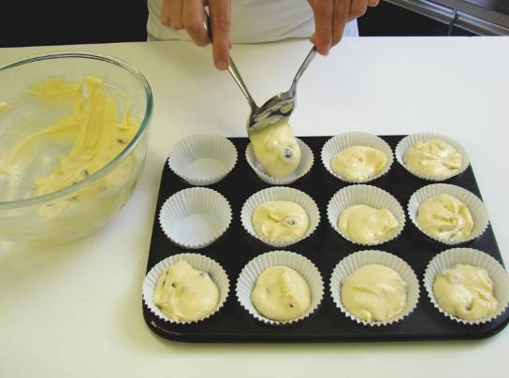
7. Bake for 15 – 20 minutes, until golden. | 8. Allow to cool on a cooling rack.
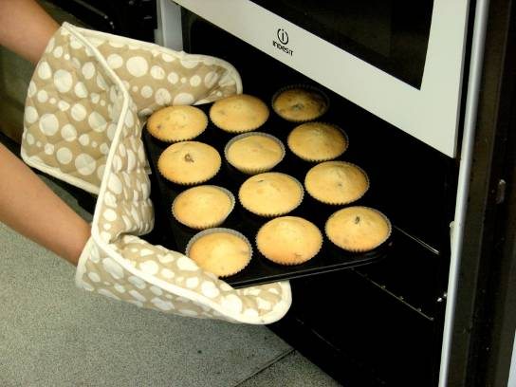 | 

