
Shepherd’s Pie

Ingredients | Equipment
1 onion  1 carrot  3 medium potatoes (700g)  ¼ Savoy cabbage  250g lean minced lamb  1 x 15ml spoon plain flour  1 x 15ml spoon tomato purée  1 x 15ml spoon Worcestershire sauce  300ml water, boiling  1 x 5ml stock cube  150ml semi-skimmed milk | Chopping board, knife, vegetable peeler, weighing scales, measuring spoons, saucepan, non-stick frying pan, wooden spoon, measuring jug, colander, potato masher, ovenproof dish/foil tray, baking tray.
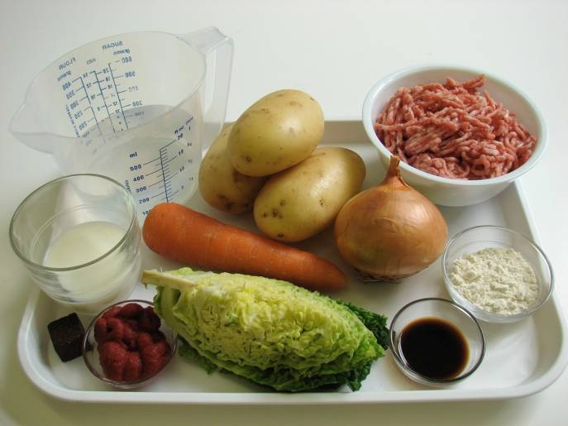 | 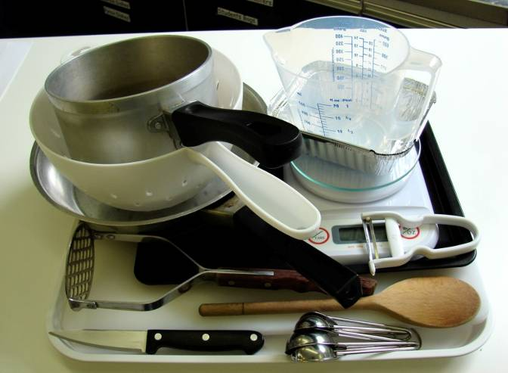
Method
1. Preheat the oven to 200°C or gas mark 6. | 2. Prepare the vegetables:  - chop the onion;
 | 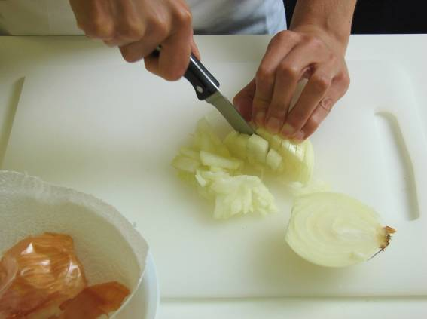
- peel and dice the carrots; | - peel and cut the potatoes into chunks;
 | 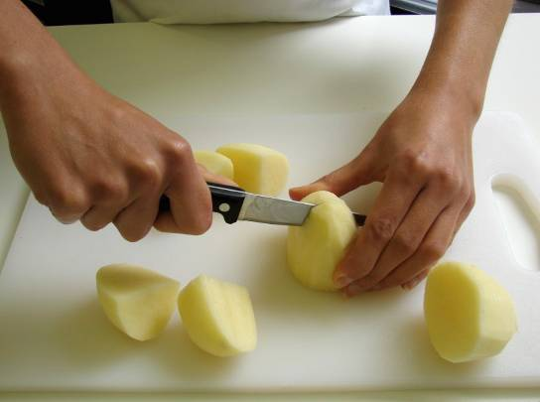
- shred the cabbage. | 3. Place the potatoes in a saucepan of water, bring to the boil and simmer for 20 minutes, until soft.
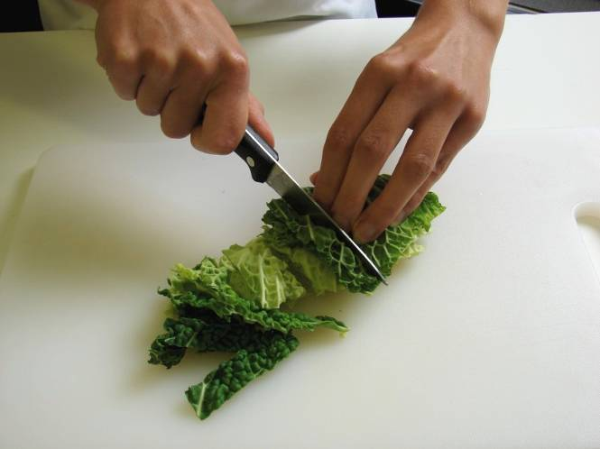 | 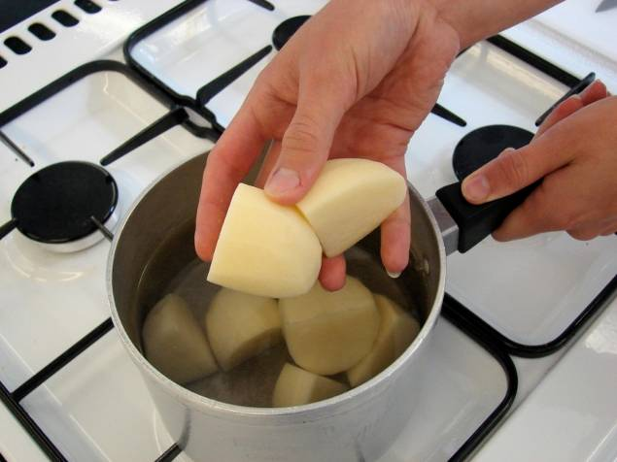
4. Meanwhile, in a non-stick frying pan, dry fry the lamb with the onion and carrots, until the mince is browned. | 5. Stir in the flour, tomato purée and Worcestershire sauce.
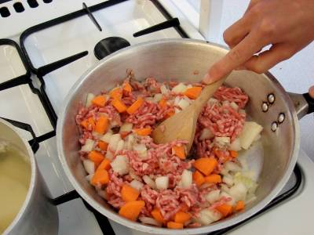 | 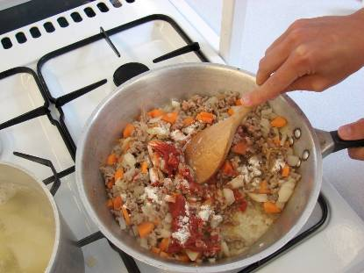
6. Add the stock cube to the water to make up the stock. | 7. Add the stock to the meat mixture, bring to the boil and then simmer for 5 – 10 minutes, until the carrot is soft.
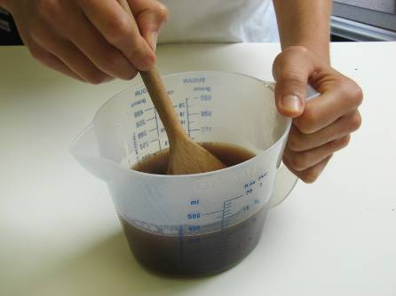 | 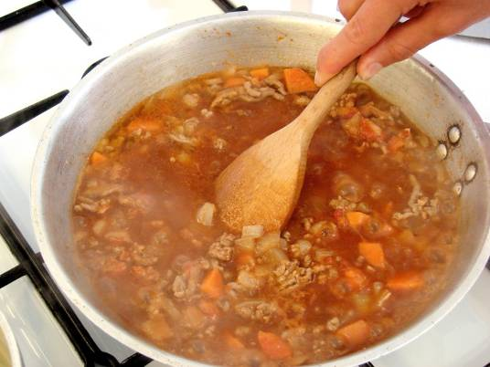
8. During the last 5 minutes of cooking the potatoes add the cabbage. | 9. Drain the potatoes in a colander over the sink and mash with the milk.
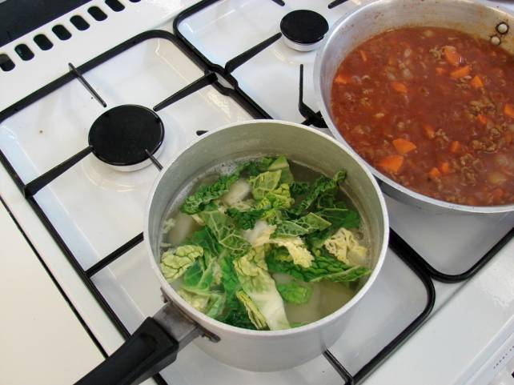 | 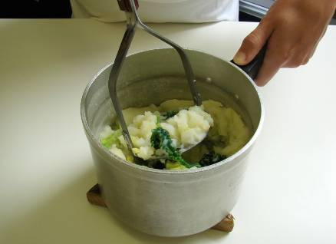
10. Place the oven proof dish or foil tray on a baking tray. Spread the meat mixture into an ovenproof dish and spoon the mash over the top. | 11. Cook for 20 – 25 minutes, until golden brown, or take home and cook in the oven for this amount of time.
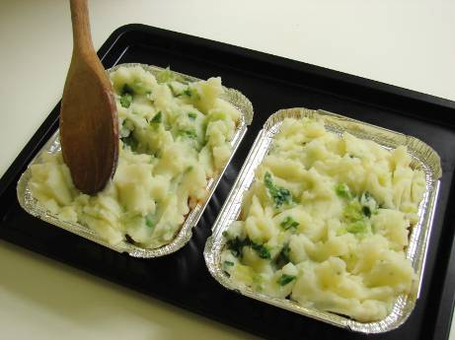 | 