
Quick ‘V’ Lasagne

Ingredients | Equipment
1 onion  1 garlic clove  1 carrot  2 celery sticks  1 x 10ml spoon oil  100g green lentils  1 can chopped tomatoes (400g)  1 x 5ml spoon mixed herbs  1 x 15ml spoon tomato puree  200ml crème fraiche, reduced fat  25g parmesan, grated  100ml semi-skimmed milk  Black pepper  6 lasagne sheets | Chopping board, knife, garlic press, peeler, measuring spoons, frying pan, measuring jug, small bowl, spoon, foil trays, baking tray.
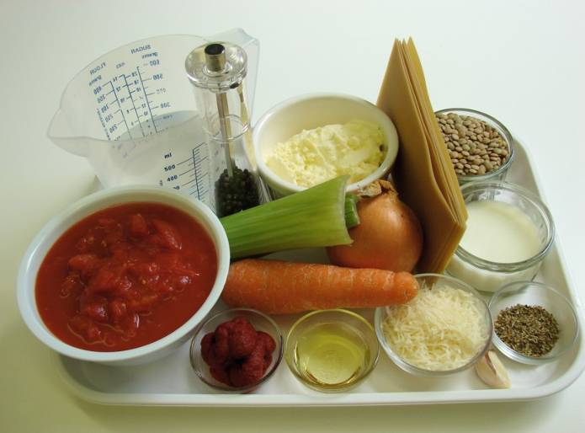 | 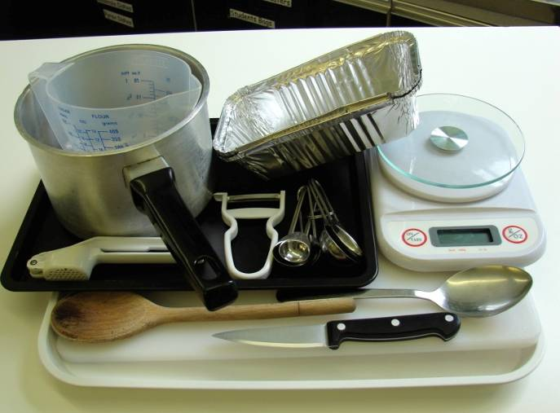
Method
1. Preheat the oven to 190°C or gas mark 5. | 2. Prepare the vegetables:  - peel and chop the onion;
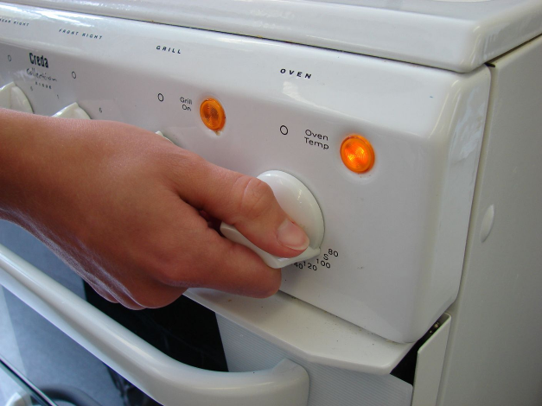 | 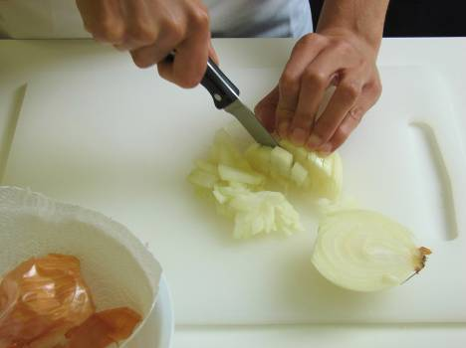
- peel and crush the garlic; | - peel and slice the carrot;
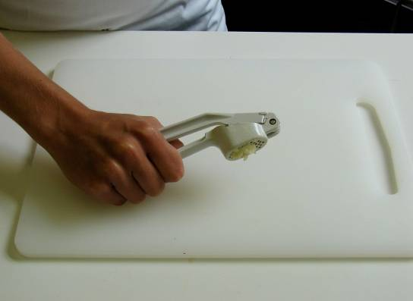 | 
- slice the celery. | 2. Fry the onion, garlic, carrot and celery in the oil until soft – about 4 minutes.
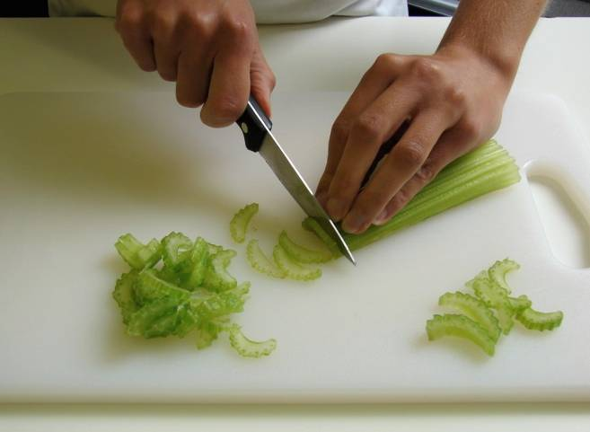 | 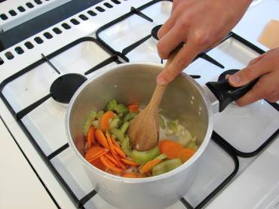
3. Add the lentils, tomatoes, herbs and tomato puree. | 4. Pour in some water, just enough to cover the mixture, bring to the boil and then allow to simmer for 15 minutes with the lid on.
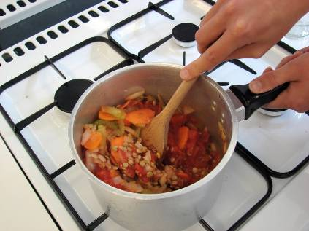 | 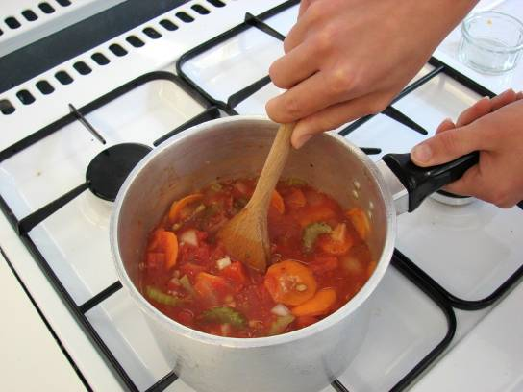
5. Blend the crème fraiche, half the grated cheese, milk and pepper together in a small bowl. | 6. Place an oven proof dish or foil tray on a baking tray spread some lentil mixture in the bottom, cover with lasagne sheets and a little crème fraiche sauce. Repeat this, finishing with the sauce on top.
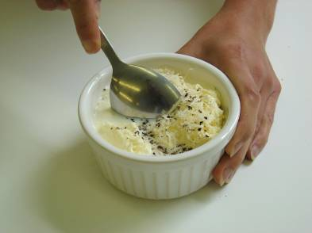 | 
6. Place an oven proof dish or foil tray on a baking tray and spread some lentil mixture in the bottom, cover with lasagne sheets and a little crème fraiche sauce. Repeat this, finishing with the sauce on top. | 7. Sprinkle the remaining grated cheese on top and bake for 20 minutes.
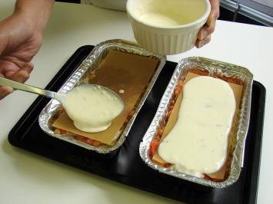 | 