
Sizzling stir fry

Ingredients | Equipment
100g noodles  1 x chicken breast (or 3-4 thighs)  1 clove garlic  ½ red chilli  1cm fresh ginger  ½ red onion  3 mushrooms  1/2 yellow pepper  1 pak choi  1 x 10ml spoon oil  1 x 10ml spoon soy sauce (reduced salt) | Saucepan, weighing scales, 2 chopping boards, 2 knives, garlic press, measuring spoons, wok, wooden spoon, colander.
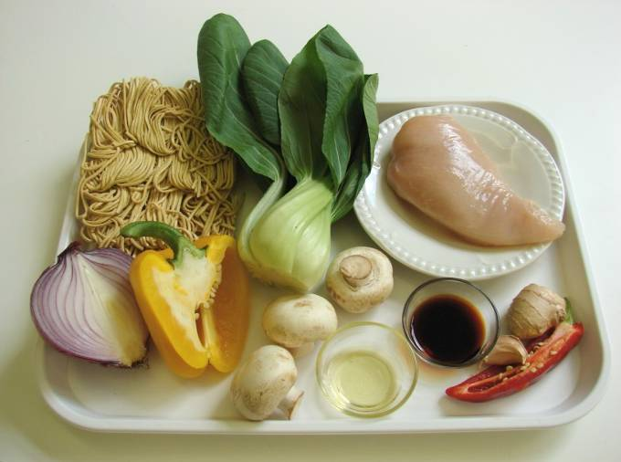 | 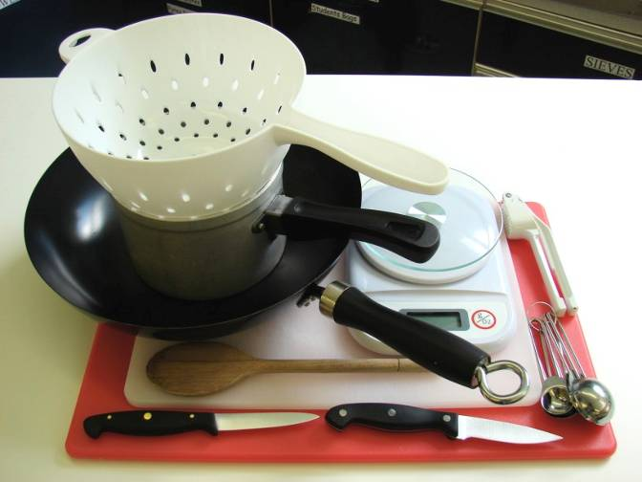
Method
1. Cook the noodles in boiling water. Check the packet for details. | 2. While the noodles are cooking, remove any skin from the chicken and cut into strips. Place in the fridge, covered, until needed.
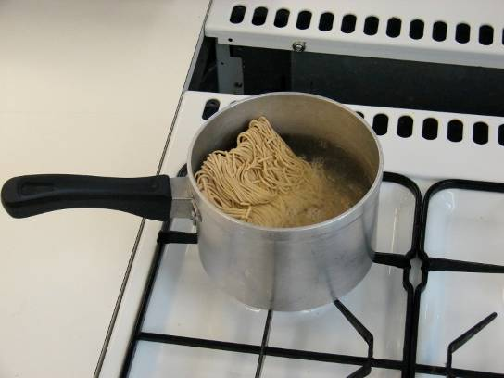 | 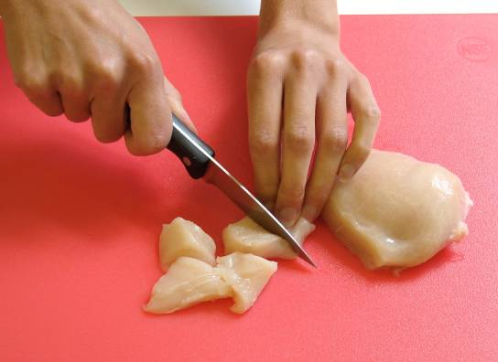
3. Prepare the vegetables with a clean knife on a clean chopping board:  - peel and crush the garlic; | - de-seed and slice the chilli;
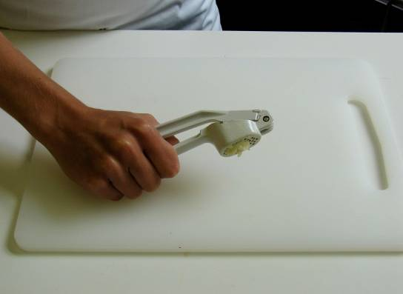 | 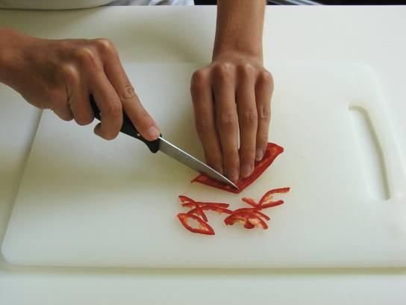
- peel and slice the ginger; | - slice the onion, pepper and mushrooms;
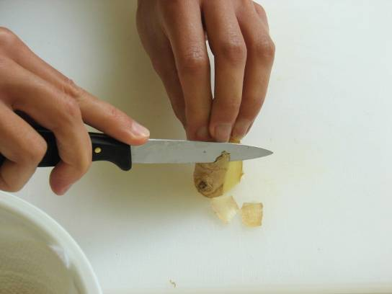 | 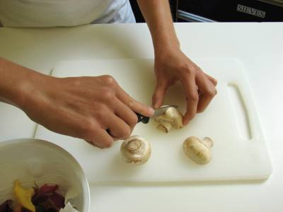
- shred the pak choi. | 4. Heat the oil the wok or frying pan.
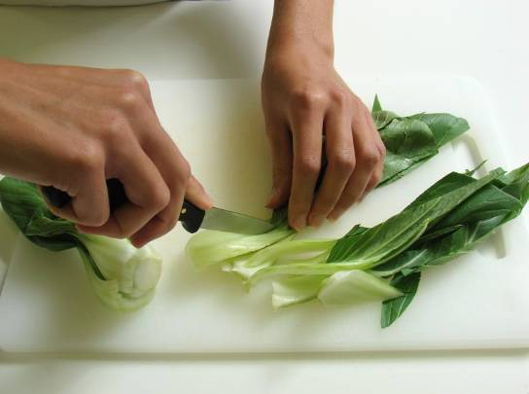 | 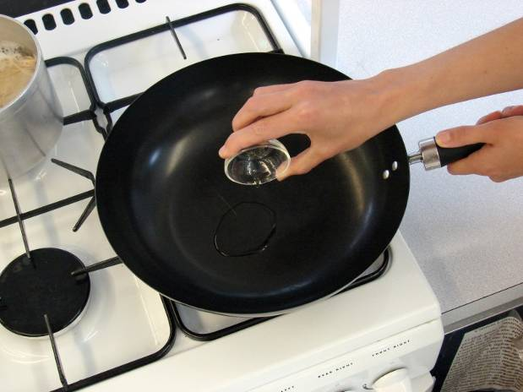
5. Add the onion, garlic, chilli and ginger. Allow to cook for 1 minute. | 6. Add the chicken and stir-fry for 3 – 4 minutes. Check that the chicken is cooked.
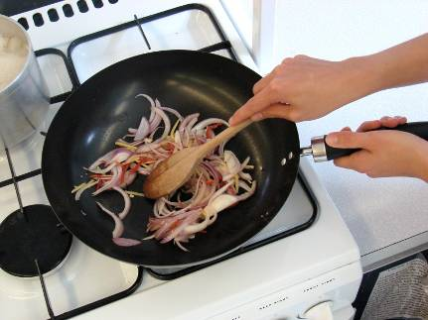 | 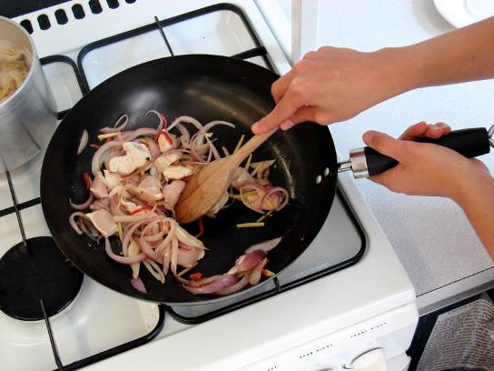
7. Add the remaining vegetables and soy sauce and continue to cook for a further 2 minutes. | 8. Drain the boiling hot water away from the noodles into a colander in the sink.
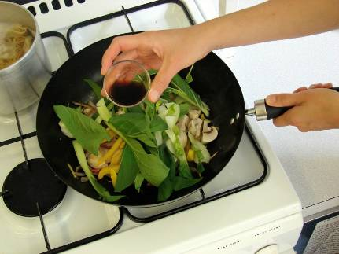 | 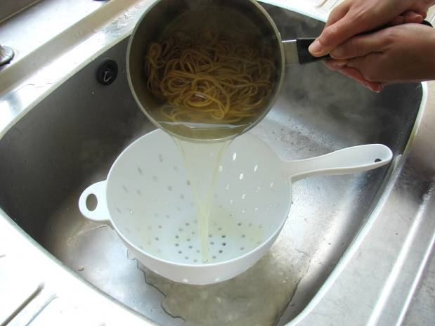
9. Stir in the cooked noodles and cook for 2 minutes until hot. | 10. Serve.
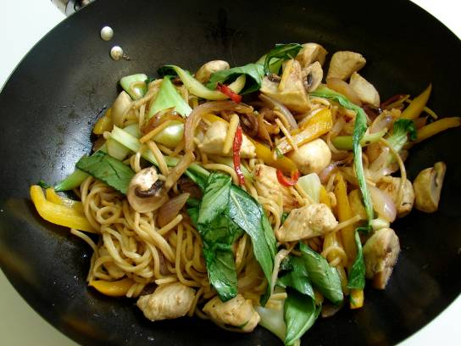 | 