

Savoury rice

Ingredients | Equipment
1 onion  3 mushrooms  ½ red pepper  1 tomato  1 x 10ml spoon oil  150g long grain rice  550ml water, boiling  1 x 5 ml spoon vegetable stock powder or cube  50g peas  1 x 10ml spoon curry powder | Chopping board, knife, saucepan, wooden spoon, weighing scales, measuring jug, measuring spoons, kettle.
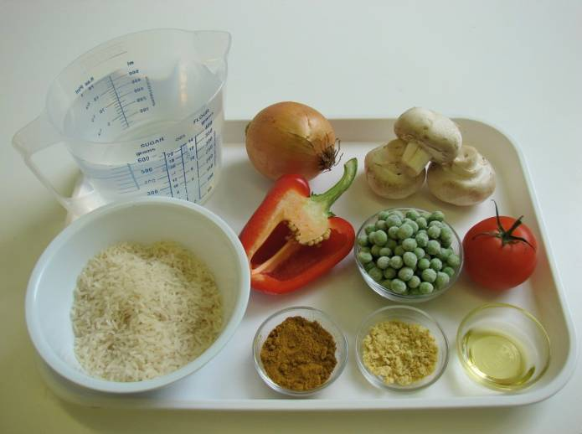 | 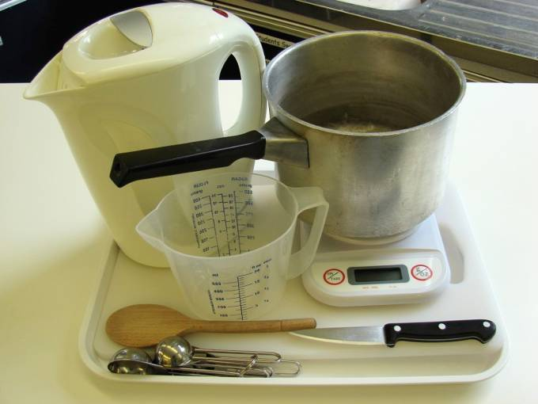
Method
- Prepare the vegetables:  - Peel and chop the onion; | - slice the mushrooms;
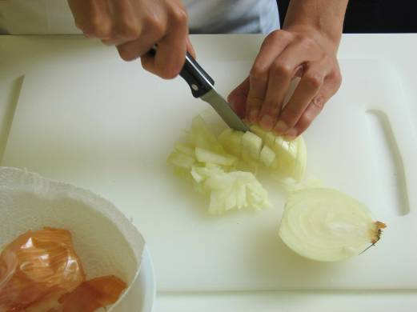 | 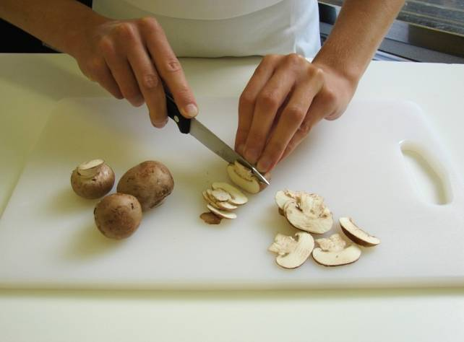
- dice the red pepper; | - chop the tomato.
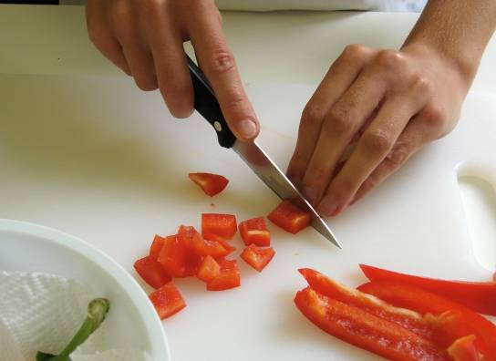 | 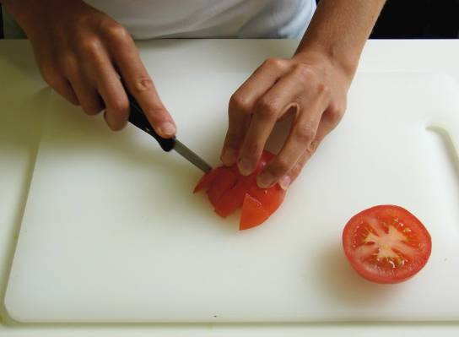
2. Fry the onion in oil until soft. | 3. Add the mushrooms and red pepper and cook for a further 2 minutes.
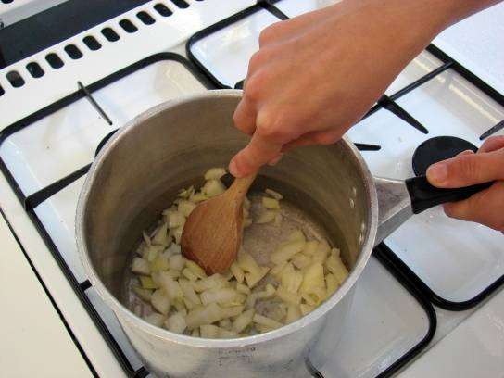 | 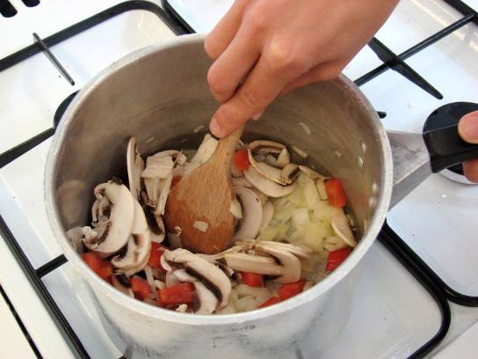
4. Stir in the rice. | 5. Mix the stock powder with the water.
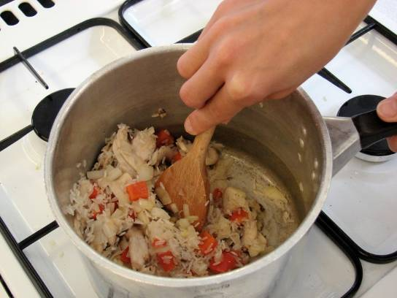 | 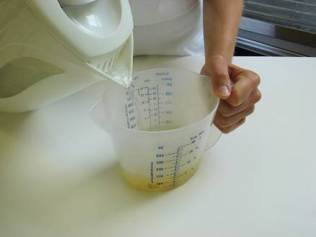
6. Add the stock, peas and curry powder. | 7. Simmer for 15 minutes, until the rice is tender.
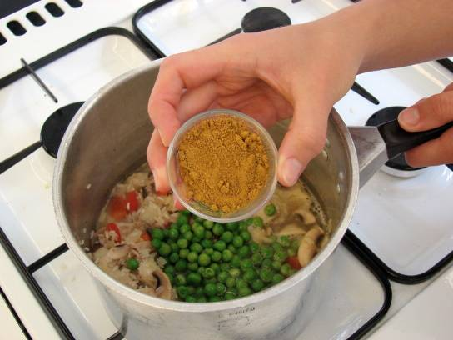 | 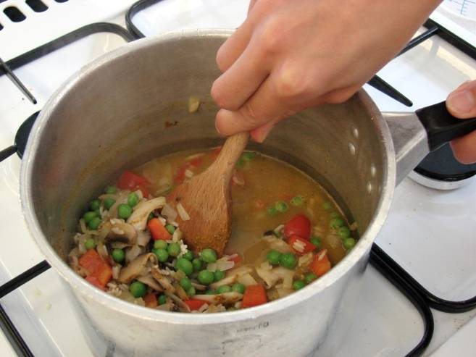
8. To serve place the rice in a bowl and sprinkle the chopped tomato on top.

