

Mushroom risotto

Ingredients | Equipment
1 onion  150g chestnut mushrooms  2 cloves garlic  1 x 15ml spoon olive oil  250g risotto rice  1 x 5ml spoon vegetable stock powder or cube  1 – 1.5 litres water, boiling  1 x 15ml spoon parmesan, grated  1 x 10ml spoon thyme, chopped | Chopping board, knife. Garlic press, weighing scales, measuring spoons, frying pan, wooden spoon, kettle, measuring jug.
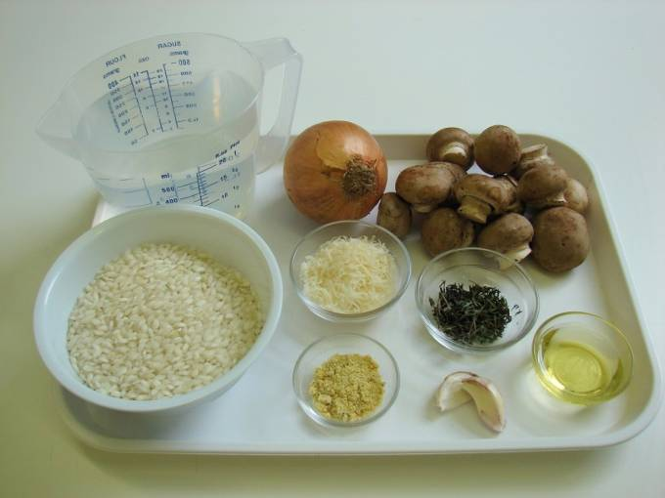 | 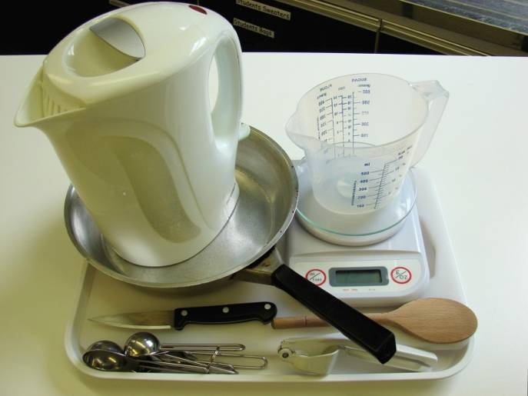
Method
- Prepare the vegetables:  - peel and chop the onion; | - slice the mushrooms;
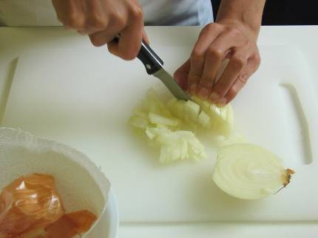 | 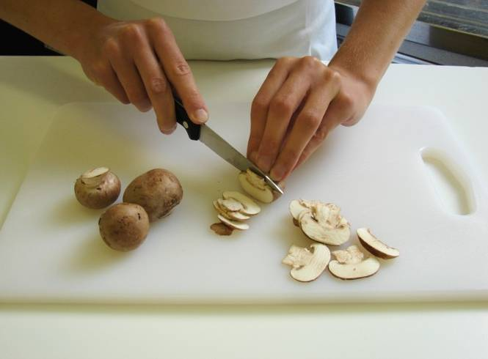
- peel and crush the garlic. | 2. Fry the onion and garlic in the oil until softened.
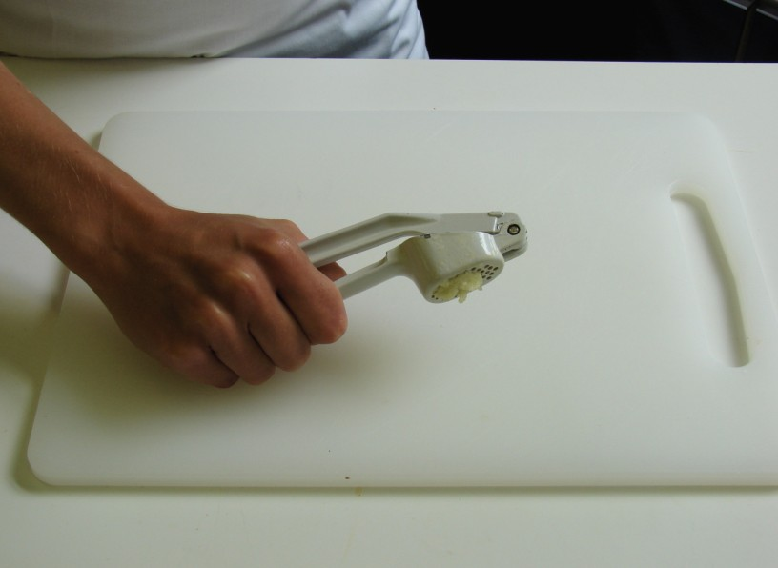 | 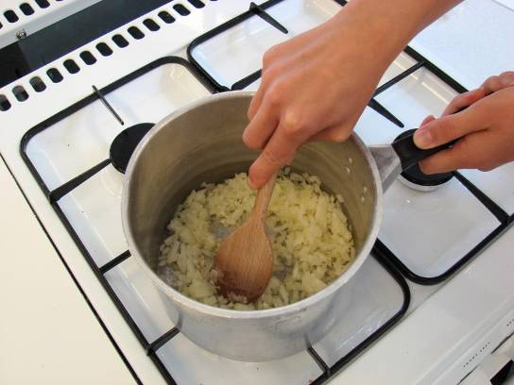
3. Add the mushrooms, and fry for another 2 minutes. | 4. Stir in the rice.
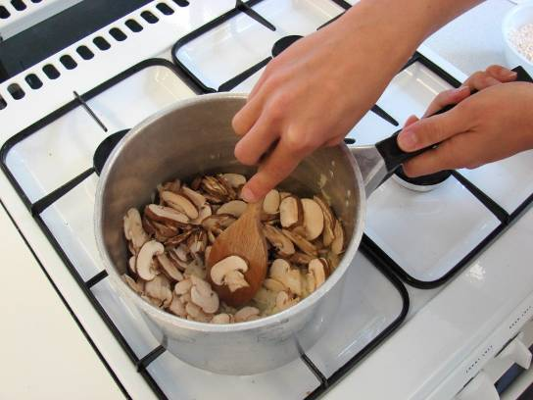 | 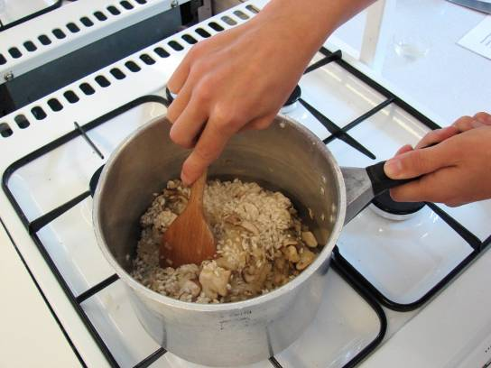
5. Mix the stock powder with the water. | 6. Add a little of the stock until the rice – a little at a time. Wait for the stock to be absorbed, stirring constantly.
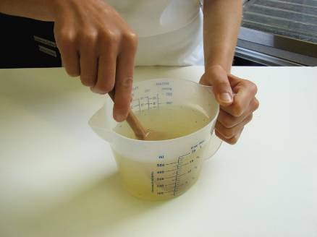 | 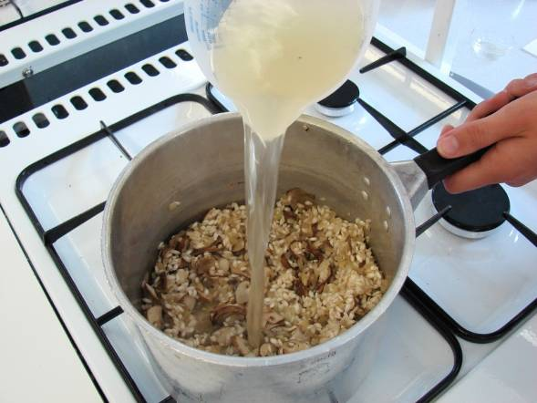
7. Continue adding the stock until the rice cooks – this will take 20 – 25 minutes. The rice should be soft, but still remain a nutty bite. | 8. Stir in the parmesan and thyme into the rice.
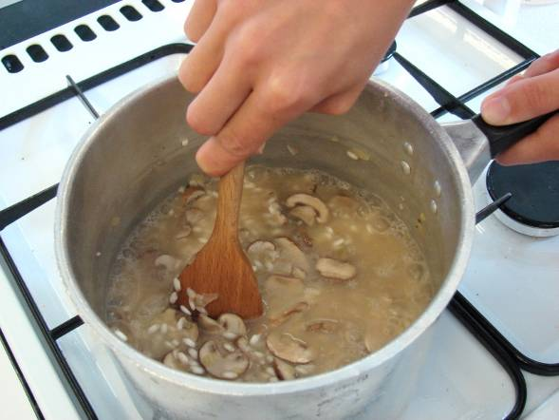 | 