
Sweet choux buns

Ingredients  60g strong white flour  2 eggs (large)  50g butter  150ml water  100g plain chocolate  300ml double cream  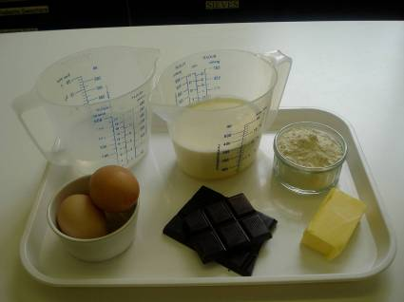 |  | Equipment  Baking tray, pastry brush, weighing scales, sieve, grease proof paper, 2 small mixing bowls, fork, measuring jug, saucepan, wooden spoon, heat proof stand, 2 x 10 ml spoons, oven gloves, mixing bowl, spatula, balloon whisk or electric hand whisk and cooling rack.  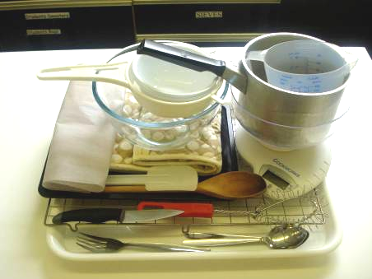
Method
1. Preheat the oven to 200°C or gas mark 6.  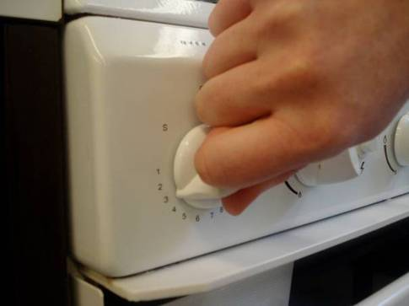 |  | 2. Grease or line the baking tray, and sprinkle a little water on top.  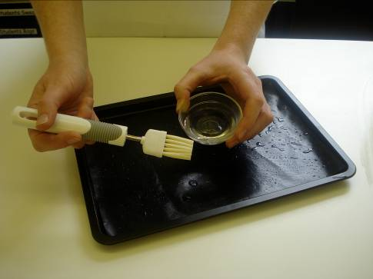
3. Sieve the flour onto the piece of greaseproof paper.  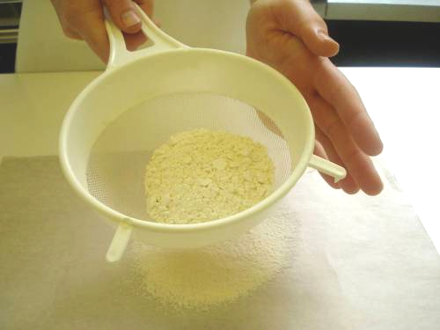 |  | 4. Beat the eggs in the small bowl with the fork.  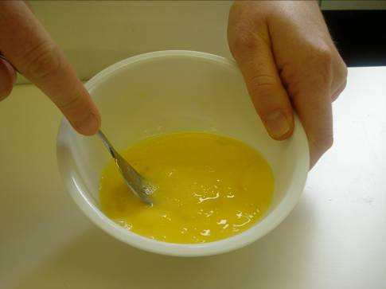
5. Melt the butter in the water in the saucepan.  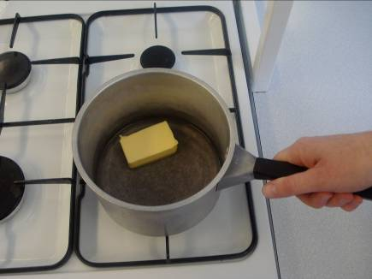 |  | 6. When it starts to boil, remove from the heat and shoot in the flour.  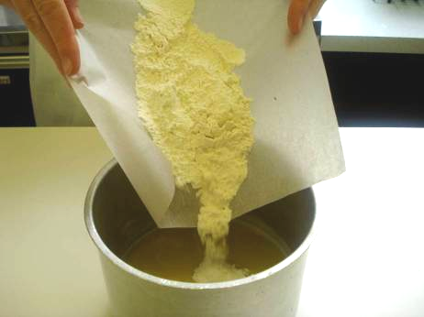
7. Beat the mixture briskly until it is smooth and leaves the side of the pan.  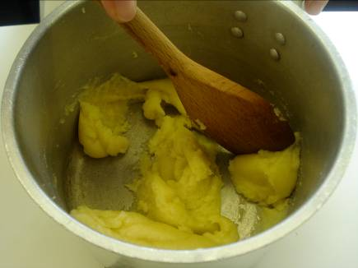 |  | 8. Stir in the egg, a little at a time, to form a smooth paste.  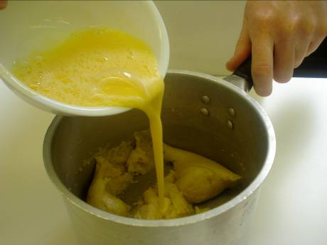
9. Place 10ml spoons of choux pastry onto the baking sheet.  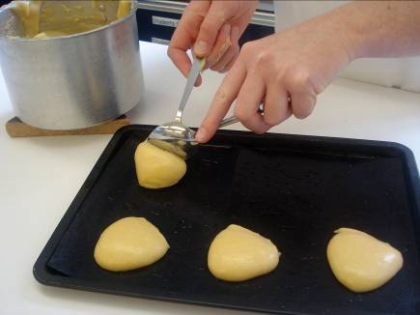 |  | 10. Bake for 10 minutes. Increase heat to 220°C or gas mark 7, and bake for 15 minutes.  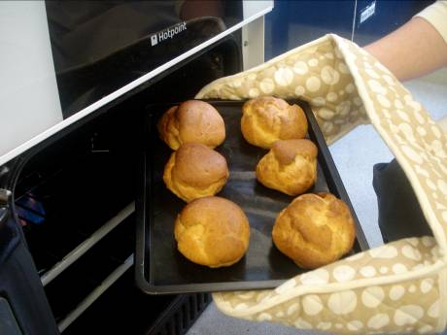
11. Slice with a knife and place on a cooling rack.  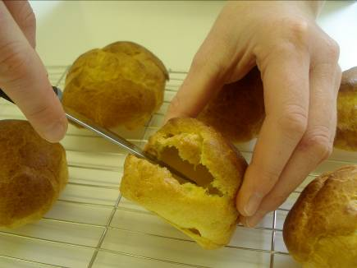 |  | 12. Whip the cream until thick.  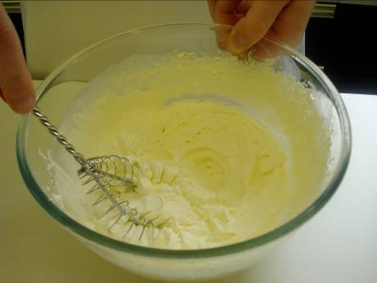
13. Melt the chocolate with microwave.  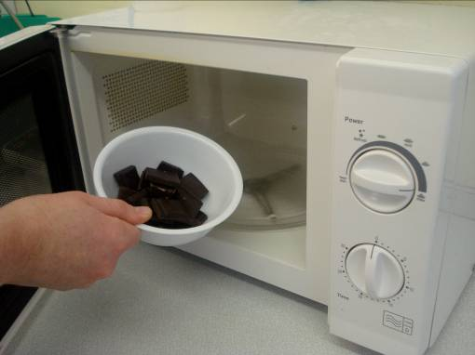 |  | 14. Fill each choux bun with cream.  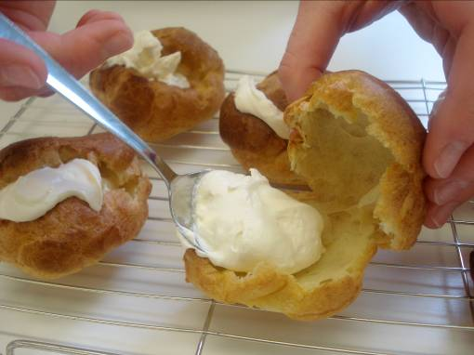
15. Spread the melted chocolate on top of the choux bun.

