
Savoury choux buns

Ingredients  60g strong white flour  Pinch of mustard powder  Pinch of cayenne pepper  2 eggs (large)  50g butter  150ml water  25g grated parmesan cheese  Twist of black pepper  100g cream cheese  2 slices of ham  1 tomato  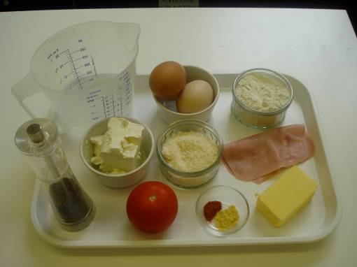 |  | Equipment  Baking tray, pastry brush, weighing scales, sieve, greaseproof paper, 2 small bowls, fork, measuring jug, saucepan, wooden spoon, heat proof stand, 2 x 10ml spoons, knife, chopping board, and cooling rack.  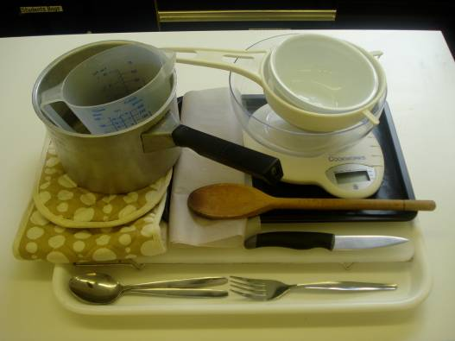
Method
1. Preheat the oven to 200 °C or gas mark 6.  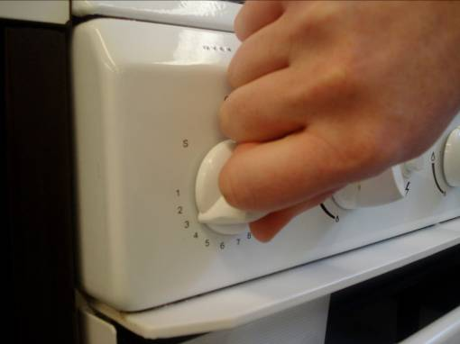 |  | 2. Grease or line the baking tray, and sprinkle a little water on top.  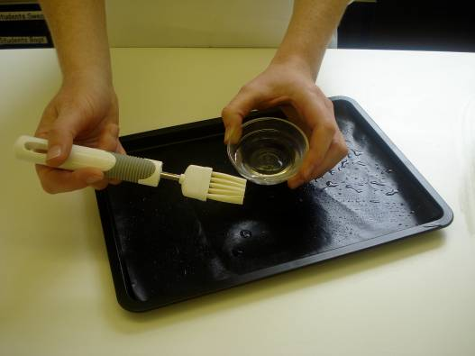
3. Sift the flour, mustard powder and cayenne pepper onto the piece of greaseproof paper.  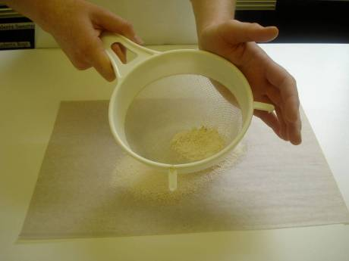 |  | 4. Beat the eggs in the small bowl with the fork.  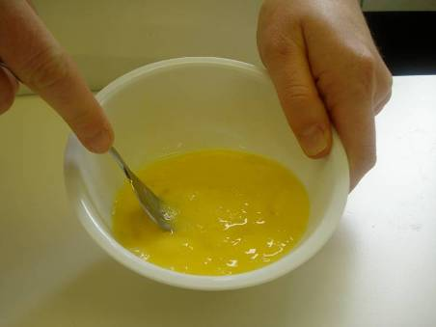
5. Melt the butter in the water in the saucepan.  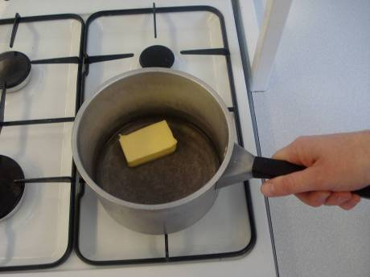 |  | 6. When it starts to boil, remove from the heat and shoot in the flour.  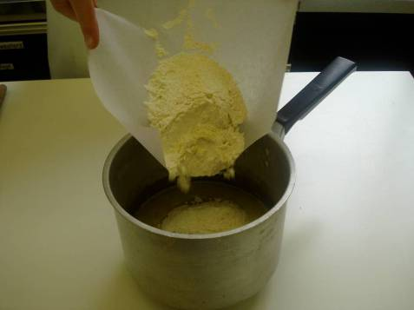
7. Beat the mixture briskly until it is smooth and leaves the side of the pan.  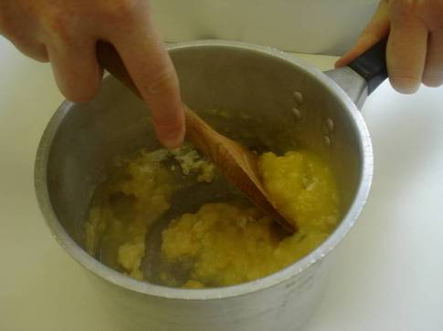 |  | 8 Stir in the egg, a little at a time, to form a smooth paste.  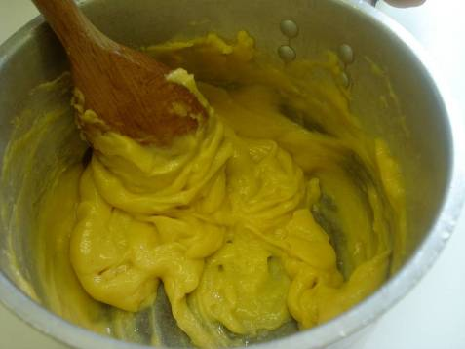
9. Add the cheese and black pepper to the mixture and mix until combined.  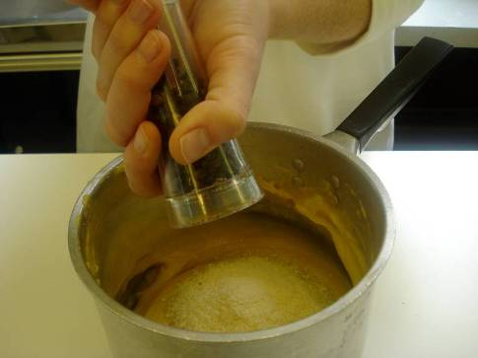 |  | 10. Place small spoons of choux pastry onto the baking tray.  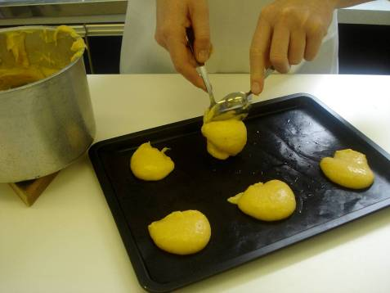
11. Bake for 10 minutes. Increase heat to  220 °C, gas mark 7, and bake for 15 minutes.  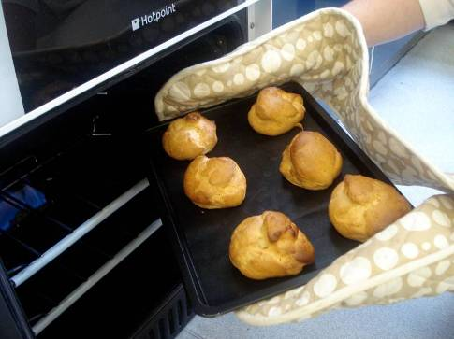 |  | 12. Slice with the knife and place on the cooling rack.  
13. Chop the ham and dice the tomato, and mix with the cream cheese in the small bowl.  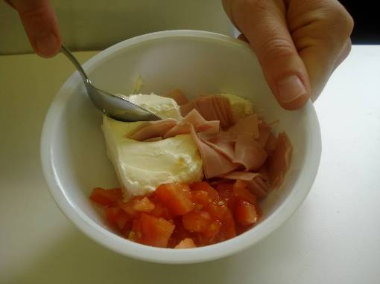 |  | 14. When the buns are cool, fill with the cream cheese mixture.  

