
Swiss roll

Ingredients  50g self raising flour  2 eggs (medium)  50g caster sugar  Extra sugar for rolling up  2-3 x 15ml spoons jam  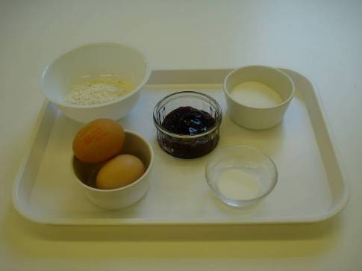 |  | Equipment  Swiss roll tin, baking parchment, scissors, pastry brush, weighing scales, mixing bowl, electric hand mixer, sieve, large metal spoon, spatula, oven gloves, greaseproof paper, tea towel, small bowl, sharp knife, palette knife, and cooling rack.  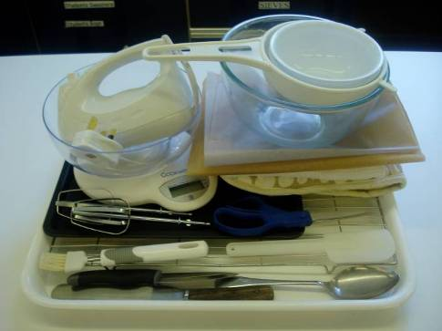
Method
1. Preheat the oven to 200ºC or gas mark 6.  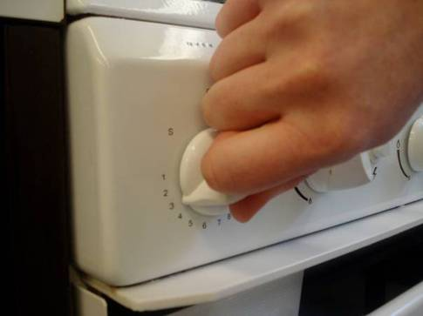 |  | 2. Line and grease the Swiss roll tin, 22cm x 30cm with baking parchment.  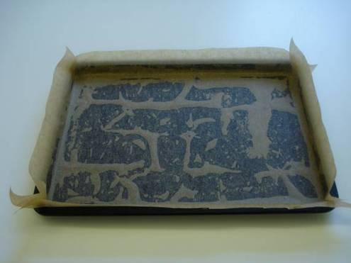
3. Whisk the eggs and sugar together until thick, creamy and white (and leaves a trail).  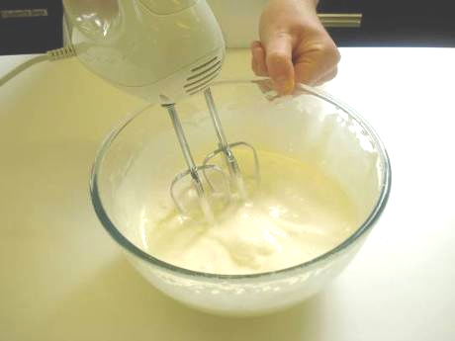 |  | 4. Sift the flour into the bowl.  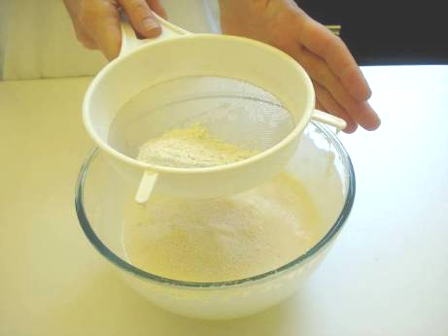
5. Gently fold in the flour, using the metal spoon.  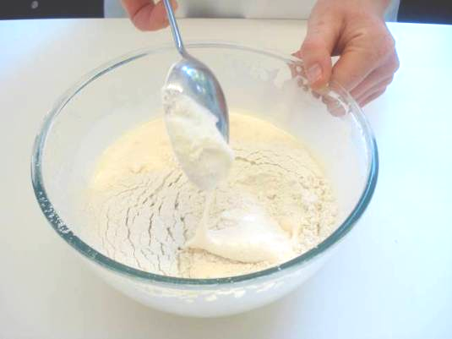 |  | 6. Pour the mixture into the Swiss roll tin. Use the spatula to scrape the bowl clean.  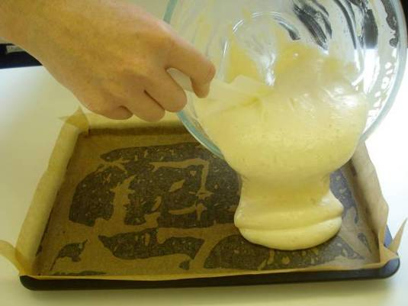
7. Bake for 8 – 10 minutes, until golden brown and firm to the touch. (Do not overcook.)  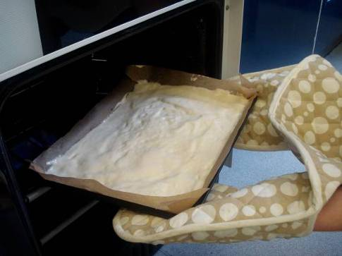 |  | 8. While the Swiss roll is baking, place the piece of greaseproof paper on top of the clean damp tea towel and sprinkle the extra sugar on top of the paper.  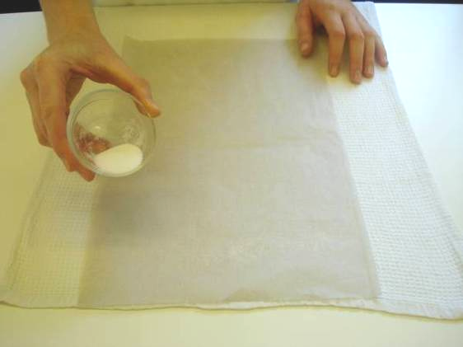
9. Warm the jam, either in the microwave or in the glass bowl over hot water.  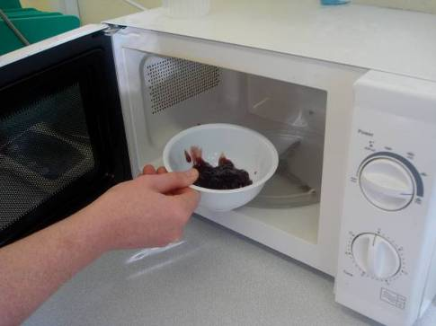 |  | 10. When the Swiss roll is cooked, tip it onto the sugared paper.  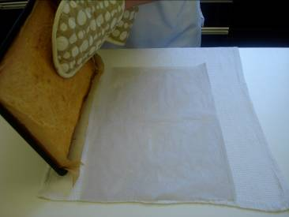
11. Carefully peel off the lining paper from the cake.  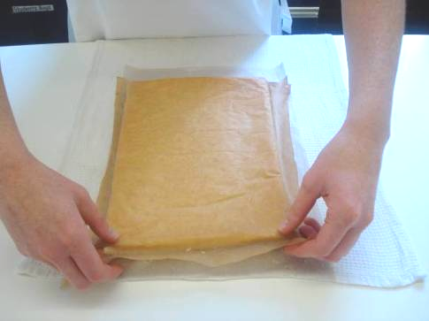 |  | 12. Trim the edges with the sharp knife.  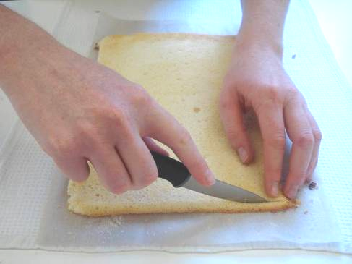
13. Spread the jam over the sponge with the palette knife right to the edge.  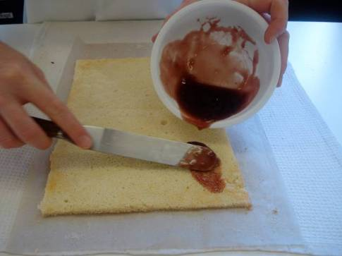 |  | 14. Roll up the Swiss roll from the top short edge, using the paper and tea towel to grip and guide the Swiss roll.  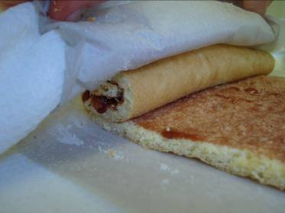
15. Stand on the cut edge on the cooling rack.

