
Marble pear tray bake

Ingredients | Equipment
100g caster sugar  100g soft margarine  2 eggs  100g self raising flour  1 x 15ml spoon coca powder  1 x 5ml spoon baking powder  ½ pear | Baking tin (20cm square) or foil tray, weighing scales, mixing bowl, electric hand whisk, small bowl, fork, sieve, spoon, chopping board, knife.
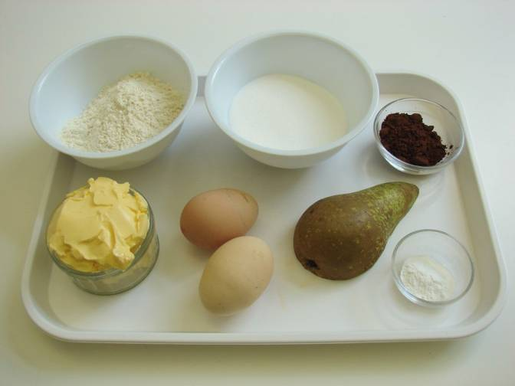 | 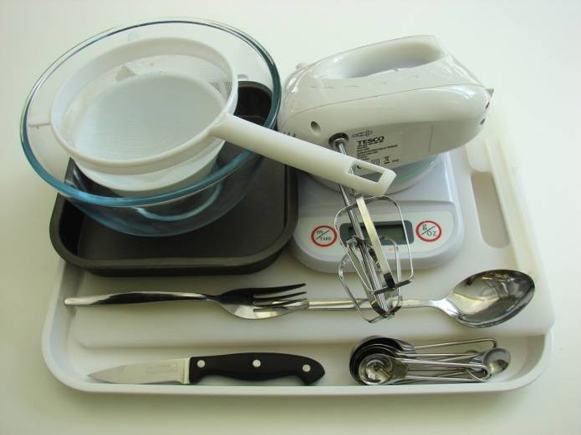
Method
1. Preheat the oven to 180°C or gas mark 4. | 2. Grease and line the cake tin.
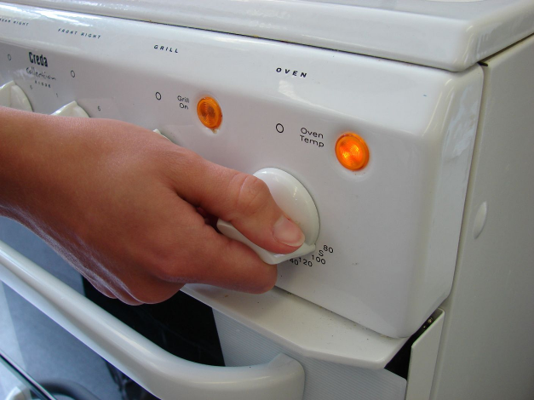 | 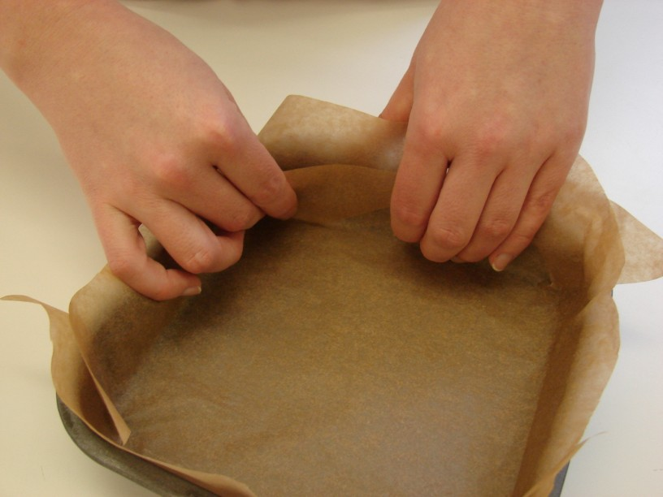
3. Cream the sugar and margarine together, ideally using an electric hand whisk, until light and fluffy. | 4. In a small bowl, beat the eggs with a fork.
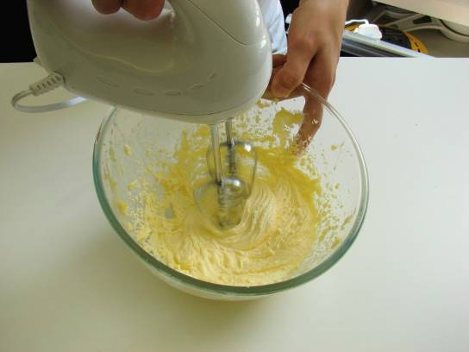 | 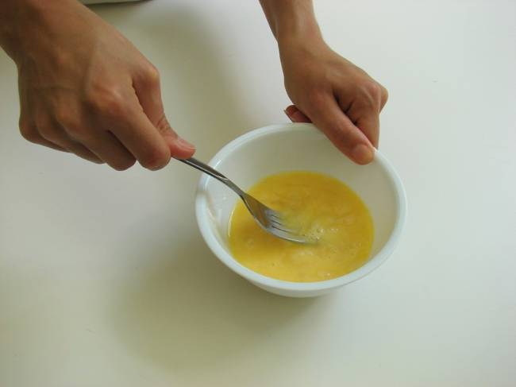
5. Add the beaten egg, a little at a time, to the margarine and sugar. | 6. Sieve the flour and baking powder into a bowl.
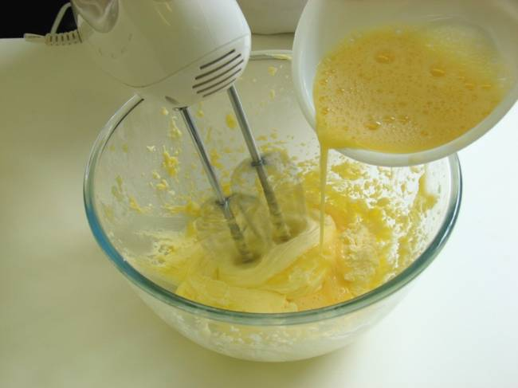 | 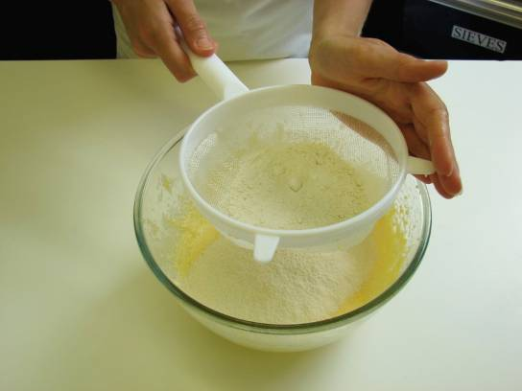
7. Fold the flour and baking powder into the mixture, a spoonful at a time. | 8. Core and chop the pear into small pieces. Scatter pieces of pear into the lined cake tin.
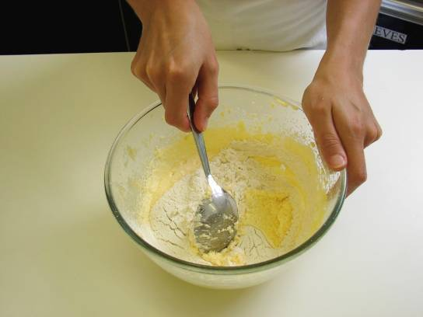 | 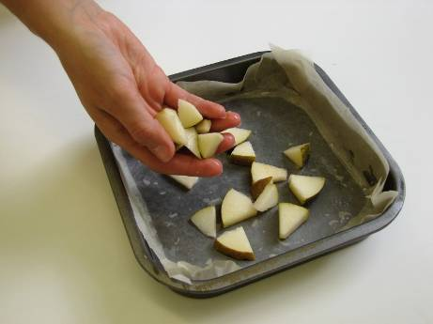
9. Spoon half of the cake mixture into the tin. | 10. Stir in the cocoa to the remaining cake mixture.
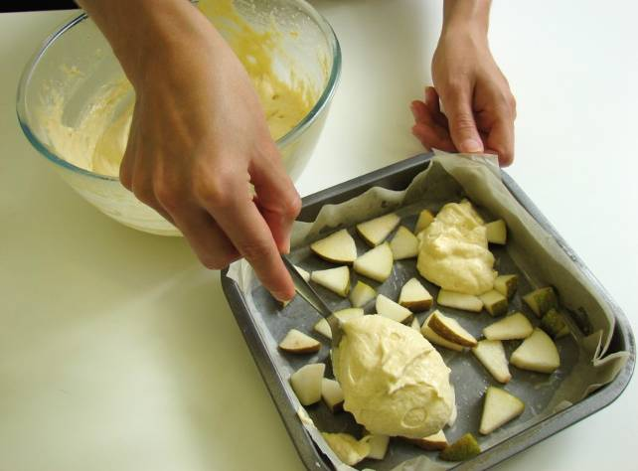 | 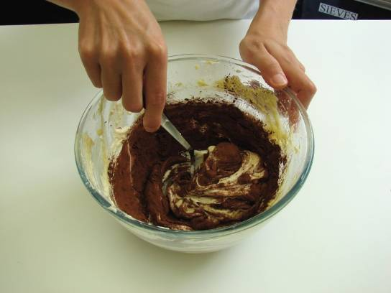
11. Spoon the chocolate mixture into the baking tin and then swirl the two mixtures together to create a marble effect. | 12. Place in the oven and bake for 20 minutes, until golden brown and springy to the touch.
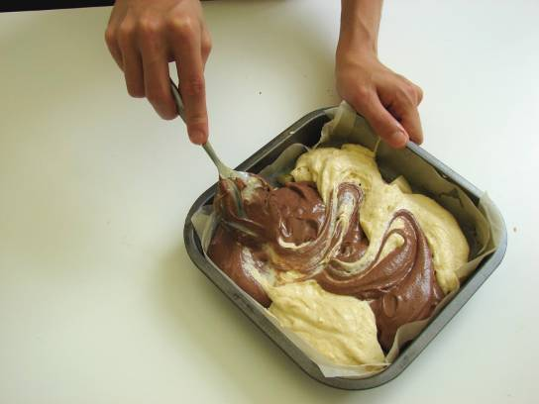 | 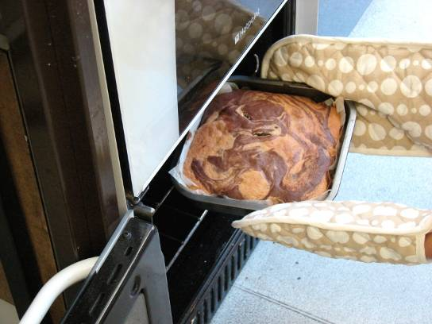
13. Remove from the oven and allow to cool.
