

Dutch apple cake

Ingredients | Equipment
100g caster sugar  100g soft margarine  2 eggs  100g self raising flour  1 x 5ml spoon baking powder  1 eating apple  1 x 5ml spoon cinnamon  1 x 5ml spoon Demerara sugar | Weighing scales, mixing bowl, electric hand whisk, small bowl, fork, sieve, spoon, knife, chopping board, measuring spoons, cake tin or foil trays.
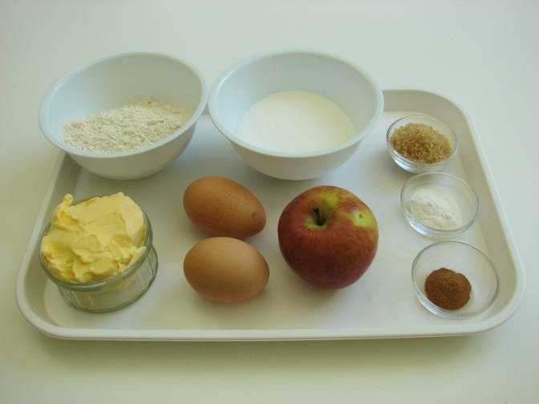 | 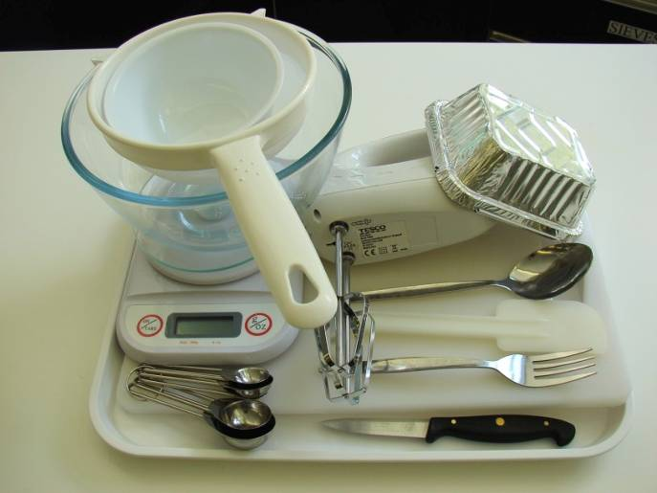
Method
1. Preheat the oven to 180°C or gas mark 4. | 2. Grease and line the cake tin or foil trays.
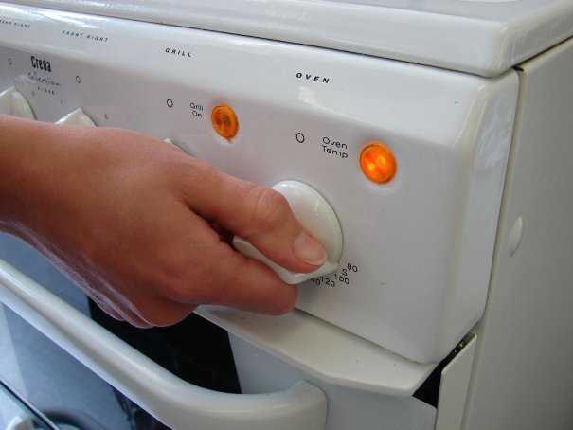
3. Cream the sugar and margarine together, ideally using a electric hand whisk, until light and fluffy. | 4. In a small bowl, beat the eggs with a fork.
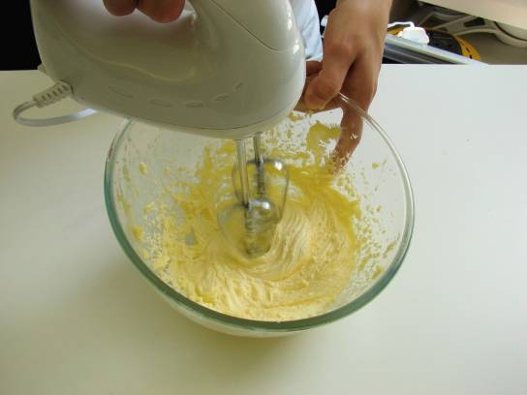 | 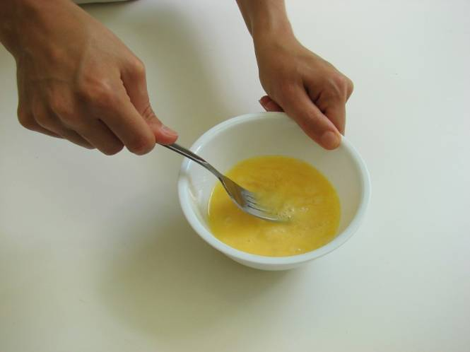
5. Add the beaten egg, a little at a time, to the margarine and sugar. | 6. Sieve the flour and baking powder into a bowl, or onto a plate or piece of greaseproof paper.
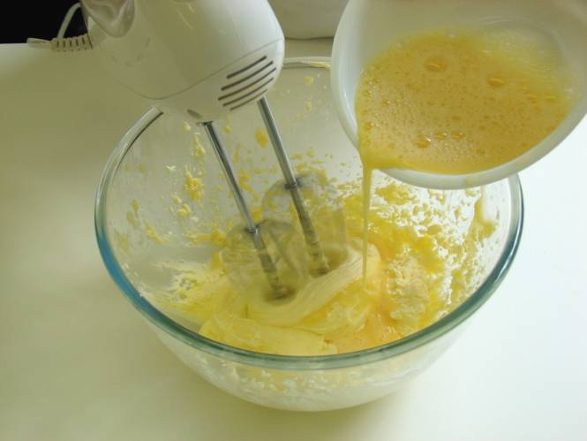 | 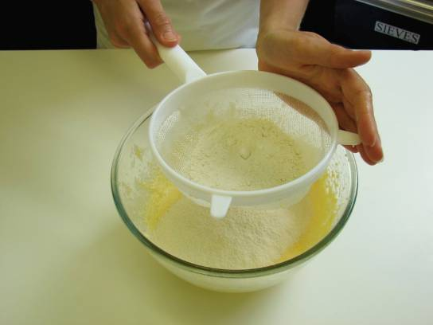
7. Fold the flour and baking powder into the mixture, a spoonful at a time. | 8. Spread the mixture in the cake tin.
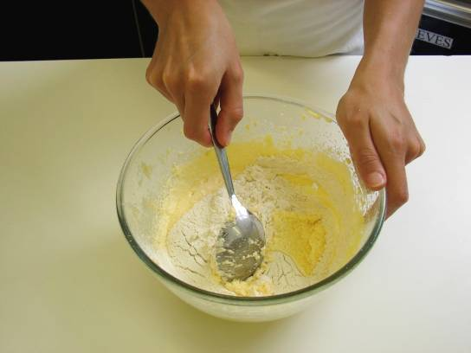 | 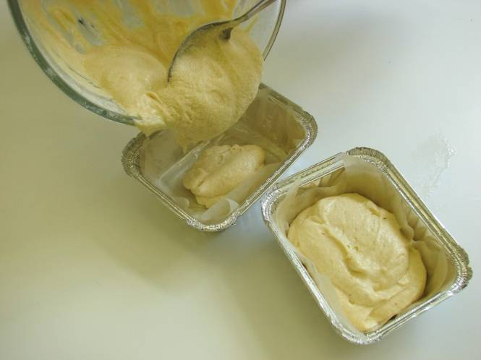
9. Core the apple and slice thinly. | 10. Arrange the apple slices over the cake mix, and then sprinkle the cinnamon and sugar on top.
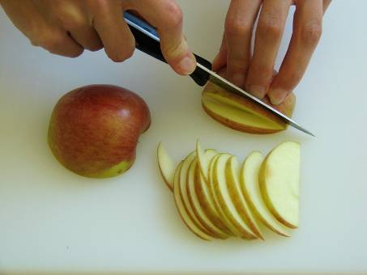 | 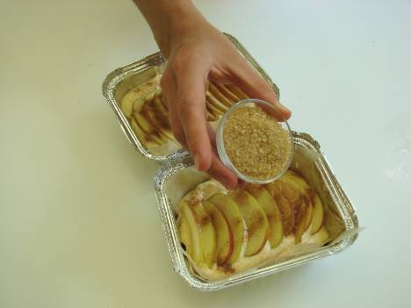
11. Place in the oven and bake for around 20 minutes, until golden brown and springy to the touch. | 12. Remove from the oven and allow to cool.
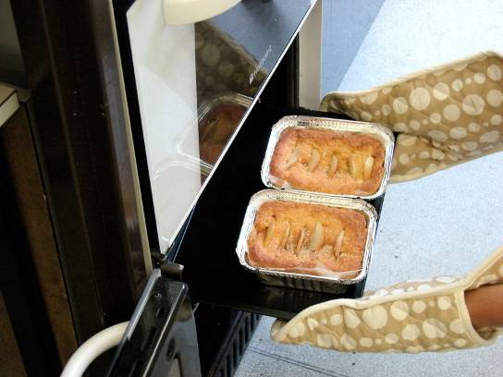 | 