

Thai green chicken curry

Ingredients | Equipment
1 x 10ml spoon oil  3 spring onions  1 clove of garlic  80g sugar snap peas  1 small chicken breast  2 x 15ml Thai green curry paste  200ml coconut milk (reduced fat)  1/2 lime  Small bunch of coriander | Two chopping boards, two knives, garlic press, frying pan, weighing scales, wooden spoon, can opener, juicer.
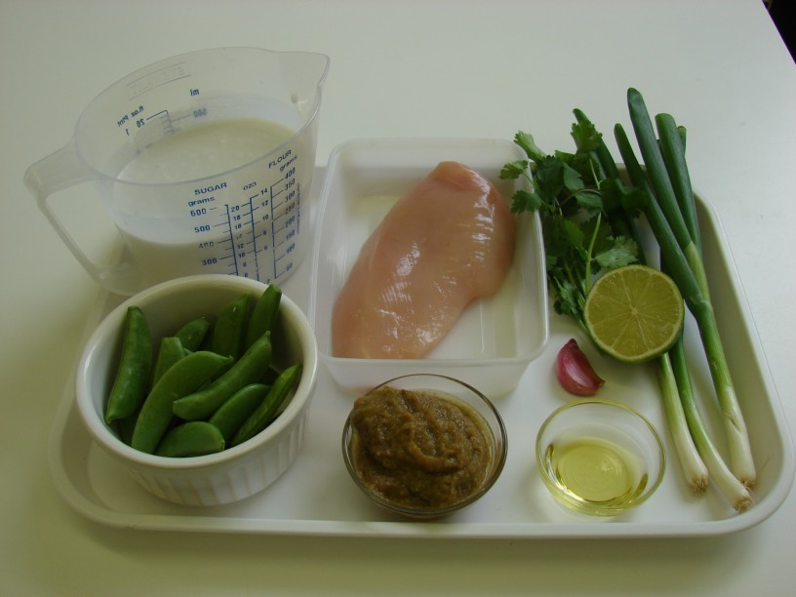 | 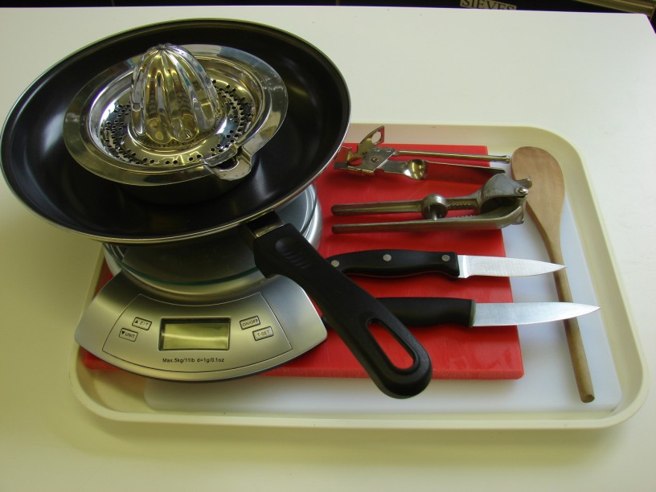
Method
- Prepare the vegetables:  - slice the spring onions; | - cut the sugar snap peas in half;
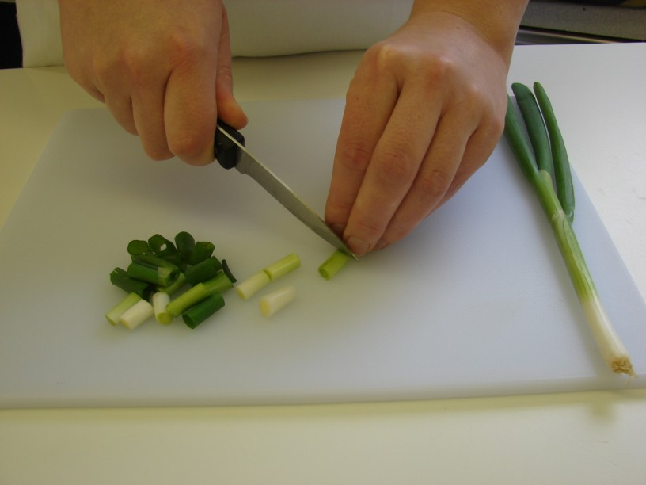 | 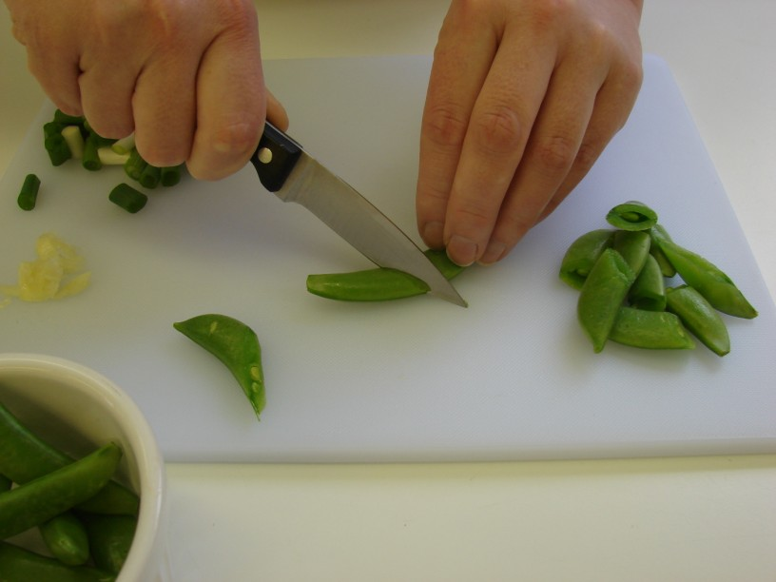
- crush the garlic. | - On a separate clean chopping board, and using a separate clean knife, cut the chicken into small chunks.
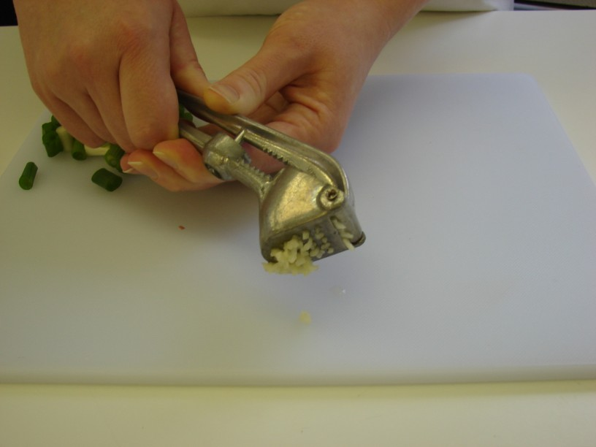 | 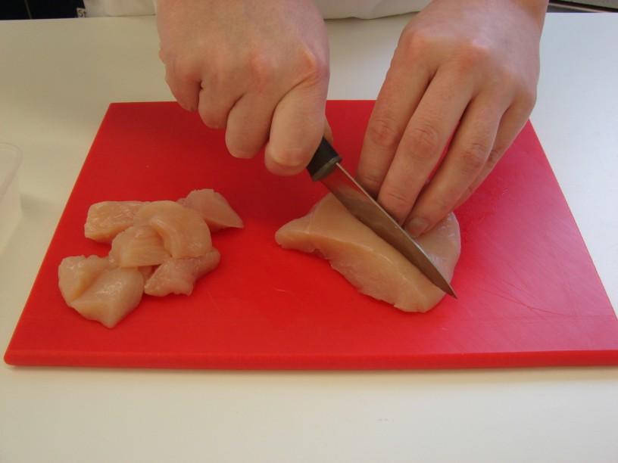
- Fry the spring onions, garlic and chicken in the oil for 3-4 minutes. | - When the chicken has turned ‘white’, stir in the green curry paste, followed by the sugar snap peas.
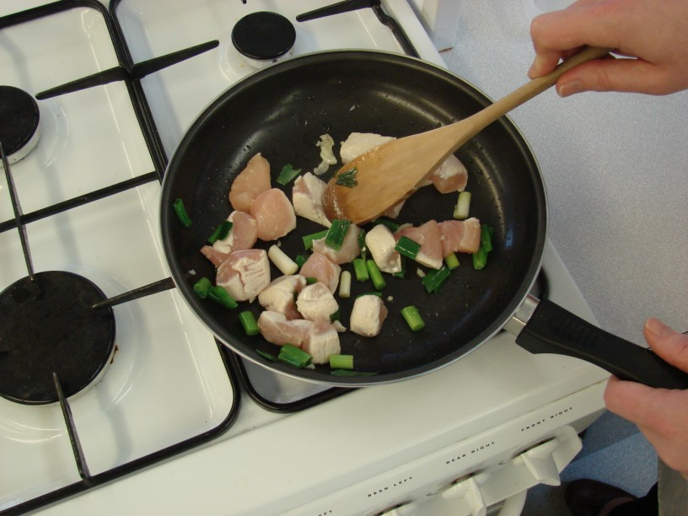 | 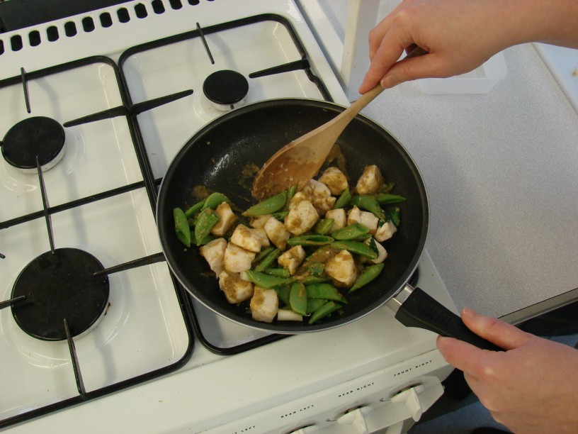
- Pour in the coconut milk and simmer for 15 minutes. | - Squeeze the lime and pour over the curry.
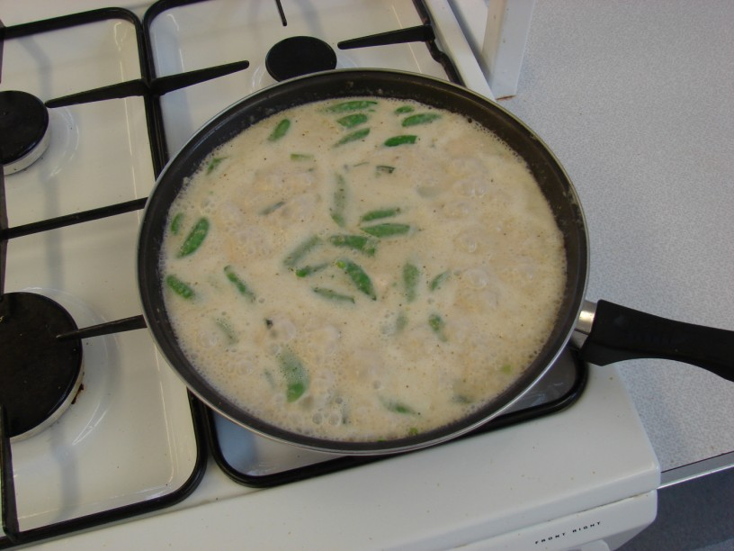 | 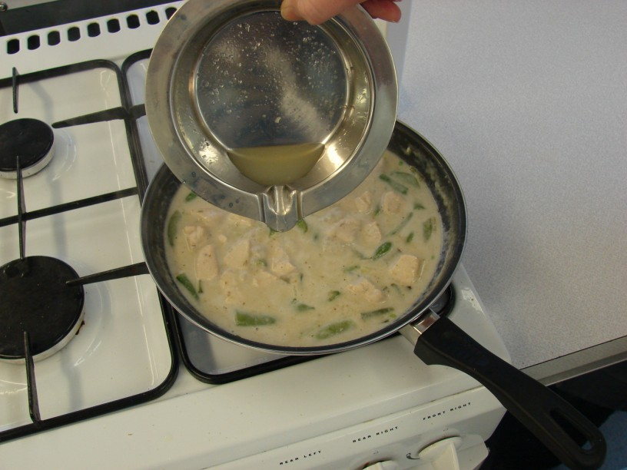
- Tear the coriander and add to the curry. | - Serve.
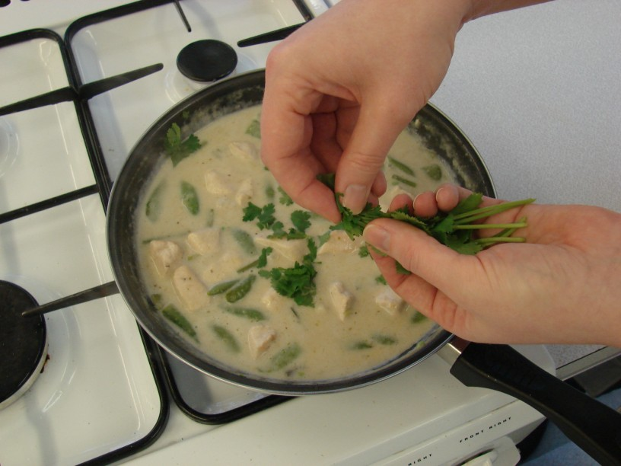 | 