

Chicken korma

Ingredients | Equipment
1 clove  1 clove of garlic  1 black peppercorn  1 cardamom pod  1 x 10ml spoon oil  200g Chicken Breast  1/2 small cauliflower  1/2 green chilli  1/2 x 5ml spoon turmeric  1/2 x 5 ml spoon ground cumin  1/2 x 5ml spoon chilli powder  4 x 15ml spoons plain yogurt  pinch black pepper  1 x 15ml spoon coriander | Weighing scales, 2 chopping boards, 2 knives, frying pan, measuring spoons, garlic press, wooden spoon, spoon, small bowl.
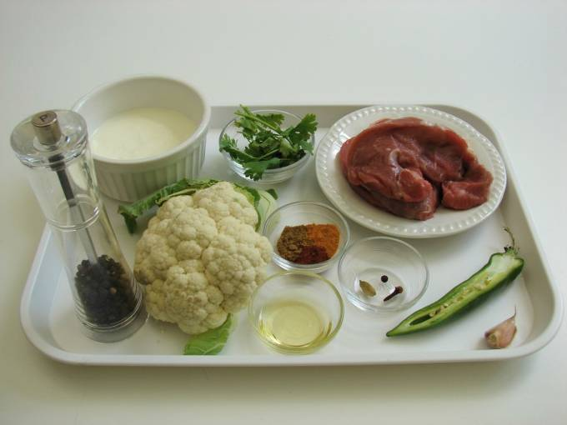 | 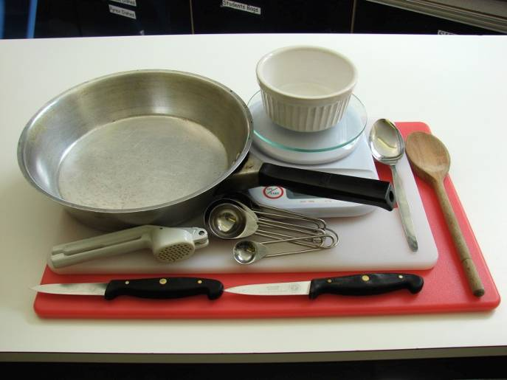
Method
- Prepare the garlic, chilli and cauliflower:  - peel and crush the garlic; | de-seed and slice the chilli;
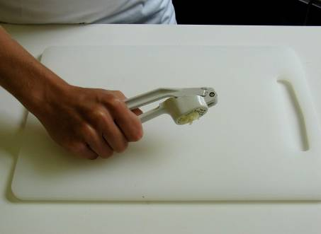 | 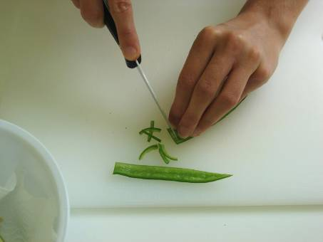
- break the cauliflower into florets. | - On a clean chopping board, using a clean knife, cut the lamb into cubes.
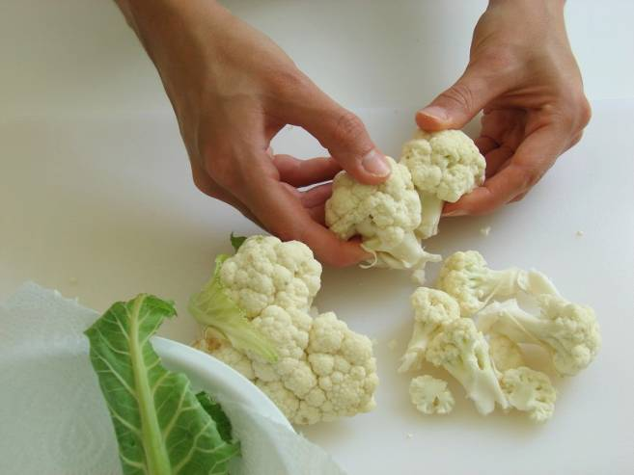 | 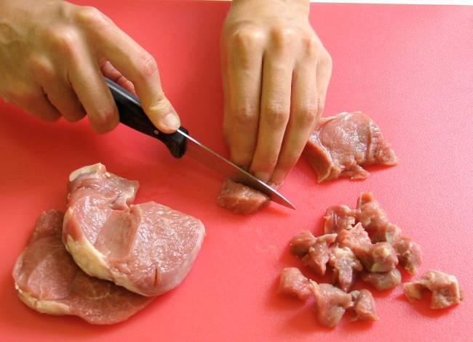
3. Fry the clove, peppercorn and cardamom in the oil until they sizzle. | 4. Stir in the garlic and chilli.
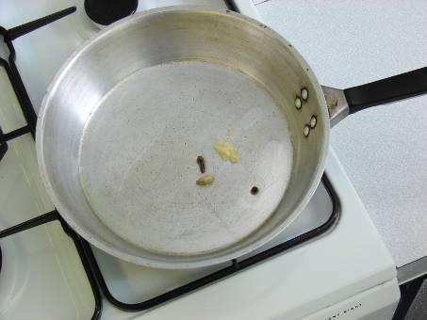 | 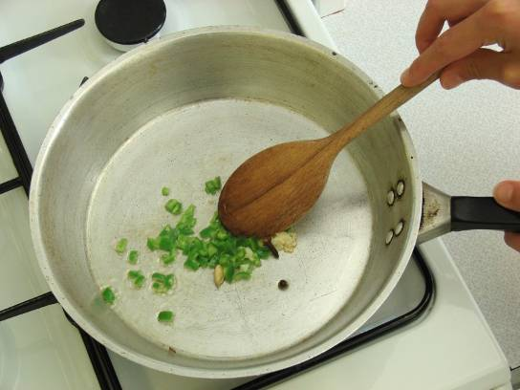
5. Add the lamb and cauliflower, cover and slowly cook for about 10 minutes. | 6. Mix the turmeric, chilli powder, pepper and cumin into the yogurt in a small bowl.
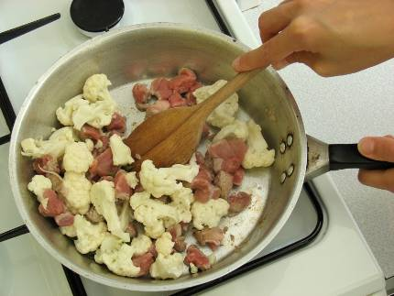 | 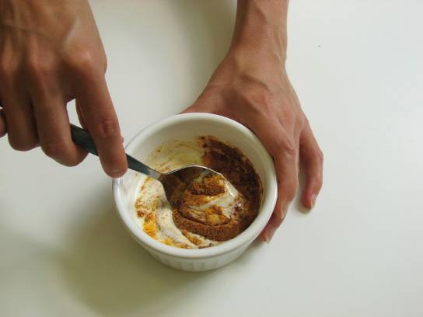
7. Increase the heat and stir in the yogurt mix to the frying pan. | 8. Allow to cook for a further 10 minutes.
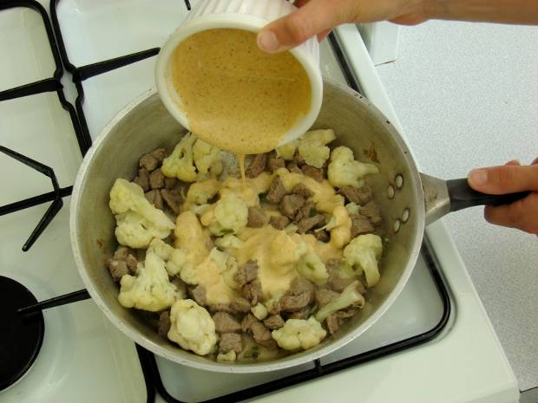 | 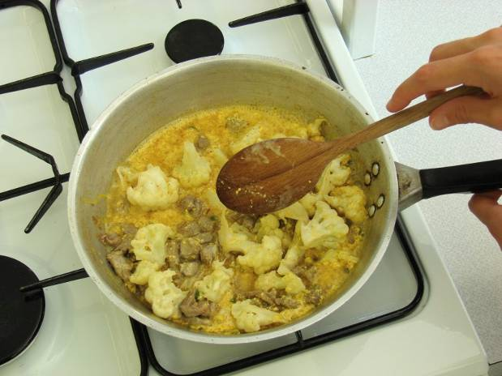
9. Chop the coriander and stir into the korma.

