
Spinach, potato and chickpea curry

Ingredients | Equipment
1 onion  1 clove garlic  1 large potato  1 x 5ml spoon oil  2 x 15ml spoons curry paste  300ml water  1 can chopped tomatoes (400g)  1 can chickpeas (410g), drained  3 handfuls of fresh spinach | Knife, chopping board, garlic press, frying pan, measuring spoons, measuring jug, wooden spoon, can opener.
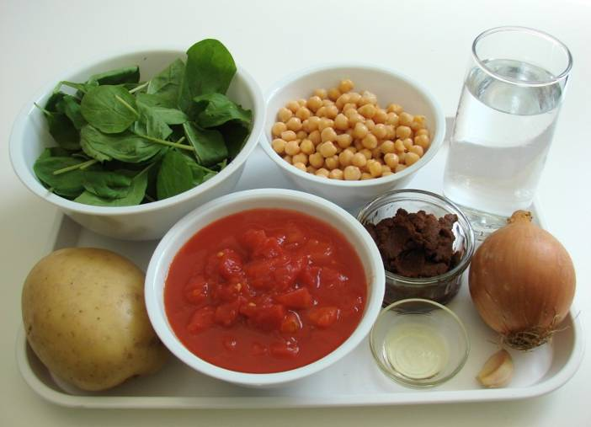 | 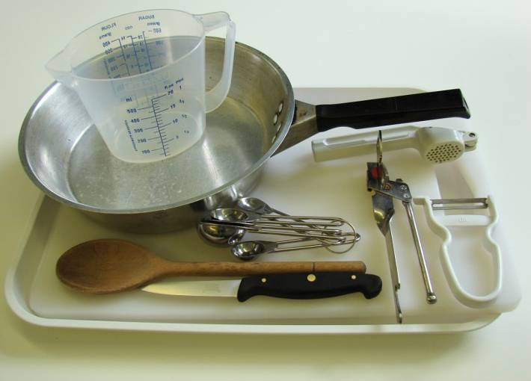
Method
- Prepare the onion, garlic and potatoes:  - slice the onion; | - peel and crush the garlic;
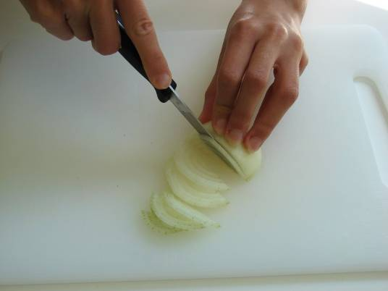 | 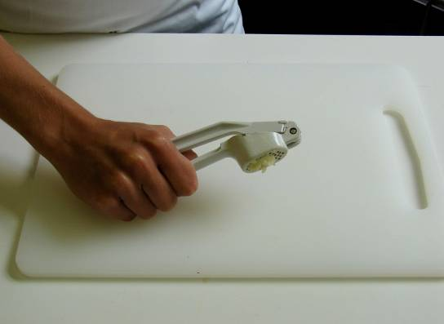
- peel and cut the potatoes into 1cm cubes. | 2. Fry the onion and garlic for 2 minutes in the oil.
 | 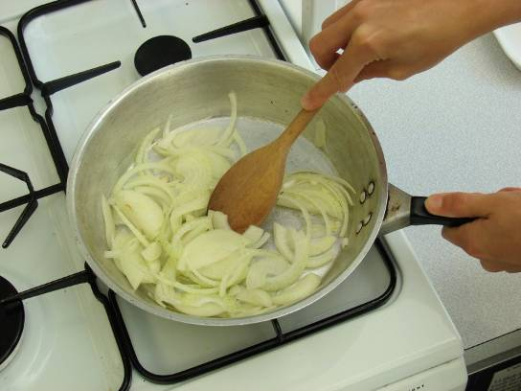
3. Stir in the curry paste, potatoes and water. | 4. Add the tomatoes and chickpeas, then allow to simmer for 20 minutes, until the potato is tender.
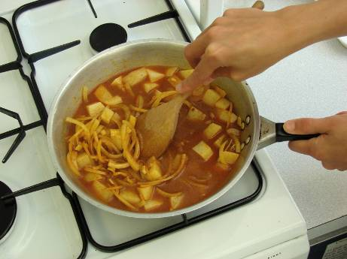 | 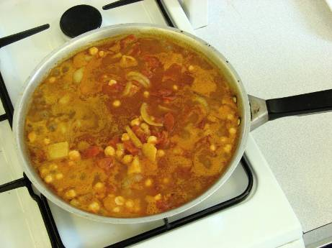
5. Stir in the fresh spinach, and allow to cook for a further 2 minutes.

