

Classic tomato ragu

Ingredients | Equipment
1 onion  1 clove garlic  1 x 15ml spoon oil  2 x 400g canned chopped tomatoes  Handful of fresh basil  Black pepper | Knife, chopping board, garlic press, measuring spoons, saucepan, wooden spoon.
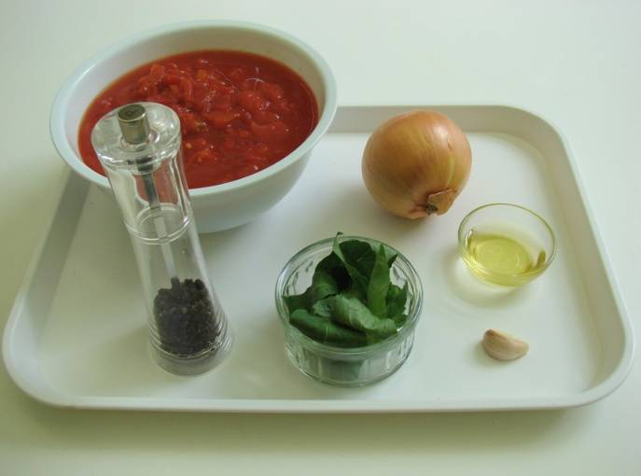 | 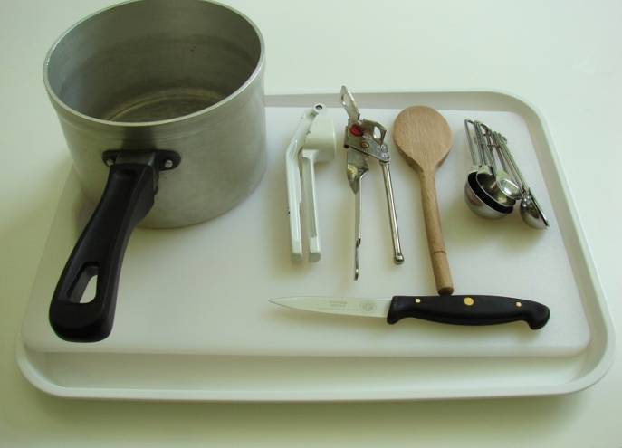
Method
- Prepare the onion and garlic:  - Peel and chop the onion; | - Peel and crush the garlic.
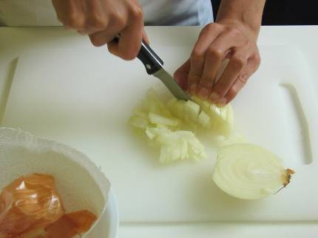 | 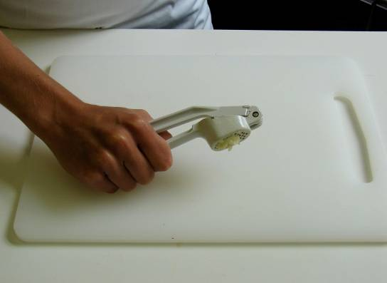
- Fry the onion and garlic in the oil for 5 minutes, until soft. | - Peel and crush the garlic.
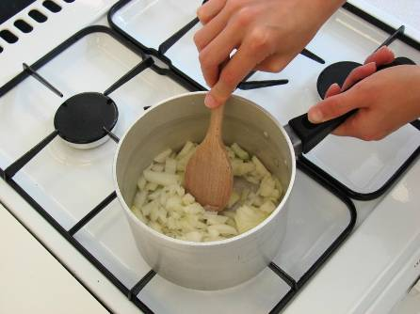
- Fry the onion and garlic in the oil for 5 minutes, until soft. | - Add the tomatoes and tear in the basil  leaves.  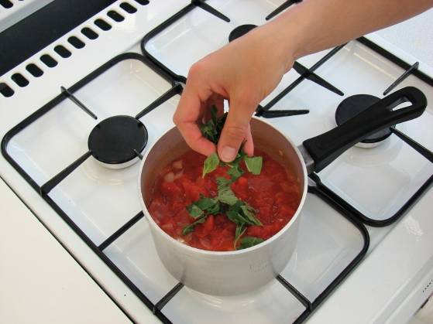
5. Add a few twists of black pepper, then allow to simmer gently for 30 minutes (longer if possible). | You may wish to serve the tomato ragu with pasta if so:  - after 15 minutes, put a large saucepan of water on to boil. When rapidly boiling, add the pasta and cook for around 10 minutes until al dente. Drain;
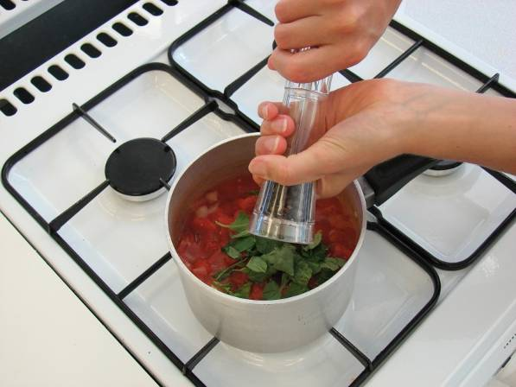 | 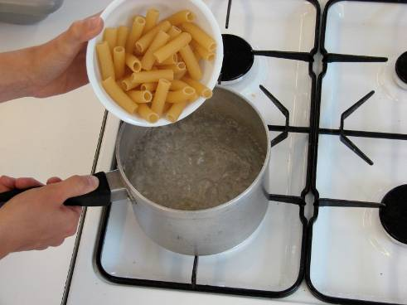
Mix the cooked pasta and tomato sauce together.

