

Ratatouille

Ingredients | Equipment
1 onion  1 clove garlic  1 small aubergine  1 green pepper  1 courgette  2 cans chopped tomatoes (800g)  1 x 10ml spoon oil  1 handful fresh basil | Chopping board, knife, garlic press, measuring spoons, saucepan, wooden spoon, can opener.
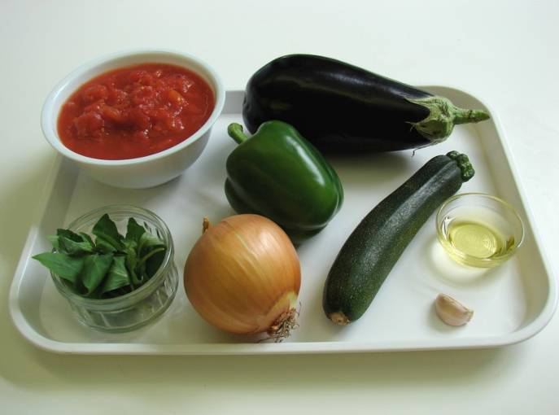 | 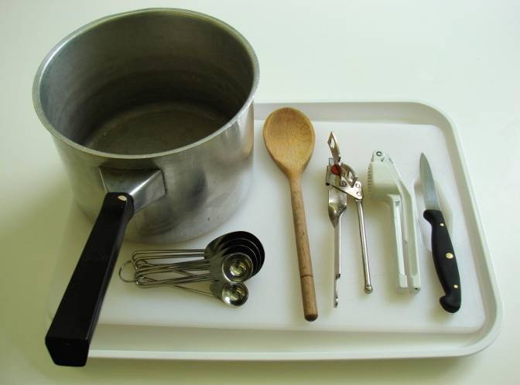
Method
- Prepare the vegetables:  - peel and chop the onion; | - peel and crush the garlic;
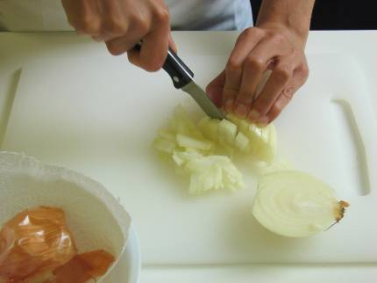 | 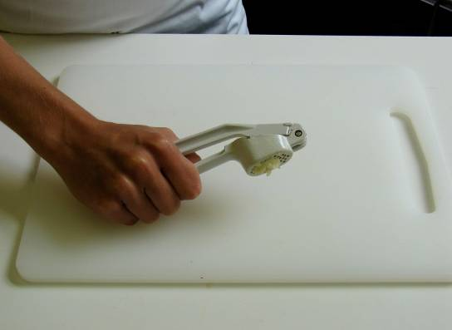
- dice the aubergine; | - de-seed and chop the green pepper;
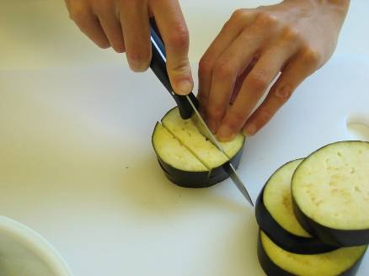 | 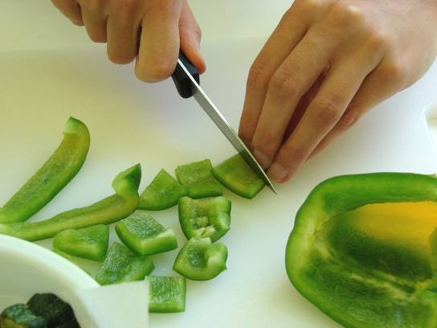
- slice the courgette. | 2. Fry the onion and garlic in the oil for 5 minutes.
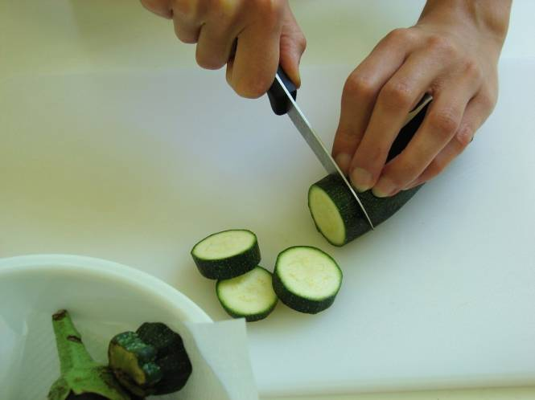 | 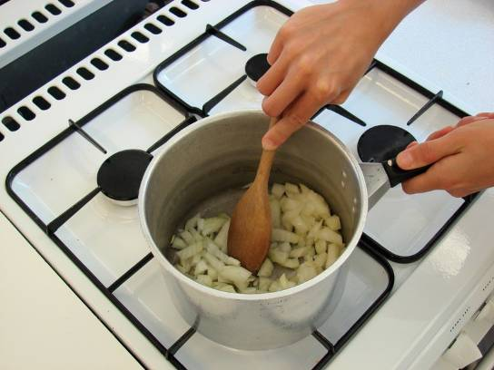
3. Add the aubergine and fry for a further 5 minutes. | 4. Add the pepper, courgette and tomatoes.
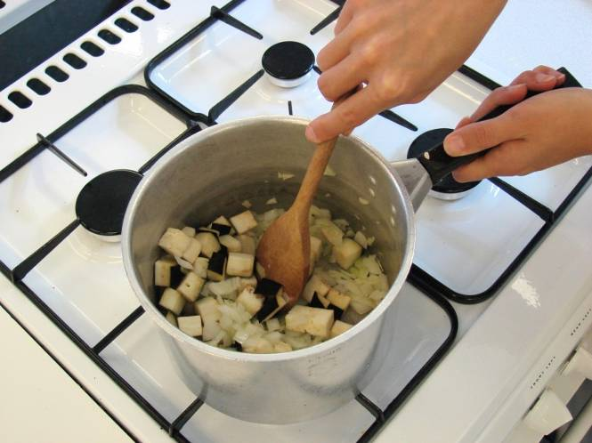 | 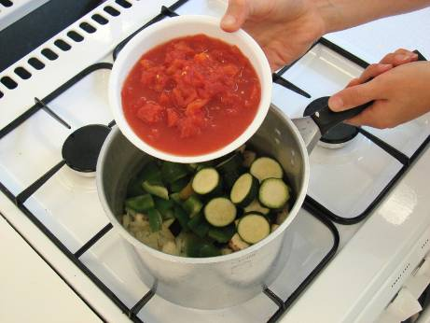
5. Stir in the torn basil leaves. | 6. Bring to the boil and then simmer gently, with the lid on the saucepan, for 20 – 30 minutes.
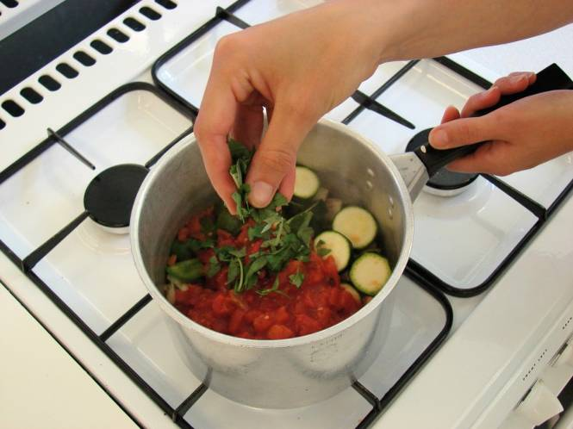 | 