

Spicy bean burgers

Ingredients | Equipment
1 slice of bread  1/2 onion  1 medium green chilli  1 x 400g can red kidney beans  1 x 5ml spoon ground chilli powder  1 x 5ml spoon dried mixed herbs | Food processor, mixing bowl, chopping board, knife, can opener, measuring spoons, spatula, flour dredger, fish slice.
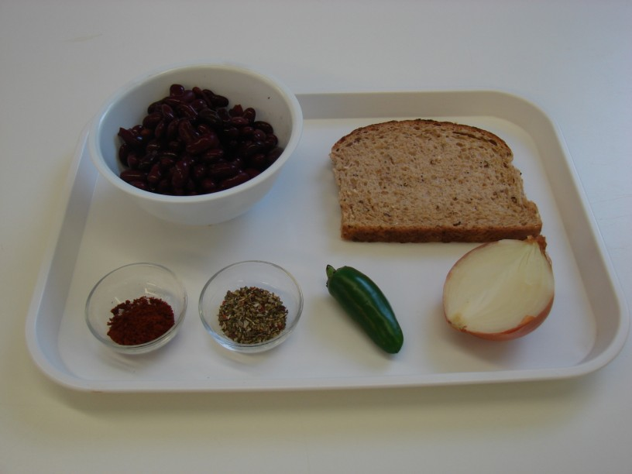 | 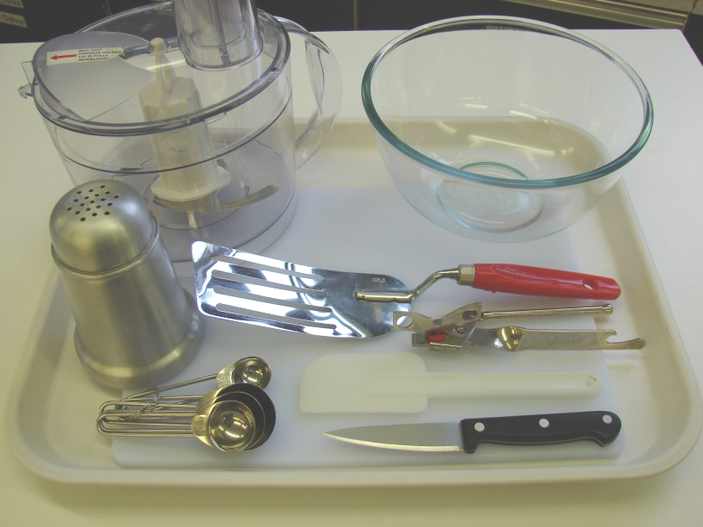
Method
- Preheat the grill. | - Put the bread in the food processor and blitz until it resembles breadcrumbs. Pour these crumbs into the mixing bowl.
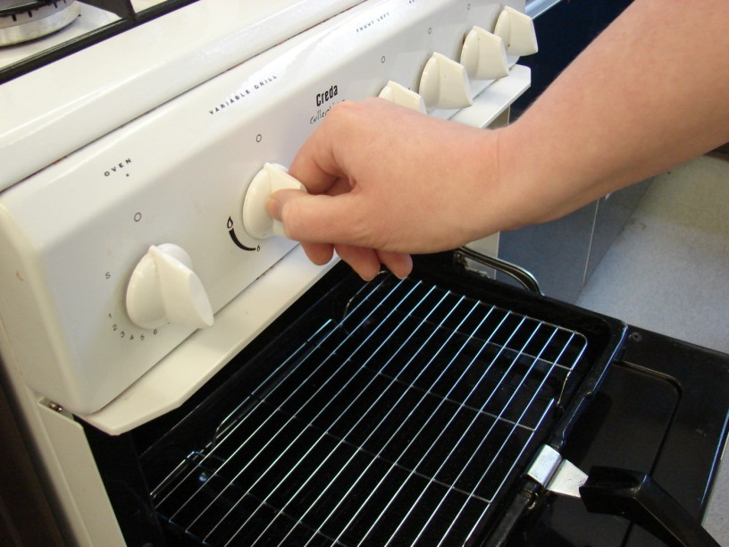 | 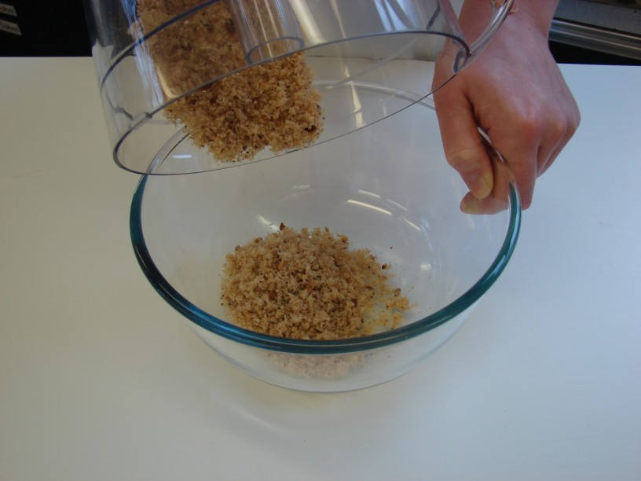
- Cut away the top of the chilli, and then de-seed. | - Peel the onion.
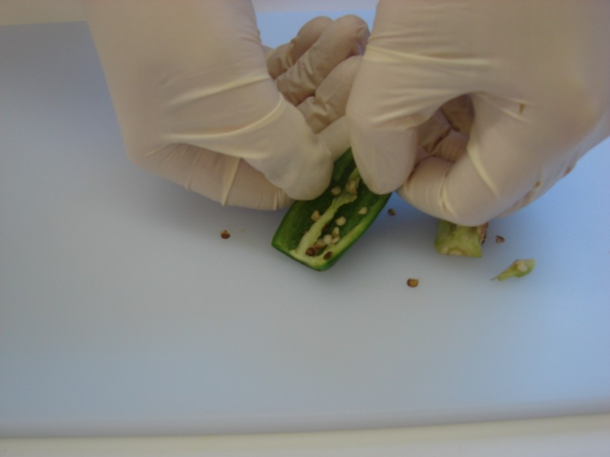 | 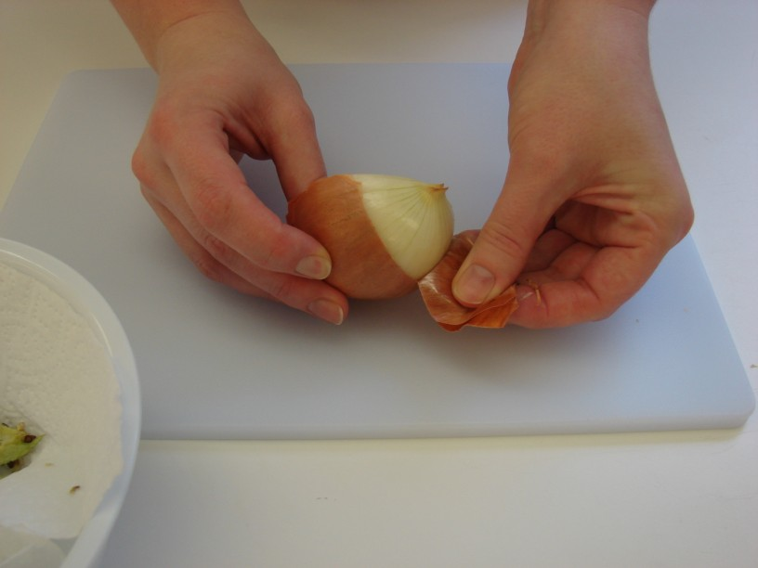
- Drain the red kidney beans. | - Place the red kidney beans, onion, chilli, chilli powder and dried herbs into the food processor. Blitz together to form a thick paste-like mixture.
 | 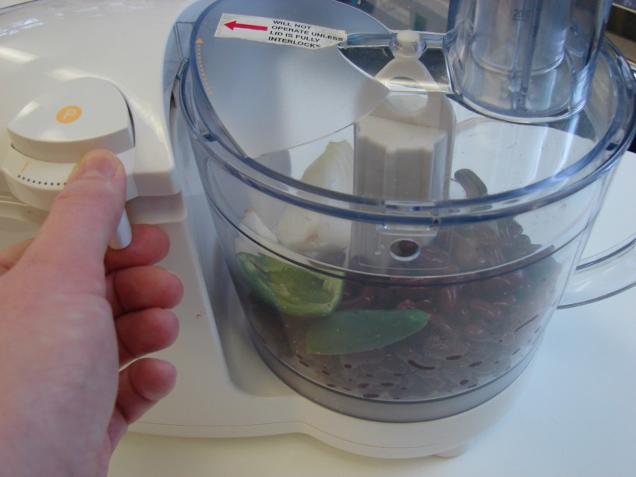
- Place the bean mixture into the mixing bowl with the breadcrumbs. Mix everything together thoroughly using the spatula. | - On a lightly floured chopping board, divide and shape the bean mixture into 8 small patties.
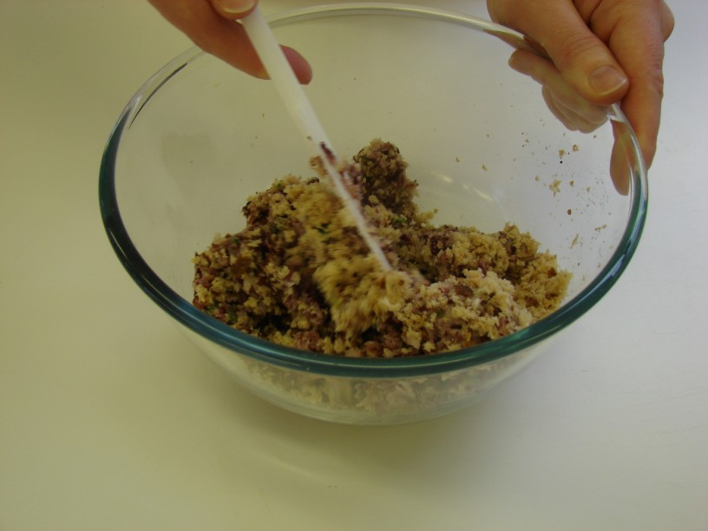 | 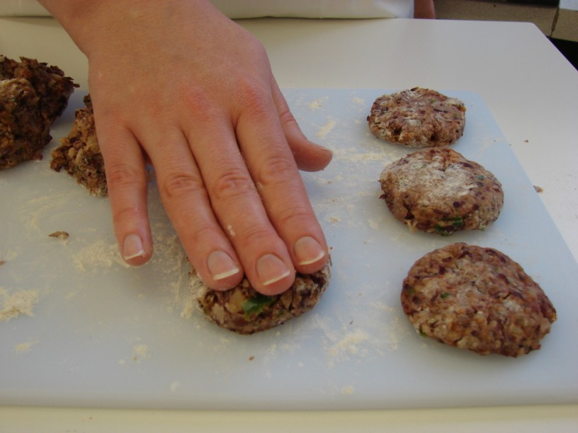
- Grill the patties for 8 minutes, turning over after 4 minutes. | - Serve in a pitta with salad.
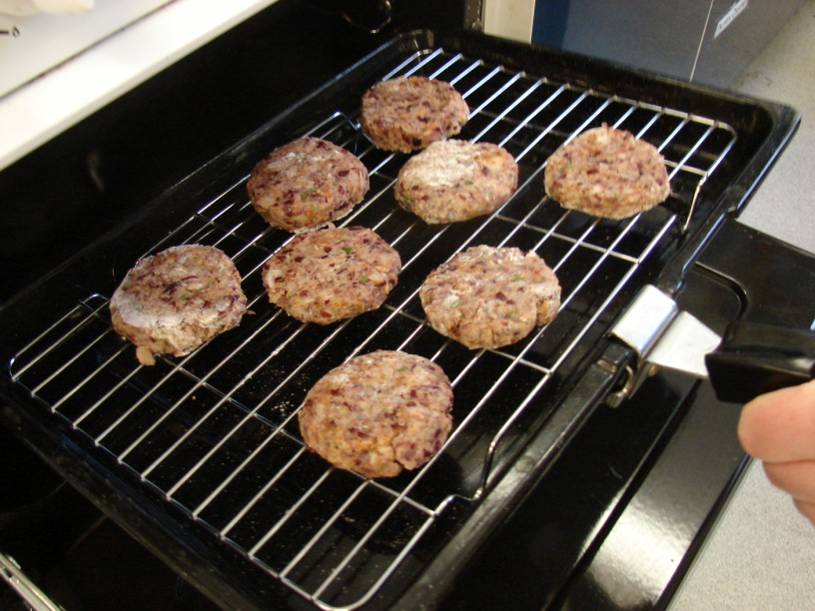 | 