

Fish and veg stack

Ingredients | Equipment
1 carrot  ½ a courgette  1 piece of fresh fish e.g. salmon (approx 200g)  25 g cheddar cheese  1 spring onion  ½ slice bread e.g. granary  1 x 5ml dried mixed herbs  Black pepper | Chopping board, knife, peeler, oven proof/foil dish, baking tray ,food processor, grater, spoon, oven gloves, weighing scales.
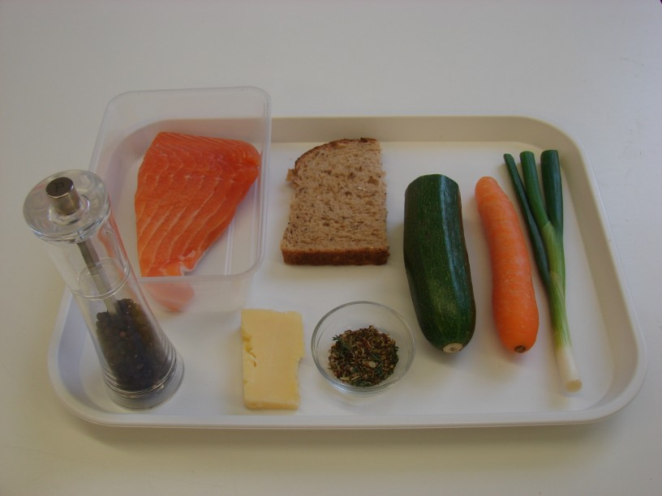 | 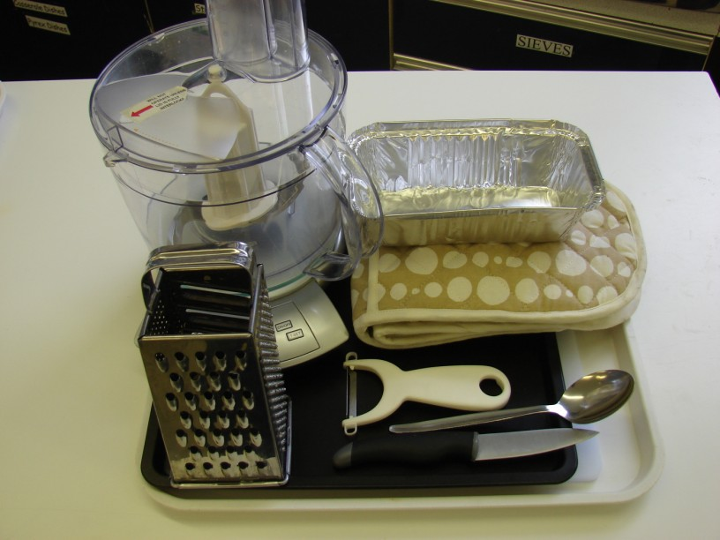
Method
1. Preheat the oven to 200c or gas mark 6. | 2. Top and tail the carrot and courgette, then run the vegetable peeler lengthways along each vegetable to make ribbons. Place an oven proof dish or foil tray on a baking tray and place the vegetable ribbons in the bottom.
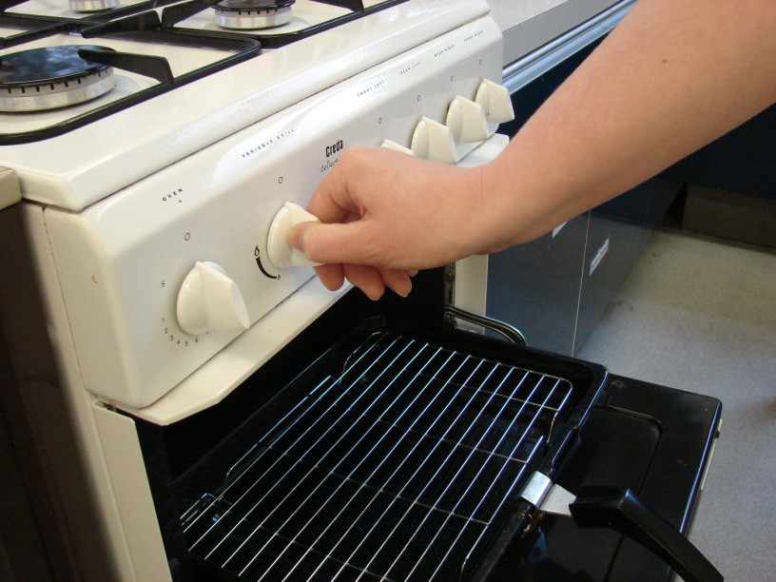 | 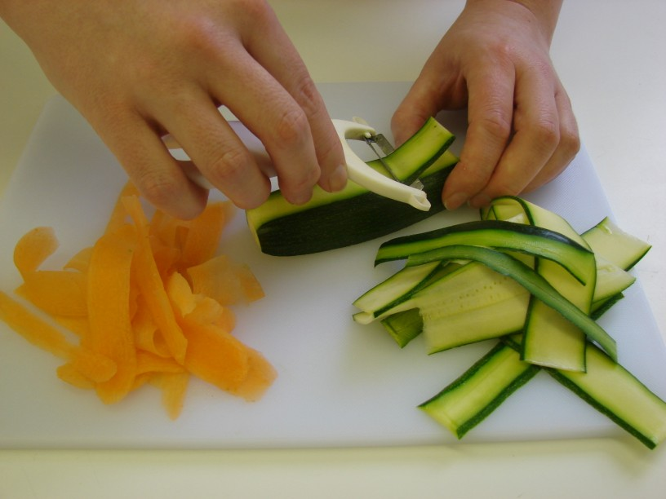
3. Lay the fish on top of the vegetables. | 4. Grate the cheese.
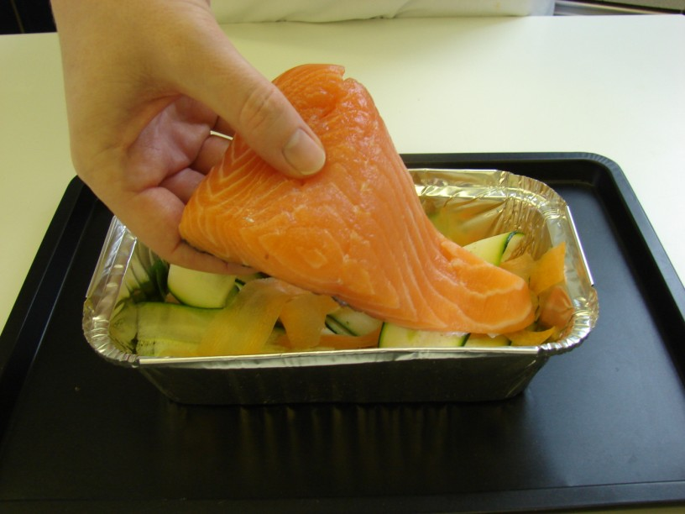 | 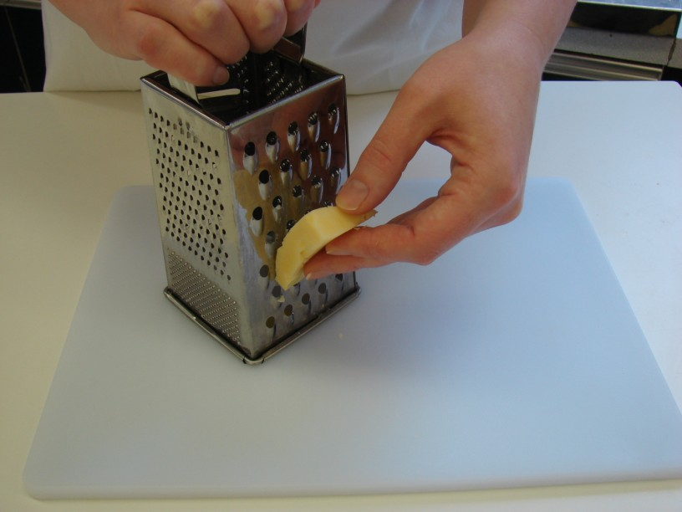
5. Put spring onion and bread into the food processor and blitz until it resembles breadcrumbs. | 6. Stir in the cheese, herbs and a few twists of black pepper.
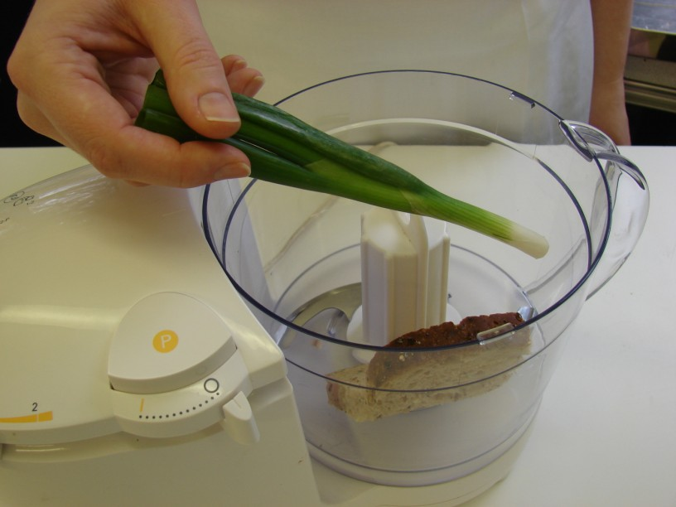 | 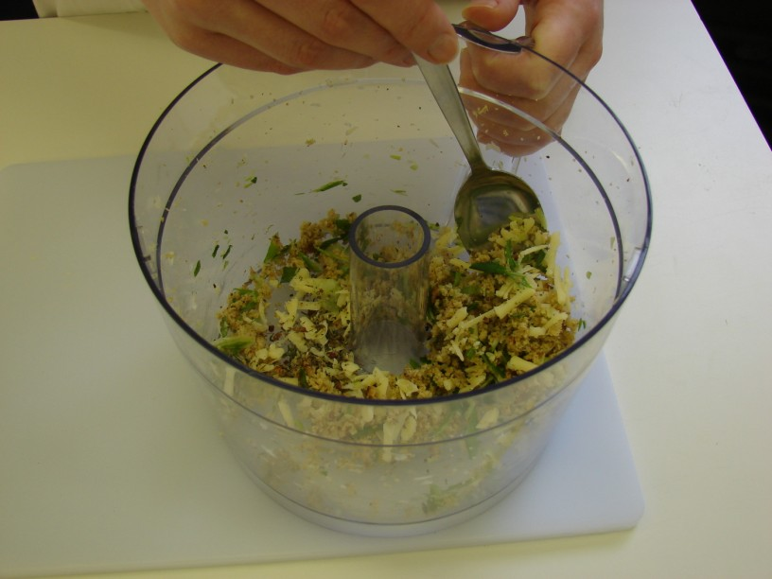
7. Spoon the mixture on top of the fish and bake in the oven for 20 minutes. | 8. Serve.
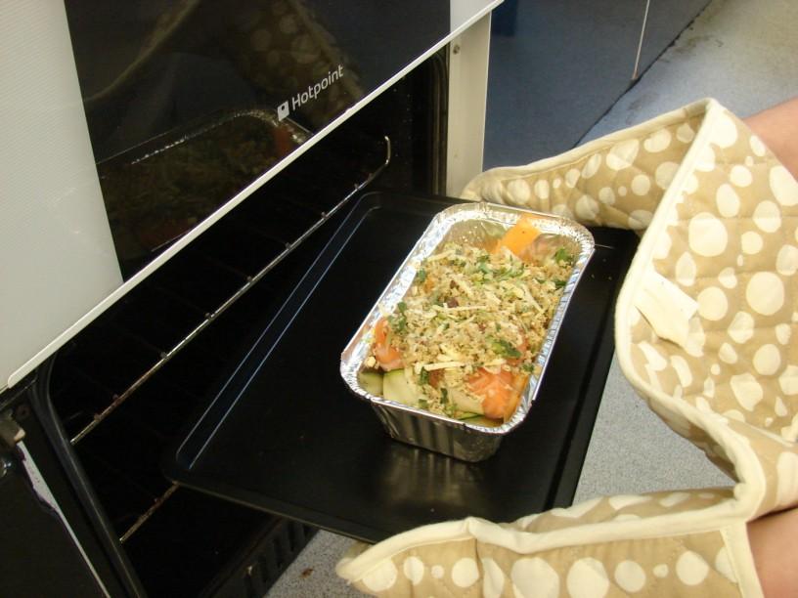 | 