

Koftas

Ingredients | Equipment
1 small onion  1 clove of garlic  1/2 red chilli  200g lamb mince  1 x 5ml spoon cumin  1 sprig of parsley, mint and coriander | Chopping boards, knife, fork, food processor, flour dredger, skewers.
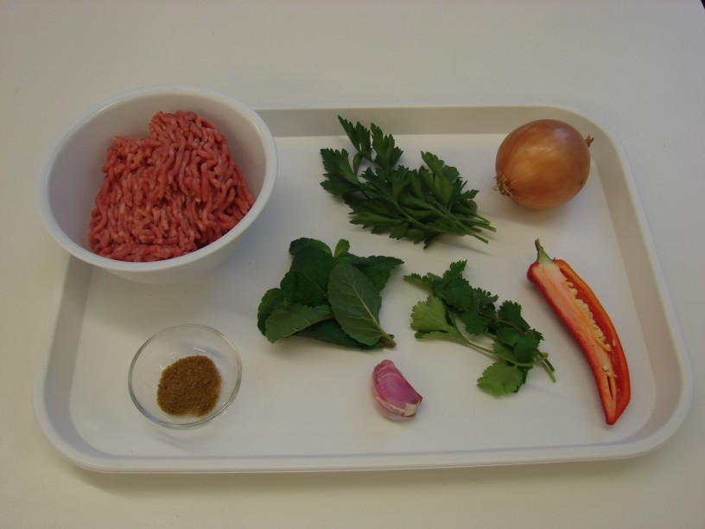 | 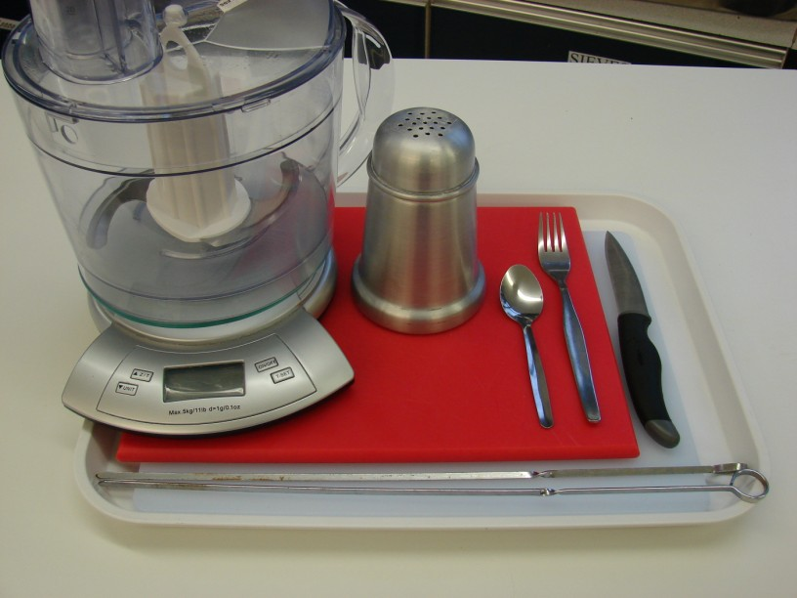
Method
1. Peel the onion and cut in half. | 2. Peel the garlic.
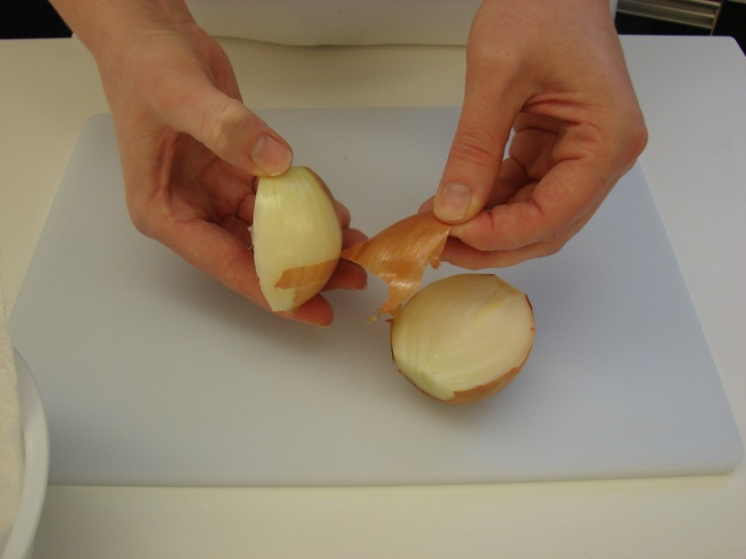 | 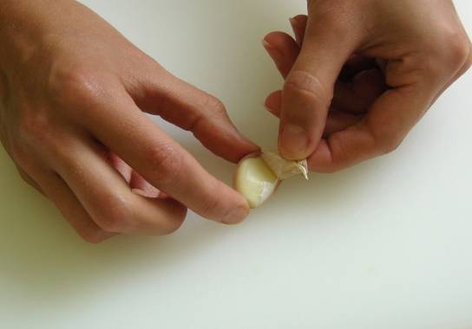
3. Cut off the top of the chilli and remove the seeds. | 4. Put the onion, chilli and garlic into the food processor and blitz.
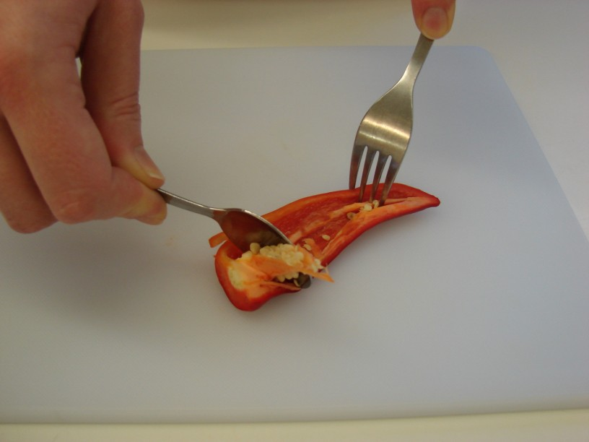 | 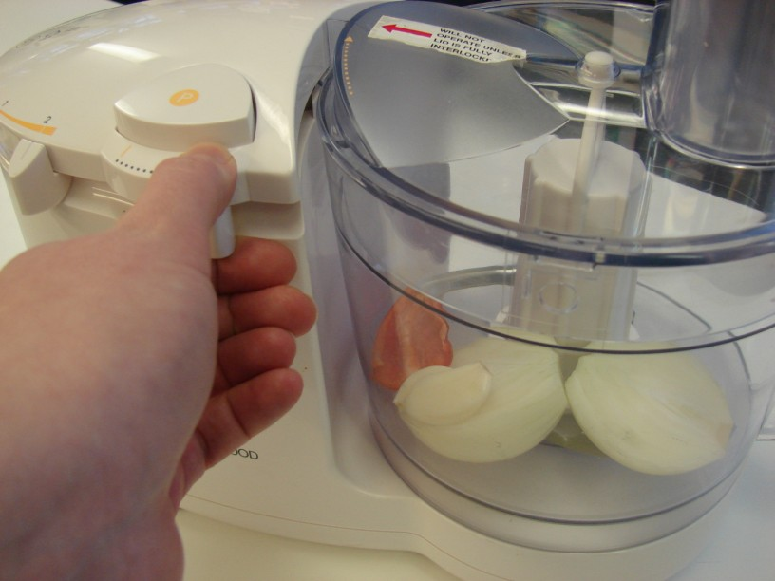
5. Add the mince, cumin and herbs and blitz together. | 6. Sprinkle a little flour onto a chopping board, then divide and shape the mixture into 8 balls.
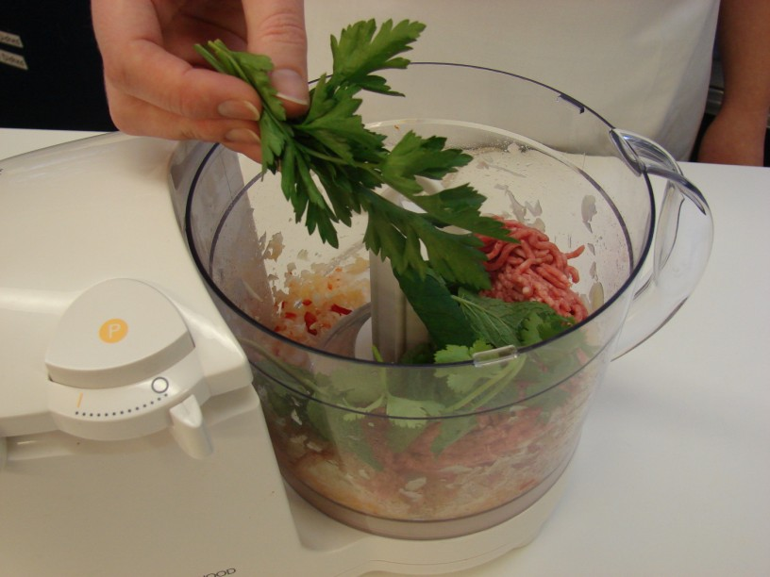 | 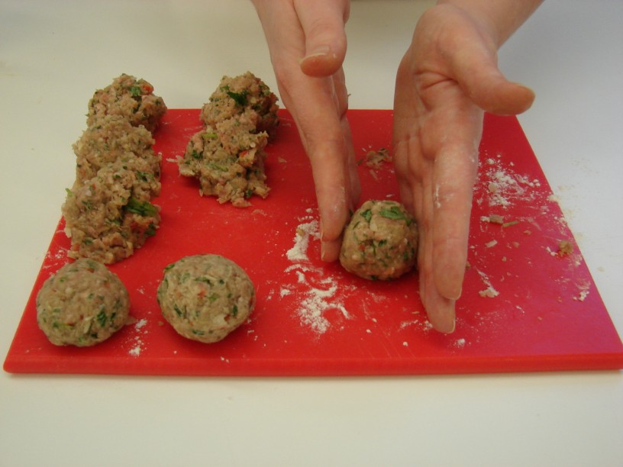
7. Thread the meat balls onto the skewers. | 8. Carefully place the skewers onto a grill pan.
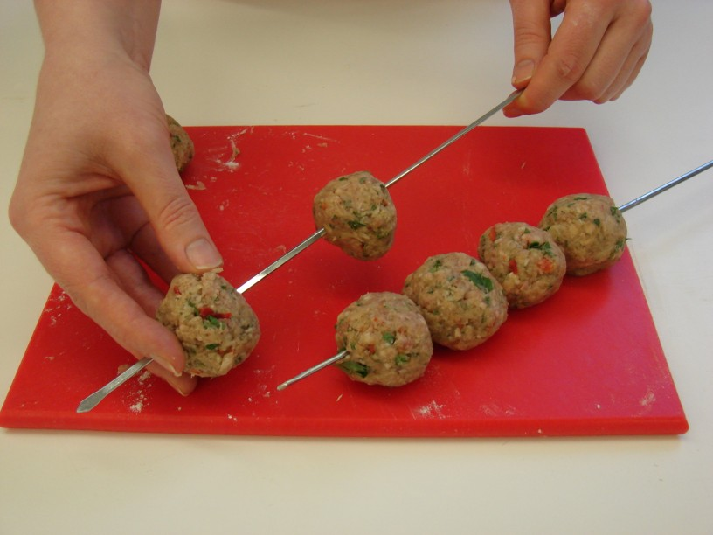 | 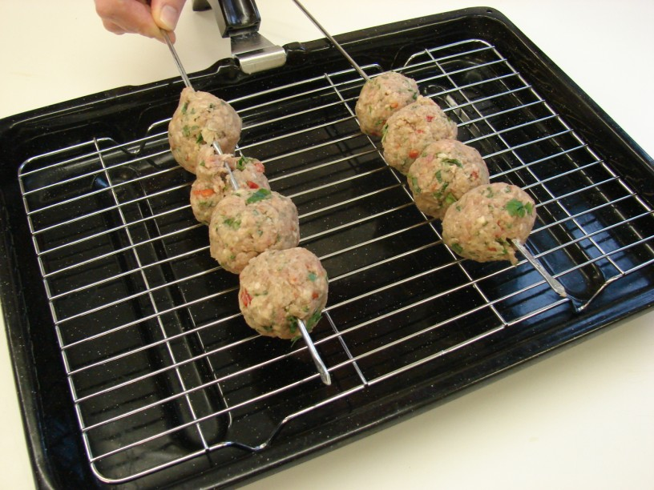
9. Grill for 10-15 minutes, turning occasionally to ensure even cooking. (The meat balls should be thoroughly cooked – no pink.). | 10. Serve in a pitta with salad.
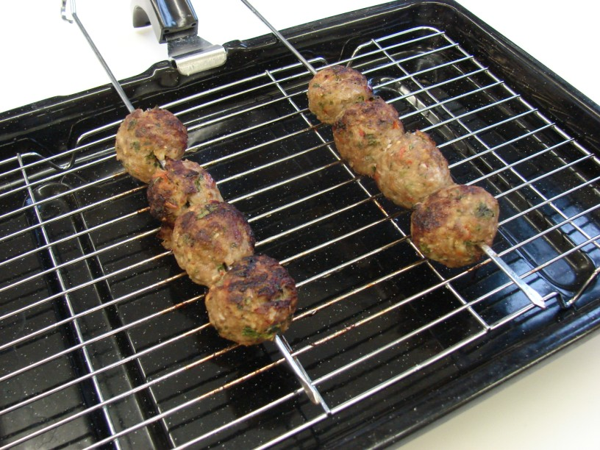 | 